

**Eklutna River**

**Aquatic Ecosystem Restoration**

**Technical Report**

**Eklutna River**

**Eklutna, Alaska**

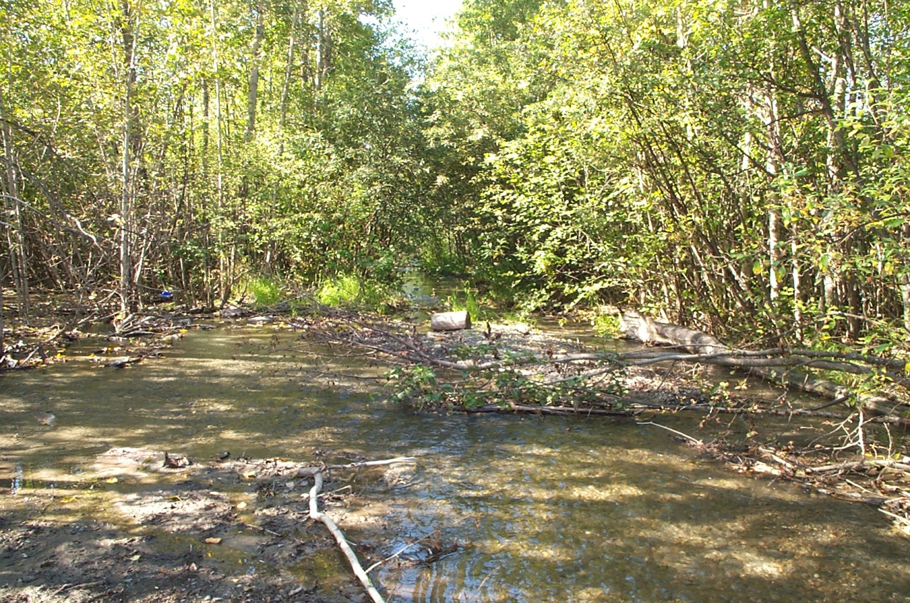

**November 2011**



**Aquatic**

**Ecosystem Restoration**

**Technical Report**

**Eklutna River**

**Eklutna, Alaska**

November 2011

# Executive Summary

The Alaska District, U.S. Army Corps of Engineers (USACE) and the Native Village of Eklutna (non-Federal sponsor) participated in an initial analysis of a potential aquatic ecosystem restoration project on the Eklutna River in Eklutna, Alaska. The proposed project was authorized under Section 206 of the Water Resources Development Act of 1996, P.L. 104-303. Section 206 authorizes the restoration of degraded aquatic ecosystem structure, function, and dynamic processes to a less degraded, more natural condition. The primary intent of the proposed project was to improve rearing habitat, over-wintering habitat, and passage for anadromous fish.

True restoration of the Eklutna River ecosystem would require removal of both dams at a cost estimated to be well beyond the funding limits on the 206 authority, and that would leave the majority of the Municipality of Anchorage without a water and electrical power supply. Therefore, the restoration project was scaled down to a project that could be achieved within the 206 authority. This modified project focuses on the lower reaches of the Eklutna River below the lower dam.

However, because there is no sponsor willing to provide the cost share to carry the project to the completion of planning and design, the following is a technical report rather than a more detailed 206 Ecosystem Restoration report. As such, this technical report does not incorporate an environmental assessment (EA) into the evaluation of the measures considered and the alternatives analyzed. Nor have the identified problems, potential solutions, and environmental effects of those solutions been coordinated with the public or resource agencies sufficiently to allow permitting based on this report. Therefore, the recommended plan is based on the analysis completed prior to formally soliciting public and agency comment and with the information developed to date.

The primary causes of degraded salmonid habitat within the Eklutna River were determined to be the diversion of 90 percent of in-stream flows from the watershed for other uses, extensive historical gravel mining within the river’s braid-plane, man-made channel/flow constrictions placed in the river at two highway bridges and one railroad crossing, and damage to within-stream and streamside habitat from human activities. The combination of these and other factors have reduced the available salmonid habitats, the number and diversity of fish that can be supported by the river, and exacerbated the negative effects of diversion of flows for power generation and water supply.

The recommended plan is to construct either alternative(s) 2, 3, 4 or 5 described in Section 3.7 after completing public and interagency comment, review and permitting processes. This study did not reach the point at which habitat units per species and habitat units per species life stages were calculated. This study did not reach the point at which a cost effectiveness/incremental cost analysis would have been completed. Therefore, the recommendations are based on the environmental engineering, ecological, and biological analyses done by the team members to date.

Based on information and the process completed to date and the reduced scope of the effort, the recommended plan maximizes ecological benefits and accomplishes the project purpose, while minimizing costs and negative environmental consequences. Work would (1) increase the number of adult salmon that are able to pass the currently heavily braided section to spawn; (2) increase the survivability of smolts; (3) restore rearing habitat; (4) restore over wintering habitat; and (5) therefore, increase the number of juvenile out-migrating salmon.

The Natural Resources Conservation Service (NRCS) will use the contents of this study to assist them in permitting and constructing some restoration project for the Eklutna River. Accordingly, activities and products of this study were coordinated with NRCS and the Sponsor. The Corps effort was performed at 100% Federal Cost. If the project was to continue as a Corps activity, then the study and the restoration construction would both be cost shared 65% federal – 35% non-federal. With NRCS, the Sponsor would only have to pay 10% of the construction cost. Obviously, the Sponsor has decided to use the NRCS grant program.

**Contents**

Executive Summary i

1.0 Introduction 1

1.1. Study Authority 1

1.2. Project Location and Background 1

1.3. Community History and Infrastructure 4

1.4. Scope 8

1.5. Study Participants 9

1.6. Reach Boundaries 9

1.7. Problem Description 10

2.0 DESCRIPTION OF THE STUDY AREA 15

2.1. Watershed Description and Historical Development of the Eklutna River 15

2.2. Geology 15

2.3. Climate and Air Quality 17

2.4. Water Quality 18

2.5. Vegetation and Wetlands 22

2.6. Fish and Wildlife 24

2.7. Land Use and Ownership 39

2.8. Cultural, Archeological and Historical Resources 40

2.9. Impacts to Cultural Resources 42

3.0 Study Formulation 43

3.1. Study Criteria 43

3.2. Scoping/Public Participation 43

3.3. Restoration needs, Problems, and Opportunities 45

3.4. Study Objectives 52

3.5. Study Constraints 53

3.6. Measures to Address Identified Study Objectives 53

3.7. Ecosystem Restoration Alternatives 58

4.0 Description of Recommended Plan 66

4.1. Recommended Plan 66

4.2. Recommended Plan Components 66

4.3. Monitoring and Adaptive Management 66

5.0 Conclusions 67

5.1. Conclusions 67

6.0 Literature Cited 68

**Tables**

Table 1. Selected 2007 Water Quality Data, Eklutna River at Railroad Trestle 18

Table 2. Species of Resident Fish in Eklutna Lake Captured by the Alaska Department of Fish and Game During Test-Net Sampling 26

Table 3. Land Ownership Status for Eklutna Project Area 40

Table 4. A Summary of Observed Habitat Problems, Causes and Effects on the Eklutna River 48

Table 5. Habitat Components of Alternatives 2-5 65

**Figures**

Figure 1. Eklutna Location Map 1

Figure 2. The Eklutna River alluvial deposit with the pre- and post-1986 100-year flood channel configurations identified. 3

Figure 3. The Eklutna River from Eklutna Lake to Knik Arm with Main Geographical Features Identified 3

Figure 4. Aerial Photograph of Lower Eklutna River Watershed (1996) 4

Figure 5. Backfilled Lower Eklutna Dam 6

Figure 6. The remains of an electrical substation perched above existing ground level after approximately 20 vertical feet of aggregate was removed by mining operations. 8

Figure 7. POWTEC Report Reach Boundaries 10

Figure 8. Errant channels of the Eklutna River flowing downstream into heavily wooded areas between the Glenn Highway and the Alaska Railroad bridges. 11

Figure 9. Eklutna River Geological Map. After: Schmoll and Emanuel 1983. 17

Figure 10. Eklutna River at Old Glenn Highway Discharge Comparison for Water Years 1954 and 2003 20

Figure 11. A pool at the mouth of a man-made pond in which adult salmon hold and acclimate to river water before moving upstream to spawn in the Eklutna River 31

Figure 12. Areas in the Eklutna River where Pacific Salmon Species are Known or Suspected to Spawn 33

Figure 13. Alternative 2 – Constructed Channel with Large Woody Debris 61

Figure 14. Alternative 3 – Constructed Channel with Upstream Cross-Vane Weirs 62

Figure 15. Alternative 4- Large Wood Debris, Boulder Clusters and Upstream Cross-Vane Weirs 63

Figure 16. Alternative 5- Constructed Channel with Downstream Large Woody Debris and Boulder Clusters 64

**Glossary**

**alevin.** Young fish, especially salmon or trout.

**bioaccumulation.** The process by which organisms absorb chemicals or elements directly from their environment.

**biota.** Organisms that occupy an ecological niche or ecosystem.

**evapotranspiration.** Loss of water by evaporation from the soil and transpiration (passage of water through plant into atmosphere) from plants.

**fecal coliform bacteria.** Aerobic (needing oxygen) bacteria found in the colon or feces, often used as indicators of fecal contamination of water supplies.

**gallinaceous.** Arboreal or terrestrial birds; most do not fly, but walk and run instead for transportation.

**herbaceous annuals.** Refers to a plant that has a non-woody stem and which dies back at the end of the growing season.

**hummocky.** Uneven.

**hydrograph.** A graph showing the stage, flow, velocity, or other property of water with respect to time.

**hyperosmotic.** Describes a cell or other membrane-bound object that has a higher concentration of solutes than its surroundings. For example, a cell that has a higher salt concentration than the salt concentration of the surrounding medium is hyperosmotic. Water is more likely to move into the cell through osmosis as a result.

**impervious areas.** Not allowing or passage through of water.

**in-situ.** In the natural or original position.

**interstitial spaces.** Small, narrow spaces found in between grains of sand.

**littoral zone.** Part of a sea, lake, or river that is close to the shore.

**macroinvertebrates.** An invertebrate animal (animal without a backbone) large enough to be seen without magnification.

**morphology.** The form and structure of an organism or part of an organism; the study of form and structure.

**osmoregulation.** The regulation of water potential in an organism. Over many years, different species have developed evolutionary adaptations in relation to their environment due to the fact that any organism will always ‘want’ to have an ideal water concentration in its cells.

**passerine.** A bird in the order of Passeriformes, which includes more than half of all bird species.

**refugia.** A location of an isolated or relic population of a once widespread animal or plant species.

**riparian zone.** Pertaining to the banks and other adjacent, terrestrial (as opposed to aquatic) environs of freshwater bodies, watercourses, and surface-emergent aquifers (e.g., springs, seeps, oases), whose imported waters provide soil moisture significantly in excess of that otherwise available through local precipitation.

**riprap.** Layer of large, durable materials (usually rocks; sometimes car bodies, broken concrete, etc.) used to protect a stream bank or lake shore from erosion; may also refer to the materials used.

**shoofly.** A temporary track laid on the ground or on cribwork at one side of a railroad line to permit trains to pass an obstruction in that line.

**smoltification.** Suite of physiological, morphological, biochemical and behavioral changes, including development of the silvery color of adults and a tolerance for seawater, that takes place in salmon as they prepare to migrate downstream and enter the sea.

**spalling.** Fragments removed from rock or concrete due to weathering.

**thalweg.** The line of deepest water within the low flow channel of a stream.

**Abbreviations**

|  |  |
| --- | --- |
| ADNR | Alaska Department of Natural Resources |
| AHRS | Alaska Heritage Resources Survey |
| ALPC | Anchorage Light and Power Company |
| ANCSA | Alaska Native Claims Settlement Act |
| AWWU | Anchorage Water and Wastewater Utility |
| C | Celsius |
| CAA | Clean Air Act |
| cfs | cubic feet per second |
| CIRI | Cook Inlet Region, Inc. |
| DOT | Dept. of Transportation |
| EEZ | Exclusive Economic Zone |
| EFH | Essential Fish Habitat |
| EPA | U.S. Environmental Protection Agency |
| ERWC | Eklutna River Watershed Council |
| EVCC | Eklutna Valley Community Council |
| F | Fahrenheit |
| LWD | Large Woody Debris |
| ML&P | Anchorage Municipal Light and Power |
| mm | millimeters |
| MW | Monitoring Well |
| NMFS | National Marine Fisheries Service |
| NRHP | Nation Register of Historic Places |
| NTU | Nephelometric Turbidity Units |
| NVE | Native Village of Eklutna |
| ppt | parts-per-thousand |
| rpm | revolutions per minute |
| USACE | U.S. Army Corps of Engineers |
| USGS | U.S. Geological Survey |

## Introduction

### Study Authority

This study was initiated under the authority of Section 206 of the Water Resource Development Act (WRDA) of 1996, P.L. 104-303 as amended. Section 206 authorizes the restoration of degraded aquatic ecosystem structure, function, and dynamic processes to a less degraded, more natural condition. Restoration involves consideration of the ecosystem’s natural integrity, productivity, stability, and biological diversity. However, there is no sponsor willing to provide the cost share to carry the project to the completion of planning and design. Therefore, this document is a technical report detailing the analysis and findings to date, not a complete Ecosystem Restoration report (Section 206 report). As such, this report does not include the typical environmental assessment and related analysis of effects, and instead makes generic recommendations based on the analyses done as of the date of this report.

### Project Location and Background

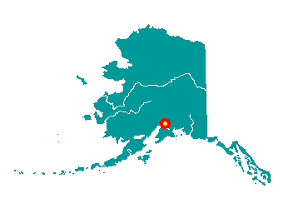

Figure 1. Eklutna Location Map

The Eklutna River is a small coastal river in Southcentral Alaska, approximately 16 miles northeast of Anchorage. The river starts at the outlet of Eklutna Lake and flows 9 miles to the Knik Arm of Cook Inlet (Figure 3). Flow from Eklutna Lake to Eklutna River is restricted by a low dam at the lake outlet. Water does not normally flow over this dam, and the dam is overtopped only during occasional periods when lake elevation exceeds 875 feet (Simonds 1995). Approximately 8 miles of the Eklutna River flows through and is confined by an eroded steep-walled canyon up to 350 feet deep with one major tributary: Thunderbird Creek. A second, but abandoned 70-foot-high concrete diversion dam built in 1929 blocks the Eklutna River canyon about 2 miles upstream from the mouth of the river. This dam is filled with sediment, and Corps of Engineers hydrologists estimated normal summer flow over the dam to be about 10 to 15 cubic feet per second (cfs) (Figure 5) and less than 10 cfs during winter when most sources of groundwater are frozen. Currently, five species of salmon return to spawn or attempt to spawn in the Eklutna River: Chinook, chum, pink, coho, and limited numbers of sockeye strays.

Thunderbird Creek, the Eklutna River’s largest tributary, is a clear-water stream that enters the left bank of Eklutna River about a half mile upstream from where Eklutna River exits the canyon and forms an alluvial fan. Thunderbird Creek flows clear and cold, and is approximately 8 feet wide and 1 foot deep. The reach of Thunderbird Creek usable to anadromous fish terminates at the base of a 200-foot-high barrier waterfall about one-third of a mile upstream from its confluence with the Eklutna River. Due to the upper and lower dams on the Eklutna River creating a severely reduced flow of the river itself, Thunderbird Creek is currently the main source of water into the Eklutna River. Eklutna River is normally turbid and characterized by low flow until its confluence with Thunderbird Creek. Adult Chinook salmon and coho salmon spawn in Thunderbird Creek. Trapping with baited traps during summer shows that at least Dolly Varden, coho and Chinook juveniles use Thunderbird Creek for summer rearing. The usability potential of Thunderbird Creek for juvenile salmonids to overwinter has not been documented.

An alluvial deposit, approximately 1 to 2 square miles in area, lies between the canyon mouth and Knik Arm (see Figure 2). This deposit is crossed in a northerly and southerly direction by the Glenn Highway and the Alaska Railroad. Both crossings form channel constrictions. The alluvial deposit is composed of silt, sand, gravel, and cobble washed down from the Eklutna River canyon and glaciers. The intertidal portion of the deposit is covered by a thick layer of silt from Knik Arm. The deposit has been intermittently, but heavily mined for construction aggregate starting with construction of the Alaska Railroad at Eklutna in 1917 (Fuglestad 1986). A borrow pit of 117 acres is currently operating on the north side of the deposit (Breese 2007). Other current and historical use of Eklutna River water includes hydro-electric power, potable water for the Municipality of Anchorage, and recreation (USDI 1948, Lesondak 2002, McFadden and Bennett. 1991, ADNR 2007).

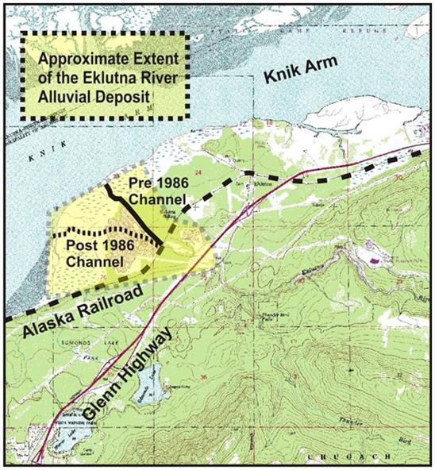

Figure 2. The Eklutna River alluvial deposit with the pre- and post-1986 100-year flood channel configurations identified.

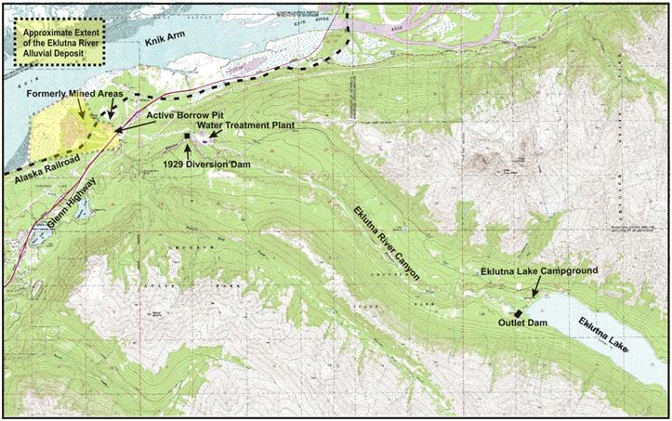

Figure 3. The Eklutna River from Eklutna Lake to Knik Arm with Main Geographical Features Identified



Figure 4. Aerial Photograph of Lower Eklutna River Watershed (1996)

### Community History and Infrastructure

The community of Eklutna is at the head of the Knik Arm of Cook Inlet, at the mouth of the Eklutna River, 25 miles northeast of Anchorage. Eklutna is unincorporated and lies within the Municipality of Anchorage. Anchorage was incorporated on November 23, 1920, and the Greater Anchorage Area Borough was formed on January 1, 1964. On September 15, 1975, the city and borough governments were unified creating a Unified Home Rule Municipality, known as the Municipality of Anchorage. Anchorage, with Eklutna as a part of its constituency, is governed by a mayor, who holds a 3-year elected term, and a city assembly (DCRA-MOA). The Native Village of Eklutna (NVE) is a federally recognized Alaska Native tribe. Under the Alaska Native Claims Settlement Act of 1971(ANCSA), Eklutna Inc. is the village corporation and Cook Inlet Region, Inc. (CIRI) is the regional corporation.

The Eklutna area has long been inhabited by Dena’ina Athabascans, and the NVE continues to be populated by Dena’ina today. In the past, the Dena’ina used Eklutna as the site of a winter village due to its proximity to Cook Inlet fishing resources, plant resources, and good sheep hunting areas (UAF, no date). In the 1840s, Russian missionaries traveled up Cook Inlet to Dena’ina territory. In 1867, the United States purchased the rights to Alaska from Russia. The discovery of gold in 1887 and later in 1922 in the Interior sparked development and the construction of the Alaska Railroad (UAF, no date). Construction began in 1914 on the federal railroad from the Port of Seward (126 miles south of Anchorage), through the coal fields of Interior Alaska, to the gold claims near Fairbanks (358 miles north of Anchorage). The railroad was built through the Eklutna area, and in 1918 a railroad station was built in the village.

The growing city of Anchorage was largely electrified by the late 1920s, and Eklutna was selected to supply electrical power due to the hydropower potential of the Eklutna River (then known as Eklutna Creek) and Eklutna Lake. In 1927, the City of Anchorage entered into a contract with the Anchorage Light and Power Company (ALPC) to construct the Old Eklutna hydroplant. Construction included a low-head storage dam at the outlet of Eklutna Lake and a 68-foot-high concrete arch diversion dam (referred to as the Lower Eklutna Dam in this study) in the Eklutna River canyon 8 miles downstream of the lake. The diversion dam diverted water through a ¼-mile-long tunnel to a turbine house near Eklutna Village. Overhead transmission lines carried the power from Eklutna to Anchorage. Its first 1,000 kW unit began service in 1929, followed by a second unit in 1935. In 1937, ALPC installed a 700 kW diesel power generating unit to supplement existing units. The City of Anchorage bought the plant in 1951. Since its construction, the Lower Eklutna Dam has been a barrier to fish movement upstream.

Expansion of military bases in Anchorage during the 1940s stressed the capacity of the Eklutna power generation system, and it was upgraded several times. In 1948 the Bureau of Reclamation recommended construction of a new dam to raise the level of Eklutna Lake to an elevation of 875 feet above sea level with a tunnel intake at 830 feet. Construction was completed in 1955. The new system replaced the aging storage dam at the lake outlet with a new dam that diverted water through a 4.5-mile-long, 9-foot-diameter concrete lined tunnel with a capacity of 640 cfs to a turbine house on the south bank of the Eklutna River. The dam, as modified, is an earth-and rock-filled structure 555 feet long, and contains approximately 5,000 cubic yards (yd3) of material. This new plant used essentially the entire storage capacity of Eklutna Lake, and no water was made available to operate the existing hydropower plant at Eklutna. The existing plant was shut down as a result, and the Lower Eklutna Dam was allowed to fill with gravel. This dam is no longer operational and is currently completely backfilled with sediment to a depth of approximately 68 feet at the upstream face of the dam (see Figure 5).

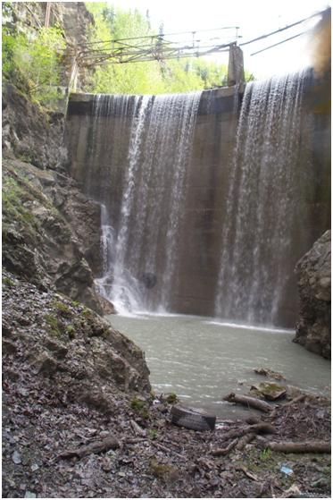

Figure 5. Backfilled Lower Eklutna Dam

In March 1964, a severe earthquake that caused widespread damage and destruction hit the Anchorage region. Due to the severity of damage to the dam, it was decided to construct a new storage dam downstream from the existing storage dam at the lake outlet. The new Eklutna Dam (referred to as the Upper Eklutna Dam in this report) is an earth- and rock-fill structure 815 feet long and 51 feet high containing 85,000 yd3 of material. The spillway is a rectangular concrete conduit through the dam with an uncontrolled overflow crest. The maximum capacity of the spillway is 3,315 cfs. There are no outlet works in the dam as the power tunnel serves in that capacity (USBR nd). The new dam is used to divert water to the Eklutna Hydroelectric Facility, now owned by Municipal Light and Power (ML&P), Chugach Electric Association, and Matanuska Electric Association (MEA), who jointly took ownership in 1996. The hydropower plant provides electricity to some of Anchorage.

In 1988 the Municipality of Anchorage completed construction of the Eklutna Water Treatment Facility located about 2 miles up Eklutna Lake Road from the NVE. Water stored in Eklutna Lake was reallocated to supply the water needs of Anchorage in addition to power generation. The Anchorage Water and Wastewater Utility (AWWU) operate the treatment plant to ensure that waters from Eklutna Lake meet all drinking water quality standards before being distributed to end users. The plant has a capacity of 35 million gallons per day.

A highway to connect Anchorage to the nearby Matanuska-Susitna Valley began construction in 1934. This road became known as the Glenn Highway and was upgraded to a modern highway in 1964. The Glenn Highway passes through the Eklutna area and serves as the main thoroughfare to connect the community with nearby Anchorage, Eagle River, and the Matanuska Valley. Also in the area are both the modern and original Glenn Highway bridges and an Alaska Railroad bridge downstream of both highway bridges. The Alaska Railroad no longer stops in Eklutna, but runs service from Anchorage to Fairbanks, Seward, and Whittier. According to the Alaska Railroad milepost system, the track begins in Seward at rail mile 0.0; Anchorage is at rail mile 114.3, Eklutna is at 141.8, and the railroad ends in Fairbanks at rail mile 470.3. The Alaska Railroad operated a gravel pit at rail mile 140 and the railroad crosses the Eklutna River at rail mile 140.8 (USACE nd).[1]

In the spring of 2007, a gravel mine began operating on the outskirts of the NVE. The mine is owned jointly by Eklutna Inc., which owns the surface land, and CIRI, who owns the gravel beneath; the two corporations share royalty income. Up to 200 truck-loads of gravel per day are extracted from the mine, which goes to construction projects in the Anchorage area. The villagers have concerns about the noise and dust generated by the mine.

Some members of the local Dena’ina Athabascan people say that aggregate mining within the lower Eklutna River ecosystem has degraded it to a low state of salmonid production (Dan Alex, personal communication 2007). Aggregate mining downstream of the Alaska Railroad Bridge did lower the ecosystem habitat adjacent to the river channel approximately 20 feet (Figure 6) and removed most of the old growth riparian vegetation between the railroad bridge and the upper intertidal zone of Knik Arm. There is also physical evidence that aggregate mining took place on the north side of the alluvial deposit between the railroad and highway bridges, but the years in which this mining took place is not known. (POWTEC 2007)

A 100-year flood event in 1986 changed the river course between the railroad bridge and Knik Arm (D. Alex, personal communication 2007). Prior to the 1986 flood, the river flowed along the northern edge of the alluvial deposit but changed course during the event to flow through the mined area after the event This event caused the river to flow through a degraded area virtually devoid of well established riparian vegetation, large woody debris, and other habitat that promotes optimum production of rearing salmonids during summer. Some riparian vegetation and woody debris has naturally reestablished itself since 1986.

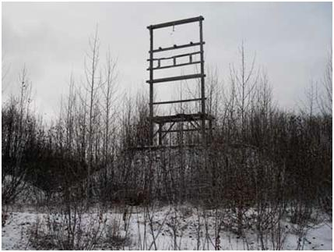

Figure 6. The remains of an electrical substation perched above existing ground level after approximately 20 vertical feet of aggregate was removed by mining operations.

### Scope

This technical report examines the need for aquatic ecosystem restoration within a particular reach of the Eklutna River and includes an outline of reasonable alternatives for possible restoration. Thunderbird Creek was minimally studied by way of identifying Eklutna River issues but not to the extent that recommendations can be made to determine its aquatic ecosystem restoration potential.

The scope of this study was limited first by the congressionally authorized limits built into the Section 206 WRDA authority and secondly by the practicability of potential solutions. The study therefore includes reasonable solutions to salmonid habitat loss/degradation, passage barrier resolution, and overall ecosystem restoration that were considered potentially constructible within the funding limits of the Section 206 authority and that do not degrade or limit multi-purpose land use of the Native Village of Eklutna.

Issues/solutions raised that were outside the scope of this study (and therefore eliminated from further consideration) include:

* removal of the Eklutna Lake dam
* reducing or ending diversions of Eklutna Lake water used for supplying drinking water for Anchorage
* removal of the downstream dam that currently acts only as a sediment trap
* substantially changing Native Village of Eklutna approved current land uses within the watershed
* installation of wells to replace riverine flows in whole or in part
* removal of or modification to the Alaska Railroad and Glenn Highway bridges
* changing land ownership within the watershed.

The final limiting factor on the scope of this study was the lack of a sponsor willing to provide the cost share necessary for a Section 206 study. This technical report defines the problem and potential solutions at a conceptual design level versus a complete planning-level study developed to a construction ready (implementation) status. This technical report does not contain a complete NEPA analysis nor does it contain the information necessary to permit the alternatives discussed in this report.

### Study Participants

The Native Village of Eklutna, a federally recognized tribe and the U.S. Army Corps of Engineers (USACE) participated in this study.

### Reach Boundaries

The reader is cautioned that all related background documents and references do not use the same reach descriptions as this report. Data was collected by numerous authors and entities over a 10-year period for multiple purposes so reach descriptions were defined for different purposes. References to the POWTEC report (Habitat Assessment of the Lower Eklutna River, May 14, 2007, Prince of Wales Tribal Enterprise Consortium [aka POWTEC Report]) used the reach boundaries depicted in Figure 7, which were determined based on an assessment of habitat types within the Eklutna River watershed.

For this report, reach boundaries were the areas above the Glenn Highway bridges, between the Glenn Highway and Alaska Railroad Bridge, and the area below the railroad bridge.[2] These areas were selected in part to define hydrologic conditions and to help define and discuss potential solutions. For the purposes of this study, the lower dam is the boundary between the “upper” and “lower” reaches of the Eklutna River. Reach boundaries related to repetitive fish surveys were determined by the surveyor and include or overlap the POWTEC and USACE hydrology boundaries.

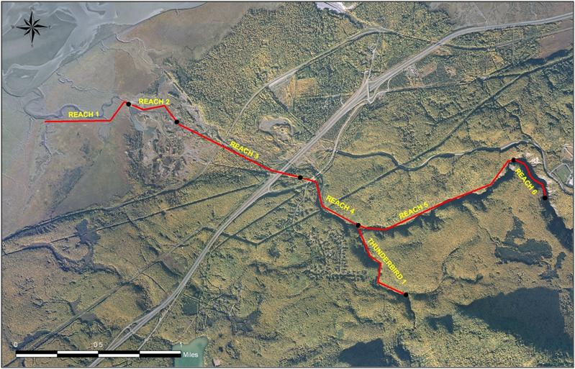

Figure 7. POWTEC Report Reach Boundaries

### Problem Description

Development within the Eklutna River watershed has degraded the functionality of the river’s ecosystem. Permanent loss of 90 percent of the natural hydrograph due to upstream dam construction and diversion of 100 percent of Eklutna River flows, impacts to the river resulting from highway and railroad bridge construction, and other anthropogenic effects have degraded channel morphology and salmonid habitat functionality in some river reaches. Additionally, aggregate mining of the alluvial deposit continues at a 117-acre borrow pit adjacent to the river.

Ecosystem damage from aggregate mining is complicated by natural bedload that accumulates between the highway and railroad bridges. Much of the bedload deposited between the bridges appears to have been caused by a relatively narrow railroad bridge that restricted flow and an elevated rail bed that acted like a dam during a 100-year flood event on October 12, 1986 (USGS 2005). This 100-year event flooded the ecosystem behind the elevated railbed to where a massive volume of bedload being carried from the canyon dropped out and superimposed a fresh alluvial deposit on the existing deposits.

This massive bedload deposit and additional bedload transported in subsequent but smaller events has elevated the river bed between the bridges to where it has become highly braided and subject to frequent channel changes within and between summer seasons. These small, braided channels change course within and between open water periods. Some of these channels dewater as they flow downstream. Conversely, when viewed from the downstream end of the reach, some of the channels braid into small and often impassable branches moving upstream. These small, shallow braided channels pictured in often run through heavily wooded areas that can dewater, strand fish, and make passage for salmon difficult or impossible. In addition to excessive sediment accumulation conditions between the bridges, the channel appears to be starved of smaller gravel and sediment for several hundred yards downstream of that reach.

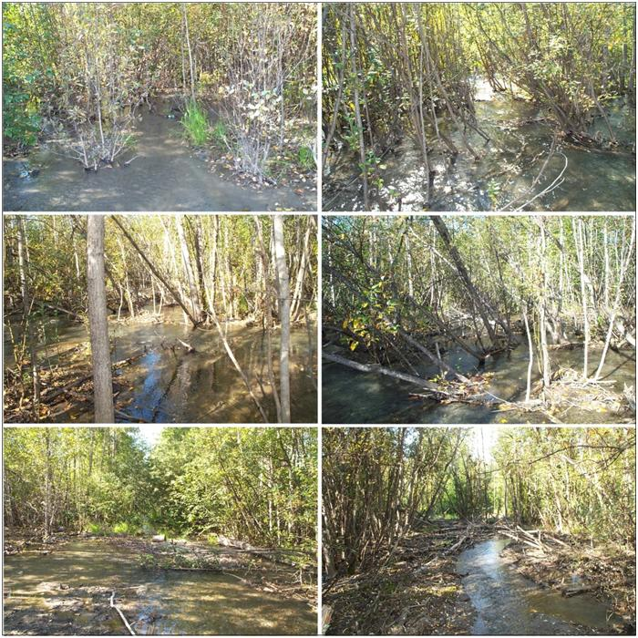

Figure 8. Errant channels of the Eklutna River flowing downstream into heavily wooded areas between the Glenn Highway and the Alaska Railroad bridges.

Further problems result from human use of the ecosystem, which continues to degrade its structure and function. Vehicle trails through the riparian habitat parallel the river and vehicles cross or drive on the riverbed for short distances at several locations. Vehicle use of the ecosystem results in compaction of the riparian soils and the riverbed. It disturbs ecosystem wildlife and introduces pollutants. Vehicle crossings create barriers to and disrupt the passage of adult salmon. Vehicles break down riverbanks that, under the right soil conditions, result in degraded channel morphology that can strand juvenile salmon during periods of rapid fluctuation in water levels.

A summary of the ecosystem problems observed includes the following;

* The natural flow of the Eklutna River is controlled by a dam at the outlet of Eklutna Lake, reducing in-stream flows by 90 percent.
* Excessive deposition of sediment occurs in the reach between the Alaska Railroad bridge and the Glenn Highway bridges.
* The channel is starved of smaller gravel and sediment for several hundred yards downstream of the Alaska Railroad bridge.
* Summer and winter rearing habitat appears to be limited due in part to embedded gravel.
* Much of the Eklutna River downstream of the canyon appears to be perched above the ground-water table.

A summary of the salmonid habitat problems resulting from the ecosystem problems observed includes the following;

* Channel morphology that results in stranding of adults and juveniles
* Limited summer rearing habitat
* Limited winter rearing (over-wintering) habitat
* Passage barriers
* Embedded spawning gravel
* Continued damage to the existing habitat by human incursion

As noted previously, some of the problems identified are outside the scope of this effort. The dam at the outlet of Eklutna Lake controls the lake elevation for hydropower and the Municipality of Anchorage’s water supply. Potentially beneficial changes in river flow relative to the outlet control dam are not achievable at this time. The 1929 hydro-diversion dam is filled to the top with sediment. Releasing this sediment to the river without adequate flushing flows may do more physical and biological harm than good and is outside the scope of this effort. The elevation of the river channel above the surrounding water table cannot be avoided, but measures to accommodate and mitigate this condition were considered. Options for work within the canyon are limited by the physical constraints of the canyon and a general desire to avoid work in areas not already impacted by human activity.

The overall goal of the Eklutna River Ecosystem Restoration study is to modify the physical conditions in the lower Eklutna River to: (1) improve degraded ecosystem conditions with emphasis on the reach between the bridges, (2) encourage the reestablishment of natural processes needed to build and maintain the ecosystem functions, (3) provide a diversity of habitat types and organisms needed to restore salmonid productivity in the Eklutna River ecosystem to a level that is as close as practical to those present prior to development (4) provide for improved passage of adult salmon; and (5) reduce likelihood of juvenile salmon stranding.

#### Restoration in the Upper Reaches of the Eklutna River, Opportunities and Limitations

For the purposes of this study, the lower dam is the boundary between the upper and lower reaches of the Eklutna River. As previously noted the upper reaches of the Eklutna River is outside the scope of this study but the opportunities and limitations are included here because their identification is necessary to characterize the status of the entire system.

* Opportunities:
* Restoration of fish passage, primarily sockeye salmon, into Eklutna Lake.
* Restoration of a portion of the natural hydrograph or the entire natural hydrograph.
* Restoration of habitats upstream of both dams.
* Limitations:
* The over-riding limitation is the inability to restore the natural hydrograph. Diversions from Eklutna Lake for water supply will not be modified.
* The next most substantial limitation is the inability to remove either the up or downstream dam on the Eklutna River that completely block upstream fish migration and that have eliminated the riverine habitat behind them.
* Both the first and second limitations combine to prevent any substantial improvement to salmonid habitat degraded by embededness (the accumulation of sediments in stream/river substrate). The annual loss of 90 percent of the riverine flows and lack of substantial flushing flows related to precipitation, melt, and flood events has resulted in gravel substrate embedding in some stretches to the point that it is no longer suitable spawning and foraging/rearing habitat.

#### Restoration in the Lower Reaches of the Eklutna River, Opportunities and Limitations

* Opportunities:
* Restoration of fish passage to the base of the downstream dam 1.75 miles upstream of the Glenn Highway Bridge and 0.7 miles downstream of the confluence with Thunderbird Creek.
* Restoration of consistent fish passage through the reach between the Glenn Highway and Alaska Railroad bridges.
* Restoration of a non-embedded channel substrate in the reach between the bridges.
* Restoration of a portion of the formerly available summer and winter rearing habitat below the lower dam.
* Restoration of a more natural channel depth and slope in the reach between the bridges.
* Elimination of non-flood event stranding (passage barrier elimination) of adults and juveniles in the reach between the bridges.
* Increase in the available spawning gravel.
* Restoration of riparian and other stream side habitats.
* A reduction in the acreage of stream and riparian habitats affected by human incursions.
* Limitations:
* The over-riding limitation is the inability to restore the natural hydrograph. Diversions from Eklutna Lake for water supply will not be modified.
* The next most substantial limitation is the inability to remove either the up or downstream dam on the Eklutna River that completely block upstream fish migration and that have eliminated riverine habitat behind them.
* Both the first and second limitations combine to limit any substantial improvement to salmonid habitat degraded by embededness (the accumulation of sediments in stream/river substrate). The annual loss of 90 percent of the riverine flows and lack of substantial flushing flows related to melt and flood events has resulted in gravel substrate embedding in some stretches to the point that it is no longer suitable spawning and foraging/rearing habitat.
* The inability to effectively modify or remove the channel constrictions created by the Alaska Railroad Bridge or Glenn Highway bridges. This is a major cause of the perched channel between them.

## DESCRIPTION OF THE STUDY AREA

### Watershed Description and Historical Development of the Eklutna River

The Eklutna watershed drainage basin is approximately 171 square miles, located above the Old Glenn Highway. The watershed extends from the Eklutna Glacier in the Chugach Mountains to the Knik Arm of Cook Inlet, approximately 27 miles northwest of the glacier. The topography of the area is very rugged, with elevation ranges from near sea level to more than 8,000 feet. The upper end of the watershed contains several glaciers, including the Eklutna Glacier. These glaciers constitute more than 6 square miles of the watershed. The Eklutna Glacier is the longest, almost 7 miles long. Downstream of the Eklutna Glacier the watershed consists of a steep-sided glaciated valley with widths varying from 2 miles at elevation 4,800 feet to about 400 feet at elevation 1,000 feet. Eklutna Lake covers most of this valley.

Eklutna Lake is 6.5 miles long and 1.2 miles wide with an average depth of 120 feet. The lake was formed when a recessional terminal moraine of the Eklutna Glacier dammed the valley. Prior to the current Eklutna Hydroelectric Project an older dam, constructed in conjunction with the Lower Eklutna River Dam in 1929, existed at the outlet of Eklutna Lake. This original dam consisted of interlocking wood timbers and pilings that could be flash boarded to increase lake storage. This dam and gate system was used to buffer outflow from the lake and to provide in-stream flow throughout the winter for the hydroelectric project on the lower river.

Current water rights allow the Eklutna Purchasers to regulate lake water levels between the water intake invert elevation of 793 feet and the dam crest elevation of 871 feet for power generation and water supply. The hydroelectric project draws water from Eklutna Lake via an underwater lake tap. This essentially eliminates flow in the Eklutna River in all but extreme circumstances. The lake water surface elevation varies on an annual basis with the maximum elevation recorded of 877 feet on September 25, 1995 and a minimum elevation of 814.2 feet on June 1, 1962. The existing dam has overtopped seven times since the dam was raised in 1964.

In addition to the lake tap, an earth filled dam with an uncontrolled spillway was constructed at the outlet of the lake to increase the amount of water storage available. Diversion of water from the lake began in 1955. The dam was damaged during the 1964 earthquake and subsequently rebuilt with a higher crest elevation of 871 feet, thereby increasing the storage capacity for the hydroelectric project.

### Geology

The Eklutna River is on the northwest side of the Chugach-Kenai Mountains geologic province. This province is composed of volcanics, sediments, and intrusives of mostly Mesozoic and Cenozoic age. Immediately to the north-northwest of the Chugach-Kenai Mountains province is the Cook Inlet-Matanuska Valley geologic province, composed of sediments and volcanics of Jurassic through Tertiary age. The boundary between these two fronts is a fundamental tectonic feature (Rose 1966). The massive Border Ranges Fault, which was active from the Cretaceous period until about 300 years ago, created the steep west face of the Chugach Mountain Range (Updike and Schmoll 1985). Other more active faults in the area include the Castle Mountain fault, which lies about 30 miles north of Eklutna. The Eklutna area has the high geologic hazard rating typical of Southcentral Alaska. During the 9.2 magnitude earthquake of March 1964, the local Eklutna area subsided approximately 2 feet (Bruhn 1998). The Eklutna River crosses the Knik Fault (the local segment of the Border Ranges Fault) as well as other lesser tectonic faults (Schmoll and Emanuel 1983; Rose 1966).

The geology of the general Eklutna area is composed of colluvium, glacioalluvium, morainal deposits, and glacial lake deposits. This glacial debris fills the valley “to the general elevation of about 900 feet to 1,000 feet” (U.S. Bureau of Reclamation 1948). The Eklutna River has excavated a narrow gorge through this debris to a depth of 50 feet to more than 500 feet (U.S. Bureau of Reclamation 1948).

Along the Glenn Highway corridor, five soil types have been identified: tidal marsh soils, peat soils, gravelly alluvial sand, silt loam, and very fine sand. These soils often overlay poorly drained clay and silt substrates (AK DOT 1988).

The Eklutna River lies on alluvium and bedrock. Alluvium is composed chiefly of moderately well sorted and bedded sand and gravel, and may also contain cobbles or silt and clay in local areas. It occurs on gently sloping to nearly flat landforms, resulting in linear or fan shaped alluvial deposits. There is a large deposit in the form of an alluvial fan at the mouth of the Eklutna River (Schmoll and Emanuel 1983).

The bedrock formations of the general area are composed of various lithologies. The Jurassic and/or Cretaceous McHugh Complex lays southeast of the Knik Fault. Northwest of the Knik Fault are the Jurassic Knik River Schist, an unnamed Jurassic dioritic formation, the Tertiary Kenai Group, and the Paleozoic and/or Mesozoic Eklutna Ultramafic Complex. The McHugh Complex is composed of metamorphosed siltstone, greywacke, arkose, conglomeratic sandstone, and greenstone associated with chert and argillite. The Knik River Schist is composed of marble, argillite, metachert, metasandstone, and metavolcanic rocks. The unnamed formation is composed of granodiorite, diorite, and quartz diorite. The Kenai Group, which underlies much of the regional area, is composed of siltstone, sandstone, and coal. The Eklutna Ultramafic Complex is composed of pyroxenite, peridotite, serpentinized dunite, and associated gabbro (Schmoll and Emanuel 1983). It extends from the Eklutna powerhouse southwestward across the Eklutna River and Thunderbird Creek, through Mt. Eklutna almost to Peters Creek. The contact of this ultramafic rock with the country rock to the southeast can be seen on the Eklutna River as a fault marked by 20 feet of sheared and gougy altered dunite (Rose 1966).

The Eklutna River flows into the Knik Arm, a marine intrusion along the west boundary of the Eklutna area. Bedrock and overlying glacial deposits under Knik Arm are mantled by a thick layer of glacial silt that is carried downstream by the Matanuska, Knik, Eklutna and Eagle Rivers that enter Knik Arm (USACE nd).

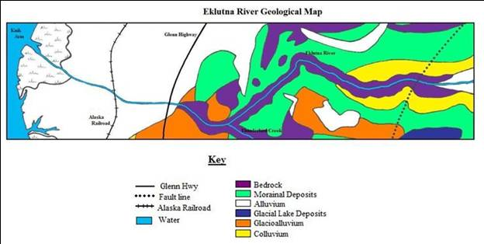

Figure 9. Eklutna River Geological Map. After: Schmoll and Emanuel 1983.

### Climate and Air Quality

Eklutna is near the northern limit of Southcentral Alaska’s maritime temperate zone. Average temperatures range from 47 to 69 degrees Fahrenheit (F) in July to 6 to 14 degrees F in January. The average annual precipitation is about 18 inches, with 56 inches of snowfall (DCA). The wettest months are July through September, while the driest are January through May. Average snow cover is highest in March, at 13 inches. High winds are not uncommon in the area, due in part to its location along the front range of the Chugach Mountains (National Climatic Data Center).

Fresh surface water along Eklutna River typically begins to freeze in mid-November and break up in April. Ice forms on the brackish estuarine waters at the mouth of Eklutna River from December through April. The Eklutna River continues to flow throughout the winter. There appears to be adequate flow to prevent freezing within main channel gravels, although freezing of spawning gravels may occur in smaller channels (USACE nd).

No direct air quality data exists for Eklutna. The project area should enjoy good air quality given its rural/suburban setting. However, the Glenn Highway and the Alaska Railroad provide conduits for a steady flow of mobile sources (i.e., cars, trucks, and locomotives) through and adjacent to the project area. This transportation corridor is one of the busiest in the state and probably contributes a significant fraction of the carbon monoxide and particulate concentrations in the project area, although the actual impact is unknown. Wood-burning stoves, the many unpaved roads in the Eklutna area, and sediment exposed by ongoing and past gravel mining, also contribute to air particulates.

Eklutna is near several communities that have failed at one time or another to meet the air quality standards of the Clean Air Act (CAA) and that have been required by the U.S. Environmental Protection Agency (EPA) to enact plans and programs to improve local air quality. Much of metropolitan Anchorage south-southwest of Eklutna was declared a “nonattainment area” for carbon monoxide in 1978, and remains on a maintenance plan for carbon monoxide that was approved by the EPA in 2004. The community of Eagle River south-southwest of Eklutna has an attainment plan in place for particulates (PM10), approved by the EPA in 1993 (EPA nd). Eagle River largely alleviated its particulate problems by paving residential roadways. The Matanuska-Susitna Borough has come close to exceeding CAA standards for fine particulates (PM2.5), largely due to windblown glacial silt (ADEC nd).

### Water Quality

Eklutna Lake and river are of glacial origin and are turbid with fine glacial sediment. Turbidity in Eklutna Lake ranges from a low of 1.1 to 4 Nephelometric Turbidity Units (NTU) in winter to a range of 47 to 70 NTU in summer (AWWU 2006).

USACE has collected field water quality data from various points along the Eklutna River system. Much of this sampling was opportunistic and sporadic or in areas outside the current project area. The most consistently sampled single location within the project area was at a point (61.4526ºN, 149.3880) on Eklutna River roughly 160 feet downstream of the railroad trestle. Data was collected at this location nearly monthly during the period of May through October 2007. Table 1 shows the results of this sampling.

Table 1. Selected 2007 Water Quality Data, Eklutna River at Railroad Trestle

|  |  |  |  |  |  |  |
| --- | --- | --- | --- | --- | --- | --- |
|  | **Turbidity**  **NTU1** | **Temperature ºC** | **Conductivity µS/cm** | **Diss. O2**  **% sat.** | **Diss. O2**  **mg/l** | **pH** |
| May 17 | 344 | 4.8 | 247 | 115 | 14.77 | 8.29 |
| May 30 | 25.9 | 5.4 | 383 | 109 | 13.75 | 8.40 |
| July 31 | 13.2 | 8.9 | 283 | 113.2 | 13.00 | 8.21 |
| August 30 | 4.1 | 8.2 | 295 | 107.6 | 12.63 | 8.46 |
| September 25 | na | 5.1 | 275 | 96.5 | 12.27 | 8.20 |
| October 26 | 3.1 | 2.3 | 247 | 106.7 | 14.57 | 7.87 |

1. NTU: Nephelometric Turbidity Units

The data for this period show some obvious seasonal variation in turbidity (highest during spring runoff, then declining through the spring and summer) and temperature. Other metrics, such as dissolved oxygen, pH, and conductivity, varied little over this period. Notably, the concentration of dissolved oxygen in the water column remained essentially saturated.

On days when water quality measurements were taken at multiple points along Eklutna River, the measurements along the main channel tended to be similar (i.e., there were no great differences in temperature, pH, dissolved oxygen, turbidity, etc., observed between different points along the river). Surface water in backwater pools and isolated ponds tended to have higher temperatures and lower dissolved oxygen (ca. 7-12 ºC and 60-65%, respectively, in late May). Turbidity could vary greatly from day to day and appeared to increase significantly after periods of rainy weather.

Water quality data were collected from Eklutna River during the winter. USACE drilled holes in river ice in March 2006 to measure ice thickness and the depth of water flowing under the ice. A hole drilled through the ice roughly 400 feet downstream of the Glenn Highway Bridge found 11 inches of flowing water beneath 23 inches of ice. The water at this location had a temperature of 1.1 degrees Celsius (C), a dissolved oxygen concentration of 10.6 mg/l (with a calculated saturation of 74 percent), and turbidity of 16 NTU. Farther downstream, a hole drilled through the ice near where the river channel enters the coastal mud flats found 4 inches of water flowing under 25 inches of ice. The water at this location had a temperature of 1.4 degrees C, a dissolved oxygen concentration of 11.6 mg/l (with a calculated saturation of 82 percent), and a turbidity of 25 NTU.

USACE collected salinity data from multiple locations along the lower extent of Eklutna River during a 30.1-foot-high tide on 12 July 2006. The purpose was to determine the extent of saltwater influence in Eklutna River. Salinity readings along the main river channel during high tide ranged from 0.13 to 0.21 parts-per-thousand (ppt), well within the normal range for fresh water and identical to salinity values typically observed for Eklutna River. Low salinity readings persisted along the main channel for hundreds of feet seaward of the high tide line, indicating that a strong flow of fresh water continues through the channel even after the channel has been inundated by seawater. The study found some brackish water (salinity values of 0.5 to 3.0 ppt) several hundred feet landward of the high tide line, in a slough to the north of the main channel. This shows that seawater can infiltrate into some sloughs and ponds in the lower Reach 1 area during high tides.

Water quality data was collected at 12 USGS sampling locations throughout the watershed. The amount of data and parameters measured vary from station to station. The smallest data set contains data from one sampling event, while the largest contains data from 43 sampling events. Data was collected at various times between 1948 and 2002. A data summary from each sampling location is included in Appendix B.

#### Groundwater Quality

In October 2006, USACE installed five groundwater monitoring wells in areas thought to be promising for the construction of over-wintering ponds adjacent to Reach 1. The wells were intended to provide information on the behavior of the shallow groundwater that would be depended upon to fill and recharge any future engineered ponds, especially during the winter months. Of particular interest were the following:

* the degree of seasonal fluctuation of the groundwater levels
* the degree of tidal influence, if any, on groundwater levels
* the degree of saltwater intrusion, if any, in the groundwater
* the concentration and seasonal fluctuation of dissolved oxygen in the groundwater

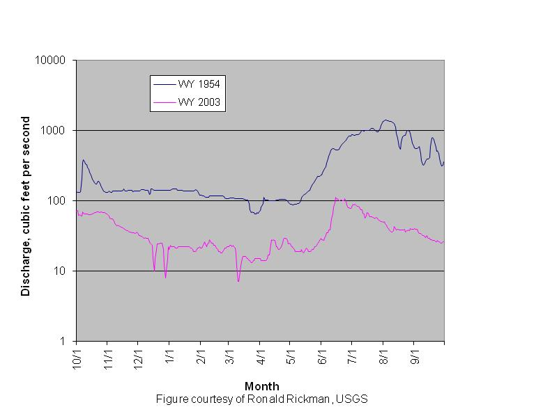

Figure 10. Eklutna River at Old Glenn Highway Discharge Comparison for Water Years 1954 and 2003

***Source:*** Figure courtesy of Ronald Rickman, USGS

Automatic water-level data-loggers were installed in Monitoring Well (MW)-1 and MW-4 to provide a continuous record of groundwater levels, and the remaining three wells were designated for monthly water quality measurements.

The winter groundwater study was impaired because groundwater within all the wells had frozen by 22 November 2006. This unexpected event was at first attributed to an unusual, prolonged period of very cold weather in early November 2006, combined with minimal snow cover and high groundwater levels caused by an unusually rainy autumn. However, in 2007 the wells again began to freeze by early December, despite relatively mild temperatures, suggesting that the freezing of shallow groundwater may be a typical phenomenon in the area. The groundwater study was abandoned in January 2008, due in part to the high cost of thawing and maintaining the monitoring wells through the winter. USACE obtained groundwater quality data spanning April through December 2007; unfortunately, no sampling was possible during the critical mid-winter period, during which groundwater would be the primary source of oxygen in the proposed over-wintering ponds.

General conclusions that can be derived from the partial data include:

* The measured concentrations of dissolved oxygen in the groundwater differed greatly between the three wells. The concentrations were highest (9.51 – 13.49 mg/l) at MW-2, presumably due to that well’s proximity to the oxygen-saturated flow of Eklutna River. The next closest well to the river, MW-3, had the lowest concentrations of the three (3.77 – 8.21 mg/l).
* The salinity and conductivity measurements showed no indication of saltwater influence in the groundwater, at least in the near-surface portion of the aquifer in which the monitoring wells were screened.
* Tidal influence (as measured by automatic data-loggers) on groundwater levels was minor at MW-4 (less than 6 inches), and too small to be measured at MW-1.

Glacial moraine and colluvial deposits within the Eklutna River canyon are basic in chemistry, at times causing pH readings from 7.5-8.1 during periods of low flow in the Eklutna River.

#### Physical Limnology of Eklutna Lake

Eklutna Lake is an exceptional source of raw water for Anchorage. Its physical characteristics reflect its pristine nature. Throughout the year, the lake's water temperature varies between 39 degrees F (3.8 degrees C) and 52 degrees F (11 degrees C). It is moderately soft water with a pH range of 7.7 to 8.3. Annual melt water from Eklutna Glacier is a major contributor to the lake's inflow as well as its turbidity. Raw water turbidity ranges from a low of 4.0 Nephelometric Turbidity Units (NTUs) in winter to a high of 70 NTUs in summer.

Although the USGS does not keep records of flow occurring over the spillway of the Upper Eklutna Dam, data from the lake elevation gage can be used to determine possible spillway flow events.[3] Lake elevations greater than the spillway elevation of 871 feet have occurred on the following dates:

1. Sep. 5 - Oct. 7, 1989: Stage ranged from 871.05 and 873.75 feet.
2. Sep. 21 - Oct. 20, 1995: Stage ranged from 871.06 and 877.68 feet. USGS verified the dam was spilling on Sep. 27 (877.36 feet).
3. Aug. 19 - Oct. 31, 1998: Stage ranged from 871.01 to 875.53 feet.

Flow over the spillway may not have occurred on all these days. Strong winds could cause water to be pushed away from the spillway and pile up near the gage on the north shore. The Alaska Power Administration collected lake stage data periodically between 1946 and 1962. The maximum observed stage during this period was 871.8 feet on September 18, 1951 (Ron Rickman, USGS, pers. comm.).

Two detailed studies on physical limnology and sediment transport characterize Eklutna Lake and the inflow streams (R&M Consultants 1986; Brabets 1993). These studies show that Eklutna Lake is a turbid environment with little light penetration during the warmer summer months. Turbidity is highest during the summer when the contributing glaciers are melting and lowest during the winter when the glaciers are frozen.

Approximately 80 percent of the inflow to Eklutna Lake is derived from two glacier-fed creeks at the head of the lake. These streams deposit from 69,000 to 91,100 tons of sediment annually into Eklutna Lake (Brabets 1993). Summer flows are higher than winter flows. Measured suspended sediment concentrations in the streams ranged from 0.15 mg/l during winter to 570 mg/l during summer. Prominent diurnal variations in discharge, water temperature and suspended sediments in the streams are evident (R&M Consultants 1986). These variations are more evident on warm, clear days with cool nights.

Eklutna Lake has two primary sedimentation processes: (1) delta propagation and (2) river plume dispersion (Brabets 1993). Course bedload sediments are deposited in a delta near the stream mouths. The delta-building bedload contributed by the two inlet streams is estimated at 10,000 tons annually (Brabets 1993).

Suspended sediments in the lake can range from 0.1 mg/l during winter to 200 mg/l during summer (R&M Consultants 1986). The extent, direction, and depth of the inflow creek’s sediment plume in the lake are highly variable and can change rapidly as the plume mixes with the lake water. This sediment plume is sometimes present on the surface, at mid water, or near the bottom as a density current, and can travel the full length of the lake (R&M Consultants 1986; Brabets 1993).

Eklutna Lake is thermally dimictic and turns over twice annually. It becomes iso-thermal around October and then cools to its maximum density of 4 degrees C in November to early December (R&M Consultants 1986). Ice formation usually begins during the first week in December. The disappearance of ice generally occurs during the second and third weeks in May.

### Vegetation and Wetlands

The Eklutna watershed has a large diversity of plant species and can be classified into different wetland types based on habitat function and species composition. Most large Southcentral Alaska tree species are also found within the watershed, in mixed and varied communities, which further add to the diversity of the existing ecosystem. Some of the largest intact stands of old growth black cottonwood grow near the lower Eklutna River. Larger trees of the ecosystem include black cottonwood, paper birch, alder, and willow with the black cottonwood dominating thickly wooded areas. Grasses include beach rye Arctic cotton and a variety of sedge grasses in the wetter areas. Cattail rushes grow in some of the peripheral ponds formed by aggregate mining.

Wetlands within the Eklutna watershed are used as a travel corridor by many species and are important to surrounding habitats such as those on the Joint Base Elmendorf-Richardson military installation, in the Palmer Hay Flats State Game Refuge, in the Anchorage Bowl, along the Knik River, and in the Matanuska-Susitna Valley. The watershed is also on the flyway for many bird species, including waterfowl. Large flocks of many species can be found using the associated wetlands during their migrations.

#### Coastal Marsh

Coastal marshes are found along the shore of Knik Arm and are influenced by the rise and fall of the tides. The shoreline on the Cook Inlet side of the Glenn Highway at the mouth of the Eklutna River is typical of coastal marshes found elsewhere in Knik Arm. Fresh water flows into Knik Arm through the Eklutna River and contributes to moderating salinities. Coastal marshes include salt marshes and tide flats. Salt marsh substrates consist of nearly level poorly drained, bluish-gray, clayey tidal sediment. Although the areas are a few feet above the level of the average tides, they are inundated occasionally by exceptionally high tides and by the overflow from the Eklutna River. Vegetation consists primarily of lyngbye sedge, marine arrow grass, alkali grass, and plantain. Higher areas may also contain a sparse to dense vegetative cover of bluegrass, silverweed, and bluejoint grass. Shrub thickets may occur along the highest shoreward areas, which are still subjected to regular, short duration inundation by high tides. These thickets generally contain little other vegetation except for algae. However, sparse stands of beach wild rye and sedges may grow on the flats. The tidal flats consist of layered tidal deposits ranging from sand to clay in texture.

#### Riparian

Riparian wetlands are temporarily flooded areas along rivers, creeks, and streams (floodplains). The associated vegetation is determined by the elevation above the stream and the duration and frequency of flooding. Some temporarily flooded areas are characterized by a mixture of broad-leaved shrubs, such as willow and alder, with emergent vegetation dominated by grasses. Other common understory vegetation may include marsh, fivefinger, nagoonberry, red currant, and prickly rose. Some wetter riparian areas dominating the lower elevations may contain most of the following: sweet gale, tufted clubrush, bladderworts, cottongrass, buckbean, sundew, livid sedge, rotund sedge, maritime arrowgrass, bog cranberry, bog blueberry, cloudberry, bog willow, bog rosemary, and various mosses. Seasonally flooded areas adjacent to the Eklutna River consist of a shrub complex dominated by black spruce, with willow and alder as the dominant shrub type. Deciduous trees such as black cottonwood and balsam poplar may dominate drier, higher elevation areas. The typical shrubby willow and alder may reach tree size in some localities. The substrate is usually a mineral soil, while some poorly drained, wetter areas in lower elevations may consist of organic or peat soil.

#### Forested Bog

These areas are commonly called black spruce bogs. The dominant canopy species is black spruce that reaches a height of at least 20 feet. Dominant understory vegetation of the forest includes Labrador tea, low bush cranberry, horsetail, cloudberry, and sphagnum moss. The understory vegetation may also be shrubby black spruce (less than 20 feet). In wetter areas there may be a layer of emergent vegetation. Some temporarily flooded areas with open canopies of evergreens may accommodate broad-leaved deciduous shrub vegetation. Black cottonwood and balsam poplar may also be mixed with stands of black and white spruce. The substrate may be hummocky from frost heaves, with standing water occurring between the heaves. In this case, the spruce grows on the hummocks with emergent vegetation and mosses between. The forested bogs may occur at the fringe, higher elevated areas of shrub bogs, or as “islands” in shrub bogs.

#### Shrub Bog

Shrub bogs are on saturated, organic soils (peat). They are commonly called black spruce bogs when the dominant vegetation is shrubby black spruce (less than 20 feet). The difference between the shrub black spruce bog and the forested black spruce bog is the height of the spruce. In shrub bogs dominated by black spruce, canopies may be open with a dense deciduous shrub understory. In areas not dominated by shrubby black spruce, canopy species consist of broad-leaved deciduous shrubs such as willow, sweet gale, thin-leaf alder, dwarf birch, Labrador tea, bog blueberry, low bush cranberry, and bog rosemary. The saturated peaty soils are usually covered with a mat of sphagnum moss. The bogs may be composed of bog ridges and islands, with wet hollows between. The ridges are generally oriented perpendicular to water movement within the bog. Broad-leaved deciduous shrubs including dwarf birch, Labrador tea, bog rosemary, sweet gale, and shrubby black spruce dominate the ridges and islands. The wetter, lower areas between the ridges and islands are typically dominated by emergent vegetation such as grasses, sedges, horsetail, and cottongrass, and are usually semi-permanently flooded. Small ponds may exist in the bog and are irregularly sized, spaced, and shaped. Larger ponds, if present, may contain peat islands.

#### Open Water/Emergent Marsh

Open water/emergent marsh wetlands encompass open freshwater areas such as lakes and ponds, the fringes of marsh surrounding the lakes and ponds, and any expanses of freshwater wetlands dominated by emergent vegetation. The lakes and ponds are permanently or seasonally flooded. Vegetation in deeper open water may be lacking, with aquatic beds of vegetation and emergent plants along the shoreline. The predominant aquatic, floating-leaved plants are yellow pond lily and pondweed. Some of the seasonally flooded small ponds contain water only during the growing season. When surface water is absent, exposed substrate either remains unvegetated or is colonized with herbaceous annuals. Mud and sand flats along the lakeshores are typically devoid of vegetation. If vegetated, the shoreline vegetation may consist of species such as sphagnum moss, great bulrush and other sedges, grasses, bladderwort, buckbean, marsh five-finger, horsetail, and sweet gale. Emergent marshes may be permanently or seasonally flooded. Permanently flooded, emergent marshes exhibit standing water throughout the entire year. The dominant vegetation is buckbean, horsetail, bladderwort, grasses, and sedges. Seasonally flooded marshes usually exhibit water for part of the growing season. Species include horsetail, sedges, marsh five-finger, and sphagnum moss. Willow shrubs may occur as sparse cover.

### Fish and Wildlife

#### Eklutna River Fish Species

Rainbow trout have been stocked in Eklutna Lake and small numbers may have entered Eklutna River with water spilling over the Upper Eklutna Dam. Although rainbow trout are native to the Susitna River and Little Susitna River on the west side of Knik Arm, they are absent from the Knik River drainage adjacent to Eklutna River, and it is unlikely rainbow trout are native to a short coastal stream of such recent geological origin as the Eklutna River.

Dolly Varden char is of the resident variety. They are relatively few in number and of small size, mostly in the 40 to 50 mm range. However, trapping results have demonstrated several groups of 100 mm plus sized juveniles within slack water at numerous locations within the river. Other fish species present include the anadromous three-spine stickleback that migrates in abundance during early spring into the labyrinth of small ponds connected to the river where they spend the summer. Few, if any, stickleback are present in the main river and few, if any, coho or Chinook salmon fry are found in the ponds. Other species present in relatively small numbers are resident coastal sculpin and burbot, and occasionally anadromous Pacific lamprey.

The Eklutna River has been catalogued as an anadromous stream (#247-50-10175) with five species of Pacific salmon presently found in the stream. These species in probable order of abundance are: chum, coho, pink, Chinook, and sockeye. Due to the diversion of water at the Eklutna Lake outlet, Thunderbird Creek (also a catalogued anadromous stream, #247-50-10175-202) is currently the main source of water in the river.

Pink salmon are the smallest of Pacific salmon found in North America. They have a relatively short stream life in short coastal drainages like the Eklutna River. Males acquire a hump-backed shape, and the flesh of pink salmon rapidly deteriorates in quality after the fish begins to mature sexually. Pink salmon have the lowest commercial value of the Pacific salmon species and are not considered to have high sport fish value compared with Chinook, coho, and sockeye salmon.

Chum salmon are larger than the pink salmon, but retain some of the pink salmon characteristics in that they have relatively short stream life in short coastal streams. The flesh of chum salmon also deteriorates rapidly as it approaches sexual maturity, and although chum salmon have some value as a sport fish, the flesh is of inferior quality when compared with Chinook, coho, and sockeye salmon. The 2002 escapement counts (Lamoreaux unpublished) suggest that chum salmon have a relatively short stream life in the Eklutna River.

Anadromous sockeye salmon typically enter systems where the adults spawn in clear water streams that enter a lake. The fry hatch and migrate to the lake where they typically spend from 2 to 4 years feeding on plankton before they migrate to the sea as smolts. Given that neither dam on the Eklutna River has a fish ladder and that Thunderbird Creek has no connection to a waterbody, no sockeye straying into the system at this time has spawning habitat they can reach.

It is doubtful that significant numbers of sockeye salmon ever spawned in the Eklutna River drainage because suitable spawning area upstream of the lake is limited and water quality in the lake would likely have limited opportunities for spawning in the littoral zone of the lake. Fully 80 percent of the water entering Eklutna Lake comes from two glacial streams that would not be conducive to the consistent survival of sockeye salmon from egg to fry, and the remaining spawning area would not be sufficient to support large numbers of spawning anadromous salmon. In addition, the physical limnology studies of Eklutna Lake suggest that the turbidity in Eklutna Lake during much of the year is not conducive to significant primary production. Low numbers and small size of the native land locked sockeye salmon (kokanee) found in the lake supports these biological assumptions (Table 2). However, the local Dena’ina Athabascan people say that sockeye salmon were once abundant in the Eklutna River and Eklutna Lake but are no longer present because the dams blocked their access to the lake.

Table 2. Species of Resident Fish in Eklutna Lake Captured by the Alaska Department of Fish and Game During Test-Net Sampling

|  |  |  |  |  |  |  |
| --- | --- | --- | --- | --- | --- | --- |
| **Date** | **Species a** | **Age** | **Number** | **Range (mm)** | **Average (mm)** | **CPUE** |
| 7/7/93 | Rainbow Trout | 0-6 | 300 | 66-386 | 157 | 1.56 |
| 7/7/93 | Dolly Varden | Wild | 36 | 84-281 | 185 | 0.19 |
| 7/7/93 | Kokanee | Wild | 7 | 101-125 | 114 | 0.04 |

a) Rainbow trout were stocked by ADF&G

*Source:* Alaska Department of Fish and Game

Chinook salmon is the largest species of Pacific salmon. Chinook salmon are highly desirable as a sport, commercial, and subsistence fish. The flesh is of good quality relative to pink and chum salmon, and Chinook salmon have a relatively longer stream life than pink and chum salmon. Historical numbers of returning Chinook salmon are not known, but spawning and rearing habitat for the species may be limited under existing habitat conditions in the river.

Up to 60 Chinook salmon may have returned to the Eklutna River drainage in 2003, but about half of these were taken illegally before they spawned (M. Lamoreaux personal communication). Villagers estimate that up to 200 Chinook have returned to the river during recent productive years (Lamoreaux unpublished), but it is doubtful that significant numbers of Chinook salmon would become established naturally in the Eklutna River because of its limited spawning and rearing habitat.

Coho salmon also return to spawn in the Eklutna River. This medium-sized salmon is highly regarded as a sport fish and has a relatively long stream life in short coastal streams like the Eklutna River. Coho salmon enter freshwater from late July through early September in nearby Knik Arm drainages and spawn in September and October. The peak of the return is from early to mid-August in most Knik Arm drainages. The nearby Knik River is an exception where coho return to spawn as late as October. Coho salmon counts also indicate that coho may be a relatively late run salmon in the Eklutna River.

Coho salmon fry emerge from spawning gravels in the spring and then rear from 1 to 2 years in side channels, ponds, and sloughs before migrating to salt water as smolts. The adults spend up to about 18 months at sea before returning to their natal stream to spawn. This species is conducive to propagation, and many stocking programs exist in Alaska for this species.

Salmon escapement in the Eklutna River, including Thunderbird Creek, was counted on 11 dates between June 15, 2002 and October 15, 2002 (Lamoreaux unpublished). Thunderbird Creek contributed relatively few fish to the overall counts because fish passage is blocked approximately one-third of a mile upstream by Thunderbird Falls (Lamoreaux unpublished). Most of the salmon seen were counted in reaches of the Eklutna River above and below its confluence with Thunderbird Creek. The NVE considers the data obtained from the fish counts as confidential and hence they are not included in this report. Anecdotal accounts of large pink salmon escapements have also been made (Stephan Lee in Manning 2001).

#### General Salmonid Species Use of the System

The salmonid species composition in the Eklutna River comprises four species of Pacific salmon: Chinook, chum, pink, and coho salmon, and Dolly Varden Char. Sockeye salmon appear to be occasional strays to the river and are not seen every year.

A major problem with the Eklutna River in its degraded condition is believed to be a lack of both summer and winter rearing habitat for juvenile Chinook and coho salmon. Winter incubation and rearing conditions in the Eklutna River can be extremely harsh, yet juvenile Chinook and particularly coho salmon survive these conditions in relative abundance. Catches of rearing coho juveniles and outmigrant smolt during early summer can be as high as 55 fish per trap baited with salmon eggs, though such a large catch is uncommon.

The winter survival strategy of juvenile Chinook and coho salmon overwintering in the degraded river is uncertain. The peripheral ponds occupied by an abundance of anadromous stickleback during summer go dry during winter if they are connected to groundwater or freeze to the bottom or become anaerobic if they are perched by impervious silt. The stickleback leave these ponds in late fall, and the likelihood of juvenile Chinook or coho salmon surviving overwinter in them is extremely low.

The groundwater table of the alluvial deposit is well below the river bed during summer and winter. Some sections of the Eklutna River downstream of the canyon are perched and remain wetted during winter, while others appear to go dry under a thick layer of ice. Some sections downstream of the railroad bridge are gravel starved and dominated by large cobble where water flows interstitially during winter. Small Dolly Varden can overwinter among the unfrozen interstitial spaces deep between cobbles (Cunjak 1996) and some overwintering Eklutna River juvenile Chinook and coho salmon may have adapted to this winter survival strategy.

Overwintering within the braided area between the highway bridges and the railroad bridge is extremely unlikely. Water in this area is spread thin and is subject to extreme overflow during winter. When the Eklutna River begins to freeze in early winter, water flowing from the canyon spreads over the wooded landscape in a sheet of overflow ice that covers the low lying areas within this reach up to 3 or more feet thick. A significant amount of water that might normally charge the river downstream of the railroad bridge during winter is captured and held by this overflow ice.

No winter surveys have been conducted in the canyon after freeze up, and little is known about overwintering conditions and the potential of suitable overwintering habitat within this reach. The riverbed between the canyon mouth and Thunderbird Creek is composed of shallow riffles and runs. During normal summer flow, the average depth in this reach appears to be around 12 inches, and there are no deep holes or substrate conditions that are likely to provide suitable overwintering habitat.

#### Juvenile Usage of the System

Anadromous streams are a structurally complex mix of habitat types required by Pacific salmon. A basic requirement for salmon of all life history stages is clean, cool, and unpolluted water. Eggs and alevins require clean, well oxygenated spawning substrates in which to incubate between egg deposition and emergence as fry. Pink and chum salmon fry emerge at night and they immediately begin a downstream migration toward the sea. In short, coastal streams like the Eklutna River pink and chum salmon fry mostly complete this journey during the night of emergence, but if not completed during the hours of darkness, the fry sometimes reenter the substrate and reemerge on the second night. Those that do not or cannot seek protection during daylight hours can be exposed to daylight predators and can suffer a relatively high proportional rate of mortality. A high proportional rate of fry mortality can influence the abundance of adults returning to the ecosystem when the overall abundance of returning adults is relatively low.

Free, unhindered downstream passage is important to the survival of pink and chum salmon fry. The braided section of the river upstream from the railroad bridge traps many out-migrating fry that emerge upstream of this reach. Fry entering this reach can easily be shunted into one of several small rivulets that dead end in thick vegetation or a dewatered channel. Fry that become stranded in these dead end rivulets fall victim to desiccation and predation by birds and small fish-eating mammals like mink and weasels. Pink and chum salmon spawn up and downstream from this reach and the proportion of the population that would be exposed to this danger is not known.

Coho salmon fry live in the Eklutna River for 1 to 2 years before they undergo physical and chemical changes and migrate to marine water as smolts. Coho are mostly spawned in headwater reaches where they might drift downstream for a few nights after emergence. As summer progresses the coho fry seek rearing habitat throughout the drainage. Juvenile coho salmon prefer quieter back water and side channel habitats and are particularly vulnerable to off channel entrapment and stranding. The braided reach of Eklutna River upstream of the Alaska Railroad Bridge is particularly dangerous for this species. Field observations indicate that coho fry become trapped and stranded in this reach during summer.

A significant area of off-channel habitat is available as ponds from past aggregate mining in the reach downstream of the railroad bridge. These ponds are heavily used by anadromous stickleback during summer, but few juvenile coho are trapped from the ponds indicating there is little use of these ponds by juvenile coho. As previously mentioned these ponds go dry or become anaerobic in winter and are not available as overwintering habitat.

Most juvenile coho in their first summer are seen in shallow backwaters with easy access to the river. With exception of the reach immediately upstream of the railroad bridge where there is danger of stranding, backwaters adjacent to the main river channel are limited in number. Few first year coho are seen in the fast water runs of the main river, although the fry use the fast runs to move between backwaters. Trapping fast water habitat in the Eklutna River usually results in catches of predatory Dolly Varden up to about 8 inches long.

Chinook salmon typically spawn lower in the river than coho salmon. Chinook salmon also spawn in Thunderbird Creek. Little is known about the freshwater life history of Chinook salmon in the Eklutna River ecosystem, but the freshwater life history of Eklutna River Chinook is likely similar to that of other Knik Arm drainages that support this species. Juvenile Chinook salmon in Eklutna River are relatively few in number compared with coho, but the first year Chinook fry could initially be mixing with coho salmon similar in size. As Chinook salmon grow in size they tend to leave habitat preferred by juvenile coho and move into faster water. Juvenile Chinook could also be spending the summer in the turbid reach between Thunderbird Creek and the 1929 dam where a few larger Chinook smolt have been trapped. Compared with coho salmon, few Chinook are trapped as smolt in the Eklutna River, and it is possible that most juveniles of this species do not spend their first winter in the Eklutna River at all, but out-migrate as age 0+ juveniles and spend their first winter in the Knik Arm estuary.

Chinook salmon fry would be subjected to similar survival pressures during their first summer of residence as are coho fry in the Eklutna River. Swimming down a disappearing rivulet in the braided reach upstream of the railroad bridge as rearing juveniles makes stranding a real possibility with Chinook fry as it is with other species.

Summer rearing habitat is important to the freshwater survival of post emergent fry because it provides the growth and conditioning necessary for successful overwintering under harsh environmental conditions.

The freshwater survival of juvenile Chinook and coho salmon in the Eklutna River system is currently limited by a lack of quality rearing habitat. Both Chinook and coho salmon fry require low velocity side or off channel habitat during their early life history. Coho juveniles continue to thrive in this type of habitat, while Chinook juveniles typically seek areas of higher velocity as they grow in size. Ideal summer rearing habitat for both species during their early life histories as fry is relatively shallow, low velocity habitat that is connected to the main channel and does not dewater. Ideal summer rearing habitat promotes moderate water temperatures that in turn promote an abundance of copepods and aquatic insect larvae while stimulating the feeding responses of the juvenile salmon, especially juvenile coho salmon. This ideal rearing habitat would include emergent vegetation or large woody debris around its margins for cover and insect productivity.

Overwinter rearing habitat is essential for the freshwater survival of juvenile coho and Chinook salmon that overwinter in the Eklutna River. Overwinter habitat is extremely harsh and currently limited to interstitial spaces between large cobbles in areas of the river that do not freeze to the bottom, deeper holes on the intertidal flats, and perhaps small areas in the ponds created from mining gravel. Yet juvenile Chinook and particularly coho salmon seem to survive these conditions in relative abundance. The winter survival strategy of juvenile Chinook and coho salmon overwintering in the degraded river is uncertain.

The groundwater table within the alluvial deposit is well below the river bed during summer and winter. Some perched sections of the Eklutna River, downstream of the canyon, remain wetted during winter, while others appear to go dry under a thick layer of ice. Some sections downstream of the railroad bridge are gravel starved and dominated by large cobble where water flows interstitially during winter. Small Dolly Varden can overwinter among the unfrozen interstitial spaces deep between cobbles and some overwintering Eklutna River juvenile Chinook and coho salmon may have adapted to this winter survival strategy.

The Eklutna River between Thunderbird Creek and the abandoned diversion dam is turbid during summer and difficult to characterize as a result. Normal summer flows are in the neighborhood of 10 to 15 cfs, while normal winter flows are typically much less. Water under the winter ice, however, is very clear. This reach has some deeper water that could, especially if influenced by oxygenated springs or upwelling, provide suitable overwintering habitat for juvenile salmonids. In Alaska, the presence of ground water may be the most important winter habitat criterion (Cunjak 1996).

There is evidence that juvenile salmon use this reach of the river during summer. Baited traps set in this reach have produced as many as 10 juvenile Chinook salmon. Winter use of this reach by juvenile salmon is likely, but is only speculated.

#### Adult Usage of the Stream

Four species of anadromous Pacific salmon return to the Eklutna River as adults. A fifth species, sockeye salmon, are occasional strays to the river (Marc Lamoreaux personal communication 2005). Run timing of these salmon has not been thoroughly documented, but it is likely very similar to other Northern Cook Inlet streams. Chinook salmon are the first to enter northern Cook Inlet streams and return as early as mid-May with the peak return in early June. Most Chinook salmon spawn from mid-July through August. Chum salmon enter northern Cook Inlet streams as early as late June, with the peak return in early August. Pink salmon enter northern Cook Inlet steams in late July with the peak in early August. Northern Cook Inlet pink salmon are more abundant during even-number years. Pink salmon have a relatively short stream life compared with other salmon species, and in short coastal streams spawn shortly after entering. Coho salmon enter northern Cook Inlet streams in late July and in most streams peak in August. Coho salmon spawn mostly in September and October with some later run races spawning as late as November.

Most adult Eklutna River salmon enter the river on the flood tides. Chinook, chum, and coho salmon will typically hold for a few days in deeper water at the edge of a pond that was excavated near the upper tidal influence during mining operations before moving upstream to spawning reaches. Figure 11 shows such a pool. Pink salmon have a relatively short stream life compared with the other species, and will typically move directly to the spawning areas.

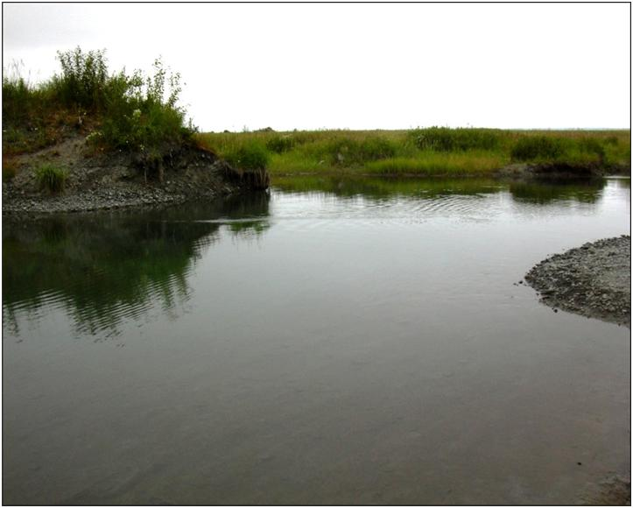

Figure 11. A pool at the mouth of a man-made pond in which adult salmon hold and acclimate to river water before moving upstream to spawn in the Eklutna River

#### Spawning Within the System

The majority of spawning currently takes place in the reach between the Glenn Highway bridges and the canyon mouth, and the reach between the canyon mouth and the confluence with Thunderbird Creek. Existing salmonid escapements appear to be underutilizing available spawning habitat, but the quality of spawning gravel may be limiting the area where successful spawning may occur, giving the appearance of underutilization.

Pacific salmon require clean well oxygenated gravel in which to survive during the incubation period. The quality of spawning gravel is characterized by its porosity and an absence of fines that prevent the free exchange of oxygenated water with the incubating eggs or alevins prior to emergence. The measure of porosity of spawning gravels is known as a Fredle Index (Lotspeich and Everest 1981).

Fine glacial silt has been an integral part of the Eklutna River ecosystem for millennia. The silt originates from two main sources: (1) the Eklutna glaciers near the head of Eklutna Lake and (2) mass wasting of the canyon walls. Prior to containment of Eklutna Lake waters behind the outlet dam in 1955, glacial silt was transported through Eklutna Lake to the river where it embedded the substrate in the canyon and downstream. Much of this silt remains embedded in the substrate because it is no longer flushed from the substrate by annual spring freshets from the lake when natural turbidity was low. The historic embeddedness is augmented by smaller volumes of recent silt that mass wastes from the steep canyon walls during the spring snowmelt. Although flow may be a little higher than normal during spring, it still lacks the velocity necessary to wash large quantities of historic and recent silt from the spawning substrate.

On the surface, spawning habitat in the Eklutna River does not appear to be limited, but the quality of the gravel in these places is not known as no studies have been done to assess its quality. In some areas of the Eklutna River the spawning gravel appears clean on the surface but it is embedded with silt just under its surface. In some areas observations of female salmon digging their nest show there is a considerable amount of turbidity associated with digging activity. Disturbing the substrate with feet also results in considerable turbidity. Restoration of degraded spawning gravel is not a consideration of this restoration effort because the source of the silt from the canyon walls cannot be reasonably controlled.

The areas where most salmon spawn in the Eklutna River have been documented by surveys of the river from the upper limit of tidal influence to the 1929 diversion dam and Thunderbird Creek (Figure 12). Some pink, chum and Chinook salmon spawn in the reach downstream from the railroad bridge. No salmon of any species have been observed spawning in the braided section of the river upstream of the railroad bridge. Pink, chum and Chinook resume spawning in the single channel that begins at the highway bridge and continues upstream to the confluence with Thunderbird Creek. Chinook salmon also spawn in Thunderbird Creek. Coho salmon typically spawn in the upper areas of their natal drainage. The areas where coho salmon spawn in Eklutna River have not been documented by survey, but they are known to spawn in Thunderbird Creek (Dan Alex personal communication 2007) and in a few areas between Thunderbird Creek and the 1929 diversion dam that are associated with upwelling (Marc Lamoreaux personal communication 2004).

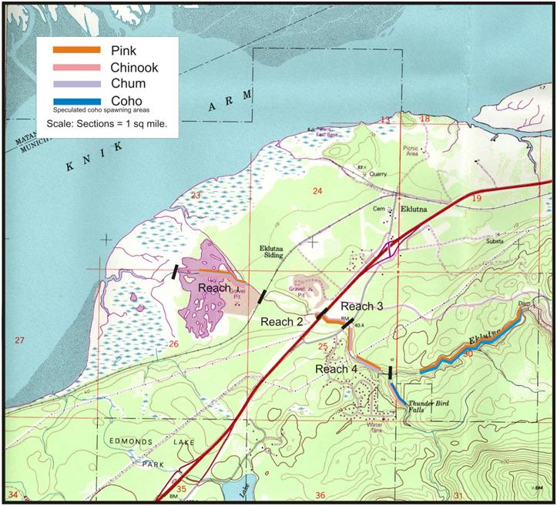

Figure 12. Areas in the Eklutna River where Pacific Salmon Species are Known or Suspected to Spawn

#### Escapement in the System

Historical escapement records have not been found, but the Native Village of Eklutna Land and Environment Director, Marc Lamoreaux, speculated that up to 200 Chinook salmon, 1,000 coho salmon, 200 pink salmon, and more than 1,000 chum salmon may return to the Eklutna River on a good year (Marc Lamoreaux personal communication 2004). The run strength of adult salmon in Eklutna River is not well known as few index escapement surveys have ever been conducted and a counting weir has never been operated.

The order of abundance in the lower Eklutna River by salmon species can only be speculated from the experience of biologists working on the river and the testimony of two NVE elders (Dan Alex and Stephan Lee) and the NVE Land and Environment Director (Marc Lamoreaux). Based on field observations and testimonies, pink salmon are likely the most abundant species of Pacific salmon during years ending with even numbers (Stephan Lee personal communication 2004, Dan Alex personal communication 2007). During years ending with odd numbers, the species in most abundance is likely the chum salmon with coho salmon a close second. Chinook salmon number less than 100 fish during the best escapement years. Few pink salmon are present in Knik Arm drainages, including the Eklutna River, during odd numbered years. Sockeye salmon, once said to be abundant, now only occasionally stray into the Eklutna River (Marc Lamoreaux personal communication 2004).

#### Eklutna Lake Fish Species – Background Information

Resident fish (rainbow trout and Dolly Varden) and landlocked sockeye salmon (kokanee) are found in Eklutna Lake. The kokanee could be landlocked ancestors of historical sockeye runs into the lake. The Alaska Department of Fish and Game stocked Eklutna Lake with excess rainbow trout fingerlings from 1987 through 1996 but stopped stocking the lake because of low catch rates and low angler participation (D. Rutz, ADFG, personal communication).

#### Subsistence Use of Resources

Subsistence fishing has always played an important role in the lives of the Dena’ina. Due to provisions enacted in the Alaska Nation Interest Lands Conservation Act (ANILCA), the Knik Arm region does not qualify under Federal or State regulations as a subsistence use area. Despite such regulatory issues, the NVE residents and other Dena’ina in the Knik Arm region that are indigenous to the area continue to harvest local resources for cultural uses and subsistence as they have done for centuries, utilizing educational subsistence permits. These types of permits allow NVE to maintain salmon gillnet sites for the purpose of educating children on the traditional subsistence lifestyle.

The Eklutna River drainage was an important hunting and subsistence area for Eklutna Natives up through the 1950’s. Eklutna Natives hunted sheep, moose, ground squirrels, and bear in the watershed (UAA/CIRI 1987, Kari and Fall 2003). Hunting and trapping on the inlands and in the mountains is also an important traditional subsistence activity that continues today, along with the gathering of berries, plants, trees, and stones (NVE letter to Knik Bridge Authority).

#### Wildlife

Wildlife resources in the Eklutna area include terrestrial birds and mammals, marine mammals, and freshwater and anadromous fish. Many species of both large and small land mammals use or reside in habitats near the Eklutna watershed. Large mammals include moose, black bears, brown bears, Dall sheep, and the occasional mountain goat. Extensive areas of regenerating felt leaf willow saplings in the Eklutna River delta provide ample moose browse. The wetlands along Knik Arm serve as winter refuge habitat, where dozens of moose can be observed congregating, especially during heavy snow winters, sometimes coming from as far away as the Susitna River. Smaller mammals such as coyotes, muskrats, beavers, shrews, voles, mink, fox, porcupine, and short-tail weasel may also be found using the project area.

Restricted hunting for moose and Dall sheep on public land in the Eklutna watershed is allowed by permit. This activity and these species are managed by the Alaska Department of Fish and Game.

Avian fauna includes most of the passerine species resident or migratory to the Cook Inlet area. The common raven is perhaps the most conspicuous of the passerine species in the area. Gallinaceous species include willow and rock ptarmigan and spruce grouse. Waterfowl visit the area, but fish-eating species, including loons and mergansers, are not likely to be abundant because, combined with the high turbidity of the water, fish are not especially abundant in the lake. Visual/auditory observations indicate that six Sandhill crane pairs nested within the delta region of the watershed in 2002.

The lower reaches of the Eklutna River are used by some species of migratory waterfowl such as mallards, greenwing teal, and widgeon. Some species of shorebirds such as sandpipers and yellowlegs probably can be seen near the mouth of the waterway as well. Though published information is scarce for this area, some passerine species likely use the habitats associated with the project area and may include species like the American dipper, magpie, and black-capped chickadee. Bald eagles are also common in the area and two there are two identified bald eagle nests in the same area.

#### Essential Fish Habitat

Essential Fish Habitat (EFH) for each Pacific salmon species is described and mapped by the National Marine Fisheries Service (NMFS 2005). Describing EFH for Pacific salmon species can be complicated as salmon use marine, estuarine, and freshwater habitats. Marine EFH for the salmon fisheries in Alaska includes all estuarine and marine areas used by Pacific salmon of Alaska origin, extending from the influence of tidewater and tidally submerged habitats to the limits of the U.S. Exclusive Economic Zone (EEZ). This habitat includes waters of the continental shelf (to the 200-meter isobath). In the deeper waters of the continental slope and ocean basin, salmon occupy the upper water column, generally from the surface to a depth of about 50 meters. Freshwater EFH includes all those freshwater streams, lakes, ponds, wetlands and other water bodies currently or historically accessible to salmon. A more detailed description of EFH for salmon found in the Eklutna watershed is provided below:

● Chinook Salmon

* Freshwater EFH for eggs and larvae of Chinook salmon is the general distribution area for this life stage occurring in freshwater habitat as defined by the absence of salinity and the mean high tide line within nearshore waters. These freshwater environments must be accessible to adult Chinook salmon and have bottom substrate, water quality, and seasonal flow adequate for the incubation and development of Chinook salmon eggs and larvae. Eggs and larvae require more than 200 days over the period from July to May for incubation in intra-gravel flows.
* Freshwater EFH for juvenile Chinook salmon is the general distribution area for this life stage occurring in freshwater habitat as defined by the absence of salinity and the mean high tide line within nearshore waters. These freshwater environments must provide adequate water quality and productivity conditions for seasonal or year-round rearing or migration for juveniles. Juvenile Chinook salmon require year-round rearing habitat and also migrate.
* Freshwater EFH for adult Chinook salmon is the general distribution area for this life stage occurring in freshwater habitat as defined by the absence of salinity and the mean high tide line within nearshore waters. These freshwater environments must be accessible to adult Chinook salmon and provide suitable water quality, migration access, holding areas, spawning substrates, and flow regimes. Adult Chinook salmon use such freshwater habitats in Alaska from April through September.
* Estuarine EFH for juvenile Chinook salmon is the general distribution area for this life stage in estuarine areas as identified by the salinity transition zone (ecotone) and the mean higher tide line, within nearshore waters. Chinook salmon smolts and post-smolt juveniles may be present in these estuarine habitats from April through September.

● Coho Salmon

* Freshwater EFH for eggs and larvae of coho salmon is the general distribution area for this life stage occurring in freshwater habitat as defined by the absence of salinity and the mean high tide line within nearshore waters. These freshwater environments must be accessible to adult coho salmon and have bottom substrate, water quality, and seasonal flow adequate for the incubation and development of coho salmon eggs and larvae. Eggs and larvae require more than 150 days of incubation (generally over the period from October to May). Preferred substrate is gravel containing less than 15 percent fine sediment (less than 2 mm in diameter).
* Freshwater EFH for juvenile coho salmon is the general distribution area for this life stage occurring in freshwater habitat as defined by the absence of salinity and the mean high tide line within nearshore waters. These freshwater environments must be accessible to juvenile coho salmon and provide adequate water quality and productivity conditions for seasonal or year-round rearing or migration for juveniles. Juvenile coho salmon require year-round rearing and migration habitat from April to November to provide access to and from the estuary.
* Freshwater EFH for adult coho salmon is the general distribution area for this life stage occurring in freshwater habitat as defined by the absence of salinity and the mean high tide line within nearshore waters. These freshwater environments must be accessible to adult coho salmon and provide suitable water quality, migration access, holding areas, spawning substrates, and flow regimes. Adult coho salmon may be present in freshwater from July to December.
* Estuarine EFH for juvenile coho salmon is the portions of the salinity transition zone (ecotone) and contiguous intertidal and nearshore habitat below mean high tide in Alaska where coho salmon currently or historically occur. Smolts may be present May to August; non-smolts rear in spring and summer.

● Sockeye Salmon

* Freshwater EFH for eggs and larvae of sockeye salmon is the general distribution area for this life stage occurring in freshwater habitat as defined by the absence of salinity and the mean high tide line within nearshore waters. These freshwater environments must be accessible to adult sockeye salmon and have bottom substrate, water quality, and seasonal flow (including upwelling ground water) adequate for the incubation and development of sockeye salmon eggs and larvae. Sockeye often spawn in lake substrates as well as streams. Eggs and larvae are in habitats from July through May. Preferred substrate is medium to course gravel containing less than 15 percent fine sediment (less than 2 mm in diameter); finer substrates can be used in upwelling areas of streams and sloughs.
* Freshwater EFH for juvenile sockeye salmon is the general distribution area for this life stage occurring in freshwater habitat as defined by the absence of salinity and the mean high tide line within nearshore waters. These freshwater environments must be accessible to juvenile sockeye salmon and provide adequate water quality and productivity conditions for seasonal rearing and migration for juveniles. Juvenile sockeye salmon require year-round rearing habitat and also migration habitat from April to November to provide access to the estuary. Fry generally migrate downstream to a lake or, in systems lacking a freshwater lake, to estuarine and riverine rearing areas. Migration of fry and smolts is generally in spring and summer.
* EFH for adult sockeye salmon includes those portions of freshwater and upper intertidal areas of streams within the bounds of ordinary high water in Alaska where sockeye salmon currently or historically occur. These environments must be accessible to adult sockeye salmon and provide suitable water quality, migration access, holding areas, spawning substrates, and flow regimes. Adult sockeye salmon may be present in freshwater from June through September, and sockeye often spawn in lake substrates as well as in streams.
* Estuarine EFH for juvenile sockeye salmon is the portions of the salinity transition zone (ecotone) and contiguous intertidal and nearshore habitat below mean high tide in Alaska where sockeye salmon currently or historically occur. Under-yearling, yearling, and older smolts occupy estuaries from March through early August.

● Pink Salmon

* Freshwater EFH for eggs and larvae of pink salmon is the general distribution area for this life stage occurring in freshwater habitat as defined by the absence of salinity and the mean high tide line within nearshore waters. These freshwater environments must be accessible to pink salmon and have substrate, water quality, and seasonal flow adequate for the incubation and development of pink salmon eggs and larvae. Eggs and larvae require approximately 225 days of incubation over the period of late summer to early spring. Preferred substrate is medium to course gravel containing less than 15 percent fine sediment (less than 2 mm in diameter), 15 to 50 cm in depth.
* Freshwater EFH for juvenile pink salmon is the general distribution area for this life stage occurring in freshwater habitat as defined by the absence of salinity and the mean high tide line within nearshore waters. These freshwater environments must be accessible to juvenile pink salmon and provide adequate water quality conditions for seasonal migration for pink salmon fry. Migrating pink salmon fry are in streams during spring and generally migrate in darkness in the upper water column. Fry leave streams within 15 days, and the duration of migration from a stream may last 2 months.
* Freshwater EFH for adult pink salmon includes those portions of freshwater and intertidal areas of streams within the bounds of ordinary high water in Alaska where pink salmon currently or historically occur. These environments must be accessible to adult pink salmon and provide suitable water quality, migration access, holding areas, spawning substrates, and flow regimes. Adult pink salmon may be present in freshwater and the intertidal areas of streams from June through September.
* Estuarine EFH for juvenile pink salmon is the portions of the salinity transition zone (ecotone) and contiguous intertidal and nearshore habitat below mean high tide in Alaska where pink salmon currently or historically occur. Pink salmon juveniles may be present from late April through June.

● Chum Salmon

* Freshwater EFH for eggs and larvae of chum salmon is the general distribution area for this life stage occurring in freshwater habitat as defined by the absence of salinity and the mean high tide line within nearshore waters. These freshwater environments must be accessible to adult chum salmon and have substrate, water quality, and seasonal flow (including upwelling ground water) adequate for the incubation and development of chum salmon eggs and larvae. Eggs and larvae incubate from late summer to early spring. Preferred substrate is medium to course gravel containing less than 15 percent fine sediment (less than 2 mm in diameter); finer substrates can be used in upwelling areas of streams and sloughs.
* Freshwater EFH for juvenile chum salmon is the general distribution area for this life stage occurring in freshwater habitat as defined by the absence of salinity and the mean high tide line within nearshore waters. These freshwater environments must be accessible to juvenile chum salmon and provide adequate water quality conditions for seasonal migration for chum salmon fry. Migrating chum salmon fry are in stream systems during spring and generally migrate in darkness in the upper water column.
* Freshwater EFH for adult chum salmon includes those portions of freshwater and intertidal areas of streams within the bounds of ordinary high water in Alaska where pink salmon currently or historically occur. These environments must be accessible to adult chum salmon and provide suitable water quality, migration access, holding areas, spawning substrates, and flow regimes. Adult chum salmon may be present in freshwater and the intertidal areas of streams from June through January.
* Estuarine EFH for juvenile chum salmon is the portions of the salinity transition zone (ecotone) and contiguous intertidal and nearshore habitat below mean high tide in Alaska where pink salmon currently or historically occur. Chum salmon juveniles may be present from late April through June.

#### Threatened and Endangered Species

As of this report writing, there are no threatened and endangered plant or animal species, their critical habitat, or candidate species within the Eklutna River watershed.

### Land Use and Ownership

This section describes project land areas based on publicly available Municipality of Anchorage land-use databases. This analysis should not be assumed to be a comprehensive or legal assessment of land use, and should be used for planning purposes only.

The project area for the Eklutna Ecosystem Restoration encompasses approximately 700 acres of land using estimates from Municipality of Anchorage parcel maps. The area is bordered on the east by the Old Glenn Highway, including the area surrounding the Eklutna River and all wetlands and lower ponds, and is bordered on the west by Knik Arm. Approximately 96 percent of the land area is owned by Eklutna Inc., an Alaska Native Village Corporation. The land owned by Eklutna Inc. is exempt from property taxation due to its Native Claim status, and the land value is not assessed by the Municipality of Anchorage. As described by ANCSA, Eklutna Inc. owns the surface rights to the land, while Cook Inlet Regional Inc. (CIRI) owns the subsurface estate.

The Municipality of Anchorage describes all of Eklutna Inc.’s land in the project area as either Commercial Vacant Land or Residential Vacant Land. Of the 700 acres in the project area, approximately 71 percent was zoned as a Transition District (zone code T). According to the Municipality of Anchorage zoning guidelines, a transition district, “includes suburban and rural areas that, because of location in relationship to other development, topography or soil conditions, are not developing and are not expected to develop in the immediate future along definitive land use lines.” About 11 percent of the land area is zoned as Planned Community district (PC) which is, “intended to regulate large tracts of land which are under unified ownership or development control. The purpose of this district is to allow flexibility in the selection of land use controls for the specific site.” The other 14 percent of the land area is zoned as Residential alpine/slope district (R10), in which natural physical features and environmental factors such as slopes require unique design for development.

The 4 percent of land in the project area not owned by Eklutna Inc. is right-of-way (ROW) land for local transportation. Approximately 3,000 feet of Alaska Railroad track spans the project area. The railroad has a ROW width of 200 feet, meaning that approximately 14 acres of land in the project area is owned by the Alaska Railroad as right-of-way property. Similarly, both the Glenn Highway and Old Glenn Highway cross the project area. The Glenn Highway runs approximately 1,700 feet through the project area, and the Old Glenn Highway spans about 1,250 feet. According to the State of Alaska, the Glenn Highway has a ROW width of 300 feet and the Old Glenn Highway has a 100-foot width. This means that the Glenn Highway makes up 12 acres and the Old Glenn makes up about 3 acres of land in the project area. The State of Alaska owns highway ROW land. Table 3 shows the breakdown of land ownership, size and use in the Eklutna project area.

Table 3. Land Ownership Status for Eklutna Project Area

|  |  |  |  |  |  |
| --- | --- | --- | --- | --- | --- |
| **Parcel ID** | **Owner** | **Total lot size (acres)** | **Amt in project area (approx. acres)** | **Zone** | **Land Use** |
| 052-191-01 | Eklutna Inc. | 286.23 | 286.23 | T | Residential Vacant Land |
| 052-191-02 | Eklutna Inc. | 205.00 | 175.46 | T | Residential Vacant Land |
| 052-201-01 | Eklutna Inc. | 46.63 | 6.91 | T | Residential Vacant Land |
| 052-201-02 | Eklutna Inc. | 28.80 | 28.80 | PC | Residential Vacant Land |
| 052-201-03 | Eklutna Inc. | 40.00 | 4.73 | PC | Residential Vacant Land |
| 052-231-06 | Eklutna Inc. | 12.26 | 12.26 | PC | Commercial Vacant Land |
| 052-231-07 | Eklutna Inc. | 53.79 | 31.38 | PC | Commercial Vacant Land |
| 052-231-14 | Eklutna Inc. | 199.85 | 96.26 | R10 | Commercial Vacant Land |
| 052-241-08 | Eklutna Inc. | 27.50 | 3.12 | T | Residential Vacant Land |
| 052-241-10 | Eklutna Inc. | 144.75 | 26.06 | T | Residential Vacant Land |
| 052-241-11 | Eklutna Inc. | 0.66 | 0.66 | PC | Residential Vacant Land |
| Alaska Railroad | Alaska Railroad | N/A | 13.77 |  | Right of Way |
| Glenn Highway | State of Alaska | N/A | 11.71 |  | Right of Way |
| Old Glenn Highway | State of Alaska | N/A | 2.87 |  | Right of Way |
| Total |  |  | 700.21 |  |  |

*Source:* Municipality of Anchorage

### Cultural, Archeological and Historical Resources

Eklutna is a Dena’ina Athapascan village. Eklutna is an anglicized version of the Dena’ina word “Eydlytnu” meaning “by several objects river” (Chandonnet 1985). Eklutna has been inhabited for around 800 years with Russian Orthodox missionaries arriving in the 1840s (DCRA Community Database). In 1870 the Old Saint Nicholas Church (ANC-00004) was built to serve the community. The Alaska Railroad was established at Eklutna in the early 1900s.

The Eklutna town and lower river area has 26 cultural properties listed in the Alaska Heritage Resources Survey (AHRS). These properties include ANC-00004 (Old St. Nicholas Church, Eklutna Chapel); ANC-00008 (Eklutna); ANC-00080 (Eklutna River Railroad Bridge); ANC-00091 (Eklutna Railroad Station); ANC-00118 (Eklutna Power Plant); ANC-00275 (A.C. Warehouse); ANC-00276 (Watson’s Roadhouse); ANC-00294 (Mike Alex Cabin); ANC-00437 (Eklutna Grave Sites); ANC-00757 (F. Hunt Cabin); ANC-00831 (1950s Eklutna Power Project Substation Reed); ANC-00832 (Eklutna Power Line Reed to Anchorage); ANC-00852 (Eklutna House Pit Site); ANC-00907 (FAA Radio Transmission Facility); ANC-01112 (Eklutna River Bridge); ANC-01162 (Residence Complex); ANC-01163 (Residence Complex); ANC-01330 (Power Line – Eklutna to Ship Cr); ANC-01948; ANC-01973 (Old Eklutna Power Diversion Dam); ANC-01974 (Intake Structure); ANC-01976 (Power Tunnel); ANC-01982 (Power Tunnel Complex); ANC-01991 (Eklutna Power Plant Tunnel); ANC-01992 (Eklutna Power Plant Penstock); and ANC-01993 (Eklutna Power Plant Tailrace).

The Eklutna House Pit Site (ANC-00852) is an area along an old stream bed of the Eklutna River. This site consists of three, two-room house pits and one 14-foot by 18-foot single room house pit. The site predates the homestead at this location dated to 1916. It is near NBA and the railroad granite mining operation northeast of the railroad and Eklutna Road intersection. No determination of eligibility has been made for the National Register of Historic Places (NRHP). Because of disturbance at the Eklutna House Pit Site, it probably used to be part of the Residence Complex (ANC-01162). The residence complex consists of one three-room house with surrounding activity areas, cache pits, and a larger storage pit. It is within the boundaries of the modern Eklutna Village adjacent to the railroad tracks. Another Residence Complex (ANC-01163) is early historic, possibly protohistoric, and consists of the remains of a two-room house. One room has been partially destroyed. There are no visible structural elements on the surface. This residence complex is within the boundaries of the modern Eklutna Village, but outside the area where modern structures are located.

The Old St. Nicholas Church (ANC-00004) is a squared log building constructed in 1870 that overlooks the Eklutna Grave Sites (ANC-00437). The Old St. Nicholas Church was registered as a NRHP property in 1972. Eklutna Grave Sites (ANC-00437) consist of 20 to 30 graves. Many of the graves have spirit houses. Eklutna (ANC-00008) became a permanent village in the late 1800s, with the population becoming more stable when the Alaska Railroad established a station in Eklutna in 1918.

A 1906 Alaska Central Railroad map identifies A.C. Warehouse (ANC-00275). The Alaska Heritage Resources Survey (AHRS) states that this property is associated with the Iditarod National Historic Trail. No NRHP determination of eligibility has been made for this property. A 1914 Alaska Engineering Commission map shows two buildings at H. Watson’s Roadhouse (ANC-00276). The AHRS states that this property is associated with the Iditarod National Historic Trail. No NRHP determination of eligibility has been made for this property. Across from ANC-00004 is the Mike Alex Cabin (ANC-00294). This cabin is a rectangular single-story log and frame cabin, which is considered a rare Athapaskan cabin style. The property was registered in the NRHP in 1982. The F. Hunt cabin was shown on a 1914 survey map in an area believed to be claimed by George Palmer. The AHRS states that the cabin has probably eroded into the water and no determination of eligibility has been made.

The Eklutna River Railroad Bridge (ANC-00080) consists of one 80-foot through-girder made by the American Bridge Company. No determination of eligibility for the NRHP has been made for this property. The Eklutna Railroad Station (ANC-00091) was reported as a two-story building constructed in the 1940s, but the present condition of the station is unknown. No determination of eligibility for the NRHP has been made. ANC-01112 is the Eklutna River Bridge, which is a three-span steel arch bridge built in 1935. The bridge was originally one-lane, but was expanded to two lanes between 1950 and 1952. This property is at mile 0.7 on the Old Glenn Highway. ANC-01112 has been determined eligible for the NRHP.

The Eklutna Power Plant (ANC-00118) was built in the 1920s. The existing structure is a 61- foot by 27-foot concrete walled powerhouse and was NRHP registered in 1980. The Eklutna Power Project Substation Reed (ANC-00831) is next to the 1920s Eklutna Power Plant and the structures were determined eligible for the NRHP in 1996. There are power lines 26 miles long from Reed to Anchorage (ANC-00832), which consists of transmission lines elevated on T-frame and H-frame wooden towers. The power lines were determined eligible for the NRHP in 1996.

Between the 1940s and 1970s the FAA Radio Transmission Facility (ANC-00907) provided navigational and weather information to aircraft. The facility is on top of a small hill overlooking the Knik Arm. Most of the facility has been removed and all that remains are creosote covered poles on the ground, a collection of milled lumber, and a concentration of cans on the southern edge of the hill. There are also two culturally modified trees at the top of the hill.

The project area is the riverbed between the Eklutna River Railroad Bridge (ANC-00080) and the Eklutna River Bridge (ANC-01112). ANC-01112 is the Eklutna River Bridge, which is a three-span steel arch bridge built in 1935. The bridge was originally one-lane but was expanded to two lanes between 1950 and 1952. This property is at mile 0.7 on the Old Glenn Highway. ANC-01112 has been determined eligible for the National Register of Historic Places. The northern part of the project area around ANC-01112 was surveyed by Lobdell (1984) and no cultural properties were observed. Lobdell also surveyed for prehistoric properties on the north side of Eklutna River by foot and the south side by foot and air from the project area to Eklunta Lake. The survey found no properties. ANC-00080 is the Eklutna River Railroad Bridge, which consists of one 80- foot through-girder made by the American Bridge Company. This property is at mile 140.8 of the Alaska Railroad. ANC-0080 has not been determined eligible for the National Register. A determination of eligibility will need to be made for ANC-00080.

Upstream is ANC-01973, the Old Eklutna Power Diversion Dam, from the 1920s Eklutna hydroelectric project. The dam was used to divert water from Eklutna River into a tunnel through Goat Mountain. The arch dam structure was concrete with the bottom measuring 8 feet thick and the top 5 feet thick. ANC-01973 is registered on the National Register of Historic Places for its association with the first hydroelectric project in Southcentral Alaska. It is located on the north bank of the Eklunta River about 3 miles upstream. The tunnel (ANC-01991) was used to transport the water through Goat Mountain to the penstock (ANC-01992). The tunnel is 1,800 feet long, 7 feet wide, and 8 feet high, and it took crews consisting of five men working around the clock from December 1928 to April 1929 to complete two-thirds of the tunnel. ANC-001991 is registered on the National Register of Historic Places for its association with the hydroelectric project.

### Impacts to Cultural Resources

If there is an effect to an eligible or registered cultural property, the effects to the property will either need to minimized, avoided, or mitigated.

## Study Formulation

### Study Criteria

Development of this report was initiated in accordance with the appropriate guidance and regulations including the following: *Economic and Environmental Principles and Guidelines for Water and Related Land Resources Implementation Studies (1983), Civil Works Ecosystem Restoration Policy* (ER 1165-2-501, 30 September 1999), *Ecosystem Restoration – Supporting Policy Information* (EP 1165-2-502, 30 September 1999), and *Planning Guidance Notebook* (ER 1105-2-100, 22 April 2000). However, as the study process was not concluded all requirements of and products resulting from the above references were not completed.

#### Ecosystem Restoration Objective

The objective of ecosystem restoration is to restore degraded ecosystem structure, function, and dynamic processes to a less degraded, more natural condition. This involves consideration of the ecosystem’s natural integrity, productivity, stability, and biological diversity. This study was concluded before completing the Section 206 Ecosystem Restoration analytical process. Therefore, the typical detailed analysis of outputs, costs, and environmental effects was not finalized. Alternatives as described in Section 3.7 were defined based on the studies and analyses completed to date.

As this study is a technical report and not a Section 206 study, Net Ecosystem Restoration benefits were not calculated and are not used as decision criteria.

### Scoping/Public Participation

#### Public Concerns

In April 2011, an agreement between the Native Village of Eklutna and USACE was reached to carry the study as it existed to conclusion as a technical report. No public or agency coordination that had not already been initiated was undertaken. Therefore, this document was not public noticed, and no coordination with Federal or State agencies designed to lead to permit issuance or denial was undertaken. The various potentially affected publics were not asked to comment as the report would contain a recommendation only and not be formulated to achieve permitting.

#### Stakeholders

The following stakeholders represent defined groups, interests, and issues within the Eklutna River watershed.

**Eklutna River Watershed Council.** The mission of the Eklutna River Watershed Council (ERWC) is to serve as a forum to facilitate stewardship and conservation in the development of the Eklutna River watershed for its long-term health. ERWC membership is open to organizations and individuals with significant land, water or other resource ownership or rights, management responsibility, or user interests in the Eklutna River watershed.

**Anchorage Water & Wastewater Utility.** The Anchorage Water & Wastewater Utility (AWWU) provides potable drinking water the people in the Anchorage area. Eklutna Lake is the main source of drinking water for the utility. The AWWU operates the Eklutna Water Treatment Facility in the Eklutna watershed.

**Native Village of Eklutna.** The Native Village of Eklutna (NVE) is located entirely within the Eklutna River watershed and is the project proponent for this watershed. They would be the most likely cost-sharing partner for any further recommended studies. The following are the goals for the Eklutna River developed by NVE:

Preserve, restore, and enhance the Eklutna River watershed and surrounding coastal zone habitat for salmonids, waterfowl, other wildlife, and other traditional natural resource and environmental values.

Develop Eklutna’s capacity for traditional natural resources stewardship.

Realize subsistence and economic gains for Eklutna.

**Eklutna Incorporated.** According to their web page, Eklutna Inc. was incorporated in 1972 under the Alaska Native Claims Settlement Act (ANCSA). Eklutna Inc. is the local Native Corporation and represents the interests of Eklutna shareholders. Eklutna Inc. has played a vital role in the economic landscape of the Anchorage area, and is the largest private landowner in Anchorage and in the Eklutna watershed, owning or entitled to receive more than 90,000 acres of land from Eagle River to Palmer.

**Alaska Railroad.** The Alaska Railroad Corporation is a self-sustaining, full-service railroad serving ports and communities from the Gulf of Alaska to Fairbanks. Owned by the State of Alaska since 1985, the railroad is overseen by a seven-member Board of Directors appointed by the Governor of Alaska. A portion of the railway between Anchorage and Fairbanks passes through the Eklutna watershed and over the Eklutna River.

**Chugach State Park.** Chugach State Park manages all lands in the upper watershed of the Eklutna River. The park manages Bureau of Land Management (BLM) and Eklutna Inc. lands in this watershed under formal agreements. The BLM lands are power withdrawal lands that extend from Eklutna Lake north to the Eklutna Power Plant. The Eklutna Inc. lands are managed under an agreement called the North Anchorage Land Agreement and include most of the land near and around the lake. All Chugach State Park lands in the watershed, including those under these agreements, are managed for recreation under the Chugach State Park Master Plan. The goal of the plan is to continue recreational use, develop facilities to enhance recreation, and to protect the resources for long-term enjoyment.

**Municipal Light and Power.** Municipal Light and Power (ML&P) provides electricity to more than 30,000 residential and commercial customers in a service area of 20 square miles in the Anchorage area. Within this service area is the State's commercial, industrial, medical, and transportation centers, as well as over half of Anchorage’s residential population. ML&P is the majority shareholder (53.3 percent) of the jointly owned Eklutna Hydroelectric Power Plant. Chugach Electric Association and Matanuska Electric Association own the remainder of the facility, which has 44 megawatts of installed capacity. The Matanuska Electric Association provides electricity in the Eklutna area.

**Eklutna Valley Community Council.** The Eklutna Valley Community Council (EVCC) generally encompasses the Eklutna Valley above the Eklutna Water Treatment Facility. Most of the people who live or own land in this area participate in the EVCC. While the EVCC has not developed any positions as a community council with regard to the Eklutna Watershed Council, the members have expressed three general interests (Reagan, pers. comm.):

* To protect the watershed.
* To understand the positions taken by the watershed council.
* To influence the watershed council.

### Restoration needs, Problems, and Opportunities

#### Restoration Needs

Restoration needs are typically either physical or ecological processes that are either not functioning properly or do not provide the level of benefit they are previously perceived to have provided to either the natural or human environment. This section addresses restoration needs in the context of problems and opportunities that could be addressed through water and/or related land resource management actions. These potential actions, as discussed in Section 1.0, are limited by the scope of the study.

An analysis of restoration needs was determined via meetings with the Native Village of Eklutna, a review of tribal traditional knowledge, surveys of the physical and chemical status of the system, a review of the current and historic uses of the system, completion of habitat assessments by NVE, USACE and POWTEC staff, site visits, meetings and discussions with State and Federal resource agencies.

#### Restoration Problems

Problems within the degraded Eklutna River ecosystem can be characterized as problems associated with:

* Channel morphology that results in stranding of adults and juveniles
* Limited summer rearing habitat
* Limited winter rearing habitat
* Continued damage to the existing habitat by human incursion.
* Loss of flow due to past and current human impact and management practices

Current Eklutna River water quantity and stream system quality restricts habitat potential for resident and migratory fish.The Upper Eklutna Dam has eliminated all flows from Eklutna Lake into the Eklutna River. The only means to convey water to the upper Eklutna River is via an uncontrolled spillway at the crest of the dam during extreme flood events. This dam brought any existing Eklutna River sockeye runs to extinction and severely impacted remaining coho, pink, Chinook, and chum salmon. Remaining salmon populations are severely impacted by the removal of all Eklutna Lake water (90% of pre-construction total riverine flows) from the Eklutna River. Resulting low flows have led to loss of over-wintering habitat, poor sediment transport, excessive siltation of stream channels, gravel starved stream channels, reduced water quality, and insufficient water depth for Chinook salmon spawning.

Overall quality of fish and wildlife habitat for all users is low and should be improved. Various impacts within the watershed below the Lower Eklutna Dam have resulted in excessive habitat degradation and habitat loss. The river has been diverted from its historical path, and surrounding wetlands are seasonally isolated from the river resulting in the potential loss of salmon smolt every year. De-vegetation of the stream banks and ponds has resulted in reduced productivity, nutrient levels, macro-invertebrate populations, moose browse, and beaver habitat in the system. The near elimination of water and sediment available from the upper watershed because of the two dams also limits spawning and rearing habitat.The Lower Eklutna Dam blocks fish migration to the upper watershed effectively isolating any available habitat. The construction of the first (now defunct) and subsequent second Eklutna Lake dam expanded the lacustrine habitat footprint and would have modified immediately adjacent habitats by changing the moisture and micro climatic regimes. Adequate documentation of habitat conditions 90-plus years ago does not exist to define the true nature and extent of those changes. However, the existence of the lake prior to the initial dams’ construction demonstrates that the ecosystem had a defined lacustrine component.

High quality rearing habitat for Chinook, sockeye and coho salmon in the lower Eklutna River is limited. Pink and chum salmon fry migrate to saltwater almost immediately after emergence from incubation gravels, and quality spawning habitat is more of an issue for these species than is the availability of quality freshwater rearing habitat. Quality freshwater rearing habitat is necessary for Chinook and coho salmon. Some rearing habitat in abandoned gravel pits is available to Chinook and coho salmon, but this habitat is silting in and may continue to degrade under current conditions.

The area of spawning habitat available in Reaches 2 and 3 as depicted in Figure 7 does not appear to be limiting fish production because, although substantially degraded, it is not believed to have been historically primary spawning substrate. However, the quality of the habitat has not been thoroughly evaluated to be certain it is not limiting production or that it previously provided substantial spawning habitat. The POWTEC report assessed the quality of the habitat to the degree possible given that the survey was conducted during a rare high water event. A prior informal habitat assessment was done during what should have been the peak of pink and chum salmon spawning. Salmon appeared to be using less than 10 percent of similar appearing spawning habitat, but actual measurements were not taken.

Habitat in Reaches 4 and 5 as depicted in Figure 7 very clearly reflect the long term effects of a permanent 90 percent reduction in the flow regime due to the upstream withdrawals for power and water supply. The effect of the modification in the flow regime is most obviously represented by the degree of “embeddedness” of the stream substrate (gravel and cobble) in these reaches. However, while embedded is the correct term for portions of Reaches 2 and 3 and a limited portion of 4, where the gravels and cobbles are partially or occasionally exposed, it is not the correct term for Reach 5. In relation to stream and river bed substrates, embedded refers to the degree to which gravels and cobbles are enclosed within a matrix typically of finer grained material. Given that silts and other sediments are routinely 6 to 14 inches deep in Reach 5, these substrates are not embedded but are permanently buried unless the current flow regime has been substantially changed. Gravels and cobbles in Reach 4 are very frequently buried under several inches of silts and sediments. Reaches 4 and 5 also reflect the lack of gravel input to the channel because of the diminished flows. The primary sediment size input to Reach 5 is silt sized particles. Reach 4, which starts at the confluence of Thunderbird Creek, still receives some gravel and cobble sized input from that system. Without increased flows and a greater diversity in sediment supply, these reaches will continue to provide minimal habitat.

Reaches upstream of the Lower Eklutna Dam, which has filled in completely with sediments, are isolated from anadromous fish by the passage barrier the dam created. This will continue without removal of the dam or a means to place fish directly in the river or to transport fish past the dam. Upstream reaches reflect a reduction in the flow regime and lack of gravel input to the channel because of the diminished flows. Sediment in this reach is mostly silt and cobbles and would provide only minimal areas of potential spawning and rearing habitat without restoration efforts. Productivity of the littoral and riparian zones along Eklutna Lake and its tributaries is impacted by water level fluctuations associated with the management of the lake for hydropower and water supply. Lacking a change in management priorities for the lake, these impacts will continue.

Sufficient interstitial flow of high-quality water through the gravel must be maintained to incubate salmon eggs. Currently the incubation from egg to fry is impaired by silt that interferes with the supply of oxygen to and the removal of wastes from the incubating eggs. Levels of sedimentation would continue as they are without increased in-stream flow or at least annual flushing flows.

This report concentrates on identifying habitat concerns. Suggestions to address some of the identified management concerns may be made, but the execution of them is beyond the legal mission of USACE. The key to resolving many of the management concern lies in the restoration and subsequent management of impaired habitat within the watershed. Therefore, the recommendations of this report will be a key component to adequately addressing both habitat and management concerns.

A summary of problems associated with the Eklutna River ecosystem are defined in .

Table 4. A Summary of Observed Habitat Problems, Causes and Effects on the Eklutna River

|  |  |  |
| --- | --- | --- |
| **Problem** | **Cause** | **Effect** |
| Degraded habitat | Aggregate Mining | Decreased riparian vegetation  Absence of large woody debris (LWD)  Unstable/disrupted channel morphology  Elevated stream temperatures  Lack of summer/winter rearing refugia  Decreased fish and aquatic insect productivity |
| Illegal vehicle use in streambed | Compaction of substrate  Alters natural channel morphology  Destruction of fertilized eggs and alevins  Disturbance of juvenile/adult salmon  Adult passage problems  Destruction of riparian vegetation  Destruction of aquatic insect larvae  Introduction of pollutants  Decreased instream biotic productivity |
| 1929 diversion dam | Bedload entrapment  Barrier to fish passage  Decreased fish productivity  Loss of riverine habitat due to infilling upstream of the dam |
| Suspended sediment | Decreased egg survival  Decreased fish and aquatic insect productivity |
| Low  in-stream flows | Eklutna Lake outlet dam | Reduced flows and/or dewatering of in-stream and off-channel habitats throughout the year  Insufficient sediment flushing flows  Increased siltation and embeddedness of substrate  Decreased egg survival  Fry entrapment in substrate  Increased stream temperatures  Decreased fish and aquatic insect productivity  Barrier to fish passage  Decreased gravel input  Former riverine habitats upstream of the dam permanently flooded by the lake  Loss of meandering channel below the canyon primarily between the bridges  Reduction in riparian habitat successional stage diversity and complexity  Loss of year round higher water quality (chemistry) flows through interstitial gravel/cobble habitat reducing incubating egg and alevin success |
| Sediment entrapment between bridges | Narrow railroad bridge  Natural flood events | Unstable/braided channel morphology  Adult passage problems  Juvenile stranding  Dewatering of downstream habitat in winter  Decreased LWD transport  Decreased spawning area and potential  Decreased bedload transport and throughput  Decreased fish productivity  Perched channel between the bridges |
| Thunderbird Creek | Steep gradient  Human destruction of riverbanks | Increased stream velocity  Decreased holding area  Decreased spawning area  Decreased rearing area  Absence of LWD  Decreased fish productivity |

#### Restoration Opportunities.

Restoration in the Upper Reaches.

* *Gravel Replenishment.* Replenishment of gravel, combined with periodic flushing flows, might eventually provide some spawning habitat in Reaches 4 and 5.
* *Incremental Lowering of Lower Eklutna Dam.* This restoration opportunity requires the collection of additional information to properly assess its potential impacts upon the watershed. USACE recommends the research defined in the following four paragraphs be completed to help predict the likely impacts of incremental lowering of the Lower Eklutna Dam upon the watershed.
* *Geotechnical and Environmental Characterization of Lower Eklutna Dam Backfill.* The material that has backfilled the Lower Eklutna Dam needs to be characterized to effectively design and implement potential restoration opportunities involving dam lowering and sediment transport.
* *Sediment Transport Modeling.* Using the results of the geotechnical characterization of the Lower Eklutna Dam, a sediment transport model can be utilized to determine minimum stream flows and stream channel dimensions required to transport needed gravel to downstream habitat and to flush fine-grained sediments out of the system.
* *Determine Concentration of Marine Derived Nutrients in Eklutna Lake.* Investigate the historical existence of significant sockeye salmon escapement to Eklutna Lake through analysis of the lakebed sediments and riparian soils for marine derived nitrogen(MDN).
* *Investigate Selective Withdrawal Technology and Sedimentation Basins.* The possibility of utilizing selective withdrawal technology to discharge water layers with favorable suspended sediment levels downstream to the Eklutna River could be investigated. Likewise, the use of sedimentation basins within the watershed as a means to reduce transport of fine-grained sediment downstream could also be assessed.
* *Determine the percentage of water diverted from Eklutna Lake.* To determine the amount diverted for hydropower and water supply currently needed versus the amount expected to be needed in 50 years. Rating curves would be developed to illustrate per year the daily flow that could be spilled or discharged in another manner from the Eklutna Lake Dam.

Restoration in the Lower Reaches**.** Construction of a single defined channel in the perched portion of Reach 2 between the Glenn Highway and Alaska Railroad Bridges would provide the following restoration opportunities:

* Reduction in stranding of adults in the perched portion of Reach 2, as well as the reduction of seasonal passage barrier and impediment to spawning, and enhancement of predation for adults in the perched portion of Reach 2.
* Enhancement of stream habitat substrate via enhanced movement of silts and other undesirable fines through the system reducing embedment.
* Enhancement of primary productivity (bacteria, insects, macroinvertebrates, and aquatic vegetation) in stream via provision of the required high quality stream habitat.
* Enhancement of adjacent riparian habitat productivity and complexity via provision of stable stream banks mimicking natural depths and bank line contours.
* Enhancement of survivability of all fish species moving through this section.

Installation of large woody debris and /or boulder clusters would provide the following restoration opportunities:

* A net increase in flow refugia, scour pool habitat, spawning habitat, escapement, aquatic plant and insect substrates, and foraging cover

Installation of boulder cross vein rock weir-plunge pool structures would provide the following restoration opportunities:

* A net increase in potential over-wintering habitat below structures in the deepest plunge pools that maintain year-round flow and do not freeze into the substrate

Installation of cross vane weirs would provide the following restoration opportunities:

* A net increase in scour pool habitat, increased hydrologic sorting of gravels
* Increased in-stream staging and holding habitat, aquatic plant substrate, flow refugia
* Additional flow complexity

Providing summer and winter rearing habitats would restore a portion of the system’s potential to facilitate survivability of resident and transient salmonids.

* *Gravel Pond Enhancement.* Shallow pits produced from gravel extraction activities in the watershed would provide marginal habitat connected to the Eklutna River in Reach 1. These pits could be engineered and deepened to provide winter habitat for coho and possibly king salmon, assuming they have no less than the current flow regime.
* *Vehicle Crossings*. In Reaches 1 and 2, an unimproved road crosses the river in several places and uses the riverbed for a road in one or more habitat units. This road might be realigned so no or only minimal stream crossings are necessary for access.

Based on the work done so far, it appears that the river would benefit most from more deep water habitat where most fish could survive the winter. Studies indicate that food is not a limiting factor. Stranding of fish in the shallow water between the highway and railroad bridges probably contributes significantly to limited carrying capacity.

Restoration Opportunities.

* Restoration of degraded habitat by repairing substrate at illegal stream crossings and introducing gravel to gravel-starved sections.
* Restoration of degraded habitat by creating single channel habitat through the braided section.
* Reduction of juvenile salmonid stranding mortality by restoring braided channels to a single channel.
* Increase of salmonid productivity by restoring and creating a pool riffle complex and introducing large woody debris.
* Increase of salmonid productivity by creating off-channel summer rearing refugia.
* Maintenance of lower summer stream temperature by establishing black cottonwood in the riparian zone of restored or created habitat.
* Increase of salmonid productivity by creating optimal insect growth habitat with large woody debris and pool-riffle complexes.
* Construction of fish ladders on both dams to permit passage.
* Construction of flumes for seasonal use to concentrate flows and permit up and down stream movement of fish during low flow conditions.

**Restoration Opportunities via Management Changes.**

* *Obtainment of Minimum In-Stream Flows From Eklutna Lake.* Political avenues can be pursued by the local community and watershed council to obtain a legal reservation of water from the Eklutna Lake to maintain minimum in-stream flows in the Eklutna River. Results from sediment transport modeling could be used to determine optimum levels for minimum in-stream flows.
* *Obtainment of Flushing Flows From Anchorage Waste Water Utility (AWWU) Plant.* If minimum in-stream flows from Eklutna Lake are not readily available, flushing flows might come from the AWWU treatment plant located just upstream of the Lower Eklutna Dam. Daily filter backwash water from the plant might be stored behind the dam or another structure and periodically released in sufficient quantities to flush silt and distribute gravel downstream.
* *Reservation of In-Stream Flows for Thunderbird Creek and the Lower Eklutna River.* The local community and watershed council can apply with the State of Alaska to obtain a legal reservation of water from Thunderbird Creek to maintain minimum in-stream flows in the lower section of Eklutna River (Reaches 1 through 3).
* *Fishery Regulations*. A proposal to institute a moratorium on all forms of sport fishing, including catch and release, might be drafted and submitted to the Board of Fisheries for adoption. The moratorium might last the duration of any restoration efforts.
* *Habitat Preservation and Enforcement*. Habitat damage and the destruction of fish production from ATV’s and other vehicles operated in the riverbed and on the riparian banks should be managed through realignment of access away from the riverbanks and enforcement of State fishery and habitat protection statutes.
* *Adaptive Management Approach to Incremental Lowering of Lower Eklutna Dam.* If the research recommended above in the paragraph titled *Incremental Lowering of Lower Eklutna Dam* proves to be financially or logistically infeasible to complete, an alternate option is to take an adaptive management approach to the incremental lowering of the Lower Eklutna Dam via notching of the dam to increase the flow and debris removal over several years.
* *Comprehensive Management Plan* could help protect sensitive features and natural resources as well as guide future development. A goal of the Eklutna River Watershed Council is to facilitate the adoption of a coordinated management plan. This report is in response to their efforts to do so.

**Restoration Opportunities via Mitigation**

* *Thunderbird Creek*. Thunderbird Creek might be engineered primarily via the addition of structures to provide additional quality spawning habitat and some summer rearing habitat to mitigate impacts upon the Eklutna River.
* *Stock* *Enhancement*. Stocking salmon in the Eklutna River could be a means to mitigate impacts upon the existing stocks.

#### Major Limitations Affecting Restoration

*●* Current area resource users and residents have competing or conflicting needs for available resources*.* Conflicting needs for resources include hydropower, municipal water supply, fish and wildlife habitat, subsistence, and recreation.

*●* There is expanding demand for land and natural resources from permanent and daily/seasonal sources. A comprehensive watershed management plan for the watershed is lacking.

*●* Private property trespass, illegal dumping, and other vandalism occur now and may increase in the future. The area is largely unmonitored and the public seems unaware or disregards issues of ownership or allowable uses. Illegal dumping, vandalism and operation of vehicles within stream channels have impaired habitat and water quality. Trespassing is common and the amount of fish taken from the river, legally or illegally, is unknown.

*●* Cultural resources and traditional use area are being degraded or lost.

*●* Subsistence resource needs are not being met due to inadequate habitat conditions for fish and wildlife in the watershed area.

### Study Objectives

The primary study objectives are to determine:

* Which species, to what degree, and in what manner the Eklutna River system supported salmonid use.
* What, if anything, has degraded the system’s usability by salmonids.
* Which, if any, hydrologic, geotechnical, ecological and biological processes are or are not functioning properly.
* What actions or land/resource management activities might restore degraded ecosystem structure, function and dynamic processes to improve the system for current salmonid use.

### Study Constraints

Unlike study objectives, which represent potential positive changes, study constraints represent restrictions that should not be violated. The study constraints identified for this study were:

* The lands abutting the river are owned by Eklutna Incorporated and therefore potential solutions need to meet the current and future land use plans of Eklutna, Inc.
* The ownership of the riverbed is currently being determined by the State of Alaska at the request of the Native Village of Eklutna and Eklutna, Inc. Potential solutions need to meet the current and future land use plans of the owner of the riverbed.
* There is no expectation that reducing or ending diversions of Eklutna Lake water used for supplying drinking water for Anchorage in the near term are feasible as no replacement freshwater source is readily available.
* As there does not appear in the near term to be a mechanism to replace any substantial portion of the 90 percent of the hydrograph that has been lost to hydropower and water supply, removal of the downstream dam that currently acts only as a sediment trap is not anticipated. Removal of the lower dam without continuous or high volume flushing flows post removal is expected to degrade habitat conditions further via additional turbidity, sedimentation and embeddness.
* Installation of wells to replace riverine flows in whole or in part does not appear to be feasible at this point due to the potential flow rates versus the cfs required to replace missing flows.
* Removal of or modification to the Alaska Railroad and Glenn Highway bridges is not feasible at this time.
* Changing land ownership within the watershed is not feasible at this point.

### Measures to Address Identified Study Objectives

Stream restoration and habitat enhancement can be accomplished through a variety of measures. Today the Eklutna River provides some habitat for salmonids but remains an impaired waterway as a result of anthropogenic impacts. Due to the multi-use status of the Eklutna River, total restoration of the watershed may not be practicable. However, the following measures have been identified as possible restoration and enhancement techniques for the waterway.

#### Measures Considered

**Manipulate Flows at the Upper Dam.** At present, precipitation from the canyon walls and groundwater seepage feed Eklutna River between the lake and Thunderbird Creek. Water entering Eklutna Lake is extremely turbid with glacial flour, and any surface water that escapes Eklutna Lake to Eklutna River is also highly turbid. The canyon walls near the lake are mostly eroded glacial moraine and also contribute to the turbidity in the Eklutna River upstream of Thunderbird Creek. The riverbed upstream of Thunderbird Creek is embedded with glacial flour. The riverbed downstream of Thunderbird Creek is visibly influenced by glacial flour in some backwater areas. Thunderbird Creek may also be influenced by heavy sediment loads lower in the water column while appearing relatively clean in the upper portions of the water column.

The upper dam could be operated to provide occasional flow into the river to better mimic historic events. Water could come from the water treatment plant on the canyon just upstream of the diversion dam. Daily back flush water from the plant might be stored behind the dam and periodically released to flush silt and distribute gravel, provided the dam can be refurbished to safely store water. This effort would require flows large enough to redistribute gravel and create or enhance spawning and rearing habitat for salmonids. In the event that this dam cannot be made operable to provide the desired result, then the measure should not be considered further.

As previously described, the loss of 90 percent of the natural hydrograph has changed the river’s hydro dynamic cycles and therefore radically changed the single most important element that creates, modifies, and sustains riverine habitat. Pre-dam construction high flows would have created new channels, moved existing channels, created habitat, and sustained and destroyed associated riparian zone habitats, while high and base flows sustained a variety of off-channel habitat types. As previously noted the hydrologic flow is, in and of itself, the most important factor in creating, maintaining, and modifying these related habitats.

**Creation/Modification of Backwater Pool(s).** This measure would entail excavations and/or placement of native stream substrate, boulders, large woody debris, and etc. to delay and/or retain flows to create pools for the purposes of resting, foraging, over-wintering and rearing habitats. The function and value of the habitat elements and pools created would vary depending on flows and the availability of salmonids to utilize them. Methods for creating or modifying backwater pools are listed below:

Blockage of Side Channel(s).

Dredging would involve excavation of stream substrates to restore stream channels and flows or portions of flows in current or former main or off-channel riverine habitats. This measure or some other means of achieving restoration of natural depth is necessary between the bridges to prevent continuing development of the passage barrier that reach of perched channel represents.

Overwinter Habitat Pool(s) would involve creation, restoration, enhancement of access to, or enhancement/restoration of, flows to overwinter habitat pools primarily downstream of the Alaska Railroad Bridge. A cursory analysis of the value of the creation of over-wintering pools below the Alaska Railroad Bridge determined that their value would be marginal because of the lack of water in winter. Prevalent overflow in winter between the Glenn Highway and Alaska Railroad Bridge limits the already low winter flows that reach the area below the railroad bridge. Previous winter investigations in this lower reach indicated that winter flow was either minimal or occurring subsurface, thus reducing the efficacy of creating new pools. A proposal to create over-wintering habitat in areas previously or eventually mined upstream of the Alaska Railroad Bridge was also discussed at various times throughout the evaluation of problems within this system. However, existing flows are at their lowest level in the winter. Because overwintering habitat at this level of analysis appears to be the most critical missing habitat element, without hydrologic modeling to determine if flows diverted from the Eklutna River would then return at the same volume and rate of flow or further negatively modify the existing flow regime, conclusions cannot be drawn about the value of this measure. This is a result not only of the potential effects of diverting water from the currently perched reach, and therefore, potentially further reducing its flows, but, also of the unknown effects during spring, summer, and fall riverine flows. Specifically, given the substantially degraded nature of salmonid habitats currently in the Eklutna River system, if diversion of existing flows for any reason worsens the value of the remaining salmonid habitats, the system could lose its remaining value for salmonids.

**Placement of Nourishment Gravel below the Alaska Railroad Bridge.** This measure involves placement of native gravel primarily below the Alaska Railroad Bridge to restore (re-nourish) gravel-starved and/or embedded portions of habitat. This measure would be marginally effective without flows to appropriately sort and distribute the gravel input.

**Bar Removal.** This measure involves removal of existing bars primarily below the Alaska Railroad Bridge to restore off- and side-channel habitats for resting, foraging, over-wintering, and rearing habitats.

**Stream Corridor Stabilization.** This measure involves the restoration of portions of whole reaches, primarily via riparian habitat plantings and/or restoration of riparian zones via placement of large woody debris to stabilize river banks, pools, riffles, etc. This measure is necessary primarily as a result of outdoor recreational vehicle use and trespassing issues degrading stream bank habitats.

**Structures to Slow Flow and Capture Precipitated Gravel.** This measure involves the placement of grade structures, boulders, woody debris, native stream substrates and channel modifications (deepening/shallowing via the methods noted) to slow higher flow rates and facilitate precipitation of streamload. This measure is applicable to a limited footprint of total channel length due to the lack of higher flow volumes.

**Vortex Weirs to Create Scour.** This measure primarily utilizes the placement of large woody debris and boulders in specific configurations and/or channel positions to create vortices that scour out and maintain pools if sufficient flows are present.

**Riffle Boulder Clusters**. The measure involves the placement of boulders to create shallow riffle habitats primarily between pools and sometimes deeper runs to, in part, provide adjacent pool habitat as well as provide habitat for salmonid prey organisms and spawning habitat for some species.

**Constructed Channel.** This measure involves the construction of a channel as depicted in Figure 13 and Figure 14. The constructed channel will be the thalweg through the perched section of the river channel between the Glenn Highway and Alaska Railroad bridges.

**Upstream Cross-Veins Weirs**. This measure involves the construction of an upstream oriented cross vein weir as depicted in Figure 14 to facilitate and direct flows, and to provide pool and refugia immediately downstream of the weirs.

**Anchored Large Woody Debris**. This measure involves the anchoring via burial, cabling or cabling to anchors of large woody debris (tree trunks greater than 12 inches in diameter at breast height [DBH] and at least 40 feet long).The large woody debris provides resting, pool, escape, foraging, and thermal habitats. Given the loss of 90 percent of the natural hydrograph within the river, the woody debris is expected to stay anchored unless an extreme localized rain event or radical snow melt were to occur before it deteriorates to the point of structural failure.

**Unanchored Large Woody Debris**. This measure involves the placement of un-anchored large woody debris. The large woody debris provides resting, pool, escape, foraging, and thermal habitats but may move if flows are substantial enough. It is anticipated that a 50-year flood event for this hydrologically degraded watershed would dislodge some of the placed large woody debris. Placed large woody debris is sometimes naturally buried by flows and degrades over time, so it is not possible at this level of analysis to predict with greater certainty the percentage that would survive higher flows.

**Single Channel.** This measure refers to creation or restoration of a single primary channel to the reach between the Glenn Highway and Alaska Railroad Bridges. This could be done as described above as a single construction action or via the combination of measures to place or remove structures, substrates, direct/re-direct flows etc. to artificially or as naturally as possible create a single flow path at low and moderate flow regimes.

**Deeper Thalweg Channel.** This measure deepens the thalweg of the primary channel and provides effectively the same benefits as the single channel described above albeit in a shorter period of time as only portions of the existing channel would have to recover pre-construction stability and productivity.

**Scour Pools**. This measure created via one or more of the measures above, alone, or in combination would result in the scour pools previously described for the purpose(s) previously noted.

**Placement of Native Stream Substrate.** This measure involves the harvesting of currently native (at high flows) stream substrates, re-utilization of excavated stream substrates or utilization of former substrates. This would be followed by placement of native substrates in a channel position that results in those substrates now forming the bed material of the primary/active channel.

**Water Wells to Enhance Flows.** This measure involves the drilling and operation of wells to restore or increase flows primarily to the side- and off-channel ponds below the Alaska Railroad Bridge. The intent of restoration of the flow regime as previously described is primarily to create/expand over-winter and saline pulse refugia.

**Dam Modification**. This measure could involve modifications to one or both dams. Those modifications could include spillway modifications (upper dam) or creation (lower dam), modifications to (lower dam) or additions of (upper dam) sluice gates, installation of siphons, and other similar measures.

**Eklutna Lake Spilling.** This measure involves deliberately spilling water from Eklutna Lake at the time and rate needed to provide for a specific downstream habitat need for one or more species. Spills would have to be planned to provide the correct timing, water quantity, water chemistry, and water temperature for one or more fish and/or prey species to facilitate the needs of the species for survival, movement, and spawning. This type of measure has been highly successful in other systems for salmonid and other species but has to be carefully planned, monitored, adapted and sustained in the long term to have the desired effect. The measure would be most successful if combined with one or more other measures to facilitate specific species life stage requirements.

**Excavation of Lower Dam Accumulated Sediments.** This measure involves the excavation of the accumulated sediment behind the lower dam. Given the depth of the canyon (up to 300 feet) and the estimated 200 to 300 feet the sediments would have to be lifted or roads created to haul out prior to loading and hauling out of the canyon, this measure was not considered further.

**Fish Ladder.** This measure involves the addition of a fish ladder to the lower dam and the addition of a ladder around or to the upper dam. This measure would only be functional if combined with the *Manipulate Flows at the Upper Dam, Dam Modification, Dam Removal, Eklutna Lake Spilling* measures or some combination of these measures to provide adequate flows for fish moving up or downstream at the appropriate times of year for the species’ particular life stage requirements. As sockeye are the species requiring lake habitat, the ladders and flow modifications would be primarily intended for their use.

**Vehicle Crossing Repairs**. This measure involves the conversion of existing stream crossings that may block flows, cause turbidity, cause riverbank erosion, or restrict fish passage into hardened crossings at specific elevations that allow flows and fish to pass and limit erosion up- and downstream of the structures.

**Structures to Stop Sediment Input.** These structures, primarily made of rock and log combinations, would be placed in-stream, would extend to various heights above grade level, and would temporarily restrict a small portion of the total stream load in the channel.

**Creation of a Large In-Line Overwintering Pool/Pond between the Railroad and Highway Bridges.** The large in-line pond/pool was determined to be infeasible due to sediment deposition within the pond/pool and expected impacts of sediment starvation that would occur in downstream habitats.

**Creation of off-channel ponds upstream of the Glenn Highway Bridge.** The off-channel ponds upstream of the Glenn Highway were determined to be impractical because of the perched nature of the stream and the hydrology needed to maintain the connection between the stream and the ponds.

### Ecosystem Restoration Alternatives

Large scale restoration of the Eklutna River could involve removing impediments to fish access to the headwaters of the Eklutna watershed and restoring historical flow rates. While these techniques are preferable for stream restoration, they are not always practical. Due to constraints previously discussed, alternatives for the Eklutna River restoration project have been developed primarily by focusing on improving the reach between the Alaska Railroad and the New Glenn Highway bridges. The alternatives discussed in this section are a combination of the measures presented in Section 3.6.1 Measures Considered.

**Alternative 1: No Action.** The no-action alternative is simply no change to the existing condition. If selected, habitat conditions for all species are expected to degrade for the same reasons as current conditions.

**Alternative 2: Constructed Channel with Large Woody Debris.** A stream channel will be constructed between the Alaska Railroad and New Glenn Highway bridge crossings. The new channel will allow for deeper average water depths and provide a single channel for flows. The new channel will maintain a slope of 0.12 ft/ft and will be excavated to an average bankfull depth of 1.5 feet. The cumulative cut and fill is approximately 16,000 cubic yards and 1,200 cubic yards, respectively. A temporary access road will be built near the new channel for construction. In addition to the new stream channel, large woody debris will be placed and will be used to facilitate the development of small pools and increase the overall in‐stream shelter available for this section of river. The large woody debris will be placed at a rate of 80 pieces per 1,000 feet and be a minimum of 12 inches in diameter. The total reach length between the Alaska Railroad and Glenn Highway bridges is 2,380 feet, resulting in approximately 191 pieces of large woody debris. An additional 150 pieces of large woody debris may be placed near the constructed stream as additional riparian corridor protection from bank erosion and vehicle and foot traffic. Alternative 2 is presented in Figure 13.

**Alternative 3 – Constructed Channel with Upstream Cross-Vane Weirs.** A stream channel will be constructed between the Alaska Railroad and New Glenn Highway bridge crossings. The new channel will allow for deeper average water depths and provide a single channel for flows. The new channel will maintain a slope of 0.12 ft/ft and will be excavated to an average bankfull depth of 1.5 feet. The cumulative cut and fill is approximately 16,000 cubic yards and 1,200 cubic yards, respectively. A temporary access road will be built near the new channel for construction. In addition to the new stream channel, cross‐vane weirs will be placed upstream of the New Glenn Highway bridge crossing. The cross‐vane structures are designed to create in‐stream holding water, decrease the stream width to depth ratio, and provide a natural sorting of gravel in the upwelling downstream of the structure. The structures will consist of a boulder weir that is shaped like a ‘V’ with the point oriented in the upstream direction. Each cross‐vane will have an average length of 51 feet using a minimum of 3- foot diameter boulders.

The series of structures will be spaced at five to seven bankfull widths, resulting in three structures and approximately 50 boulders. The constructed stream channel with upstream cross‐vane weirs is presented in Figure 14.

**Alternative 4 – Large Woody Debris, Boulder Clusters and Upstream Crossvane Weirs.** Large woody debris and boulder clusters will be placed within the current stream corridor between the Alaska Railroad and New Glenn Highway bridge crossings to provide in‐stream cover and resting areas. A new channel would not be constructed, but large woody debris and boulder clusters would be added to encourage stream flow through a corridor. Increased velocities around the boulders will also provide small scour pools. The large woody debris will be placed at a rate of 80 pieces per 1,000 feet and be a minimum of 12 inches in diameter. The total reach length between the Alaska Railroad and highway bridges is 2,380 feet, resulting in approximately 191 pieces of large woody debris. An additional 150 pieces of large woody debris may be placed within the corridor as additional riparian protection from bank erosion and vehicle and foot traffic. Boulder clusters will be placed in areas that are easily accessible. Each boulder will measure a minimum of 2 feet in diameter. Approximately 120 boulders will be placed between the Alaska Railroad and New Glenn Highway bridge crossings. Additional larger boulders may be placed within the corridor as additional riparian protection from bank erosion and vehicle and foot traffic. The area between the Alaska Railroad and New Glenn highway bridges is not ideal for cross‐vane weirs – there is no defined channel and the slope is very flat. However, upstream of the New Glenn highway bridge, cross‐vanes may be added. The cross‐vane structures are designed to create in‐stream holding water, decrease the stream width to depth ratio, and provide a natural sorting of gravel in the upwelling downstream of the structure.

The structures will consist of a boulder weir that is shaped like a ‘V’ with the point oriented in the upstream direction. Each cross‐vane will have an average length of 51 feet using a minimum of 3-foot diameter boulders. The series of structures will be spaced at five to seven bankfull widths, resulting in three structures and approximately 50 boulders. Alternative 4 is presented in Figure 15.

**Alternative 5 – Channel with Downstream Large Woody Debris and Boulder Clusters.** A stream channel will be constructed between the Alaska Railroad and New Glenn Highway bridge crossings. The new channel will allow for deeper average water depths and provide a single channel for flows. The new channel will maintain a slope of 0.12 ft/ft and will be excavated to an average bankfull depth of 1.5 feet. The cumulative cut and fill is approximately 16,000 cubic yards and 1,200 cubic yards, respectively. A temporary haul route will be built near the new channel for construction. The large woody debris will be placed at a rate of 80 pieces per 1,000 feet and be a minimum of 12 inches in diameter. The total reach length downstream of the Alaska Railroad Bridge is 3,700 feet, resulting in approximately 296 pieces of large woody debris. An additional 100 pieces of large woody debris may be placed as additional riparian protection from bank erosion and vehicle and foot traffic. The large woody debris will be keyed in to the river bank to prevent movement downstream. Boulder clusters will be placed in areas that are easily accessible. Each boulder will measure a minimum of 2 feet in diameter. Approximately 185 boulders will be placed downstream of the Alaska Railroad bridge crossing. Additional larger boulders may be placed within the corridor as additional riparian protection from bank erosion and vehicle and foot traffic. Alternative 5 is presented in Figure 16.

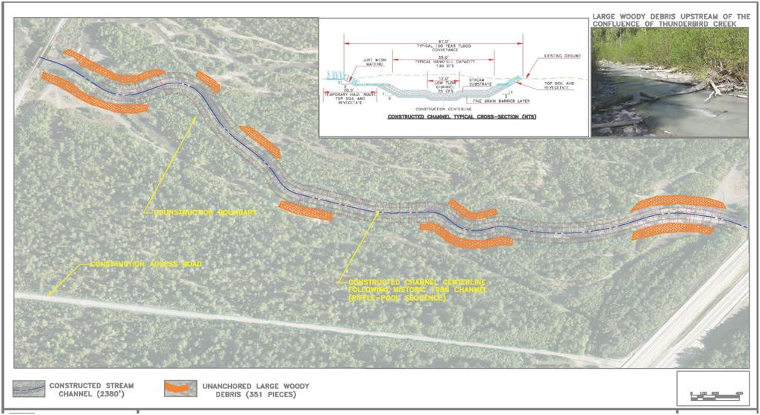

Figure 13. Alternative 2 – Constructed Channel with Large Woody Debris

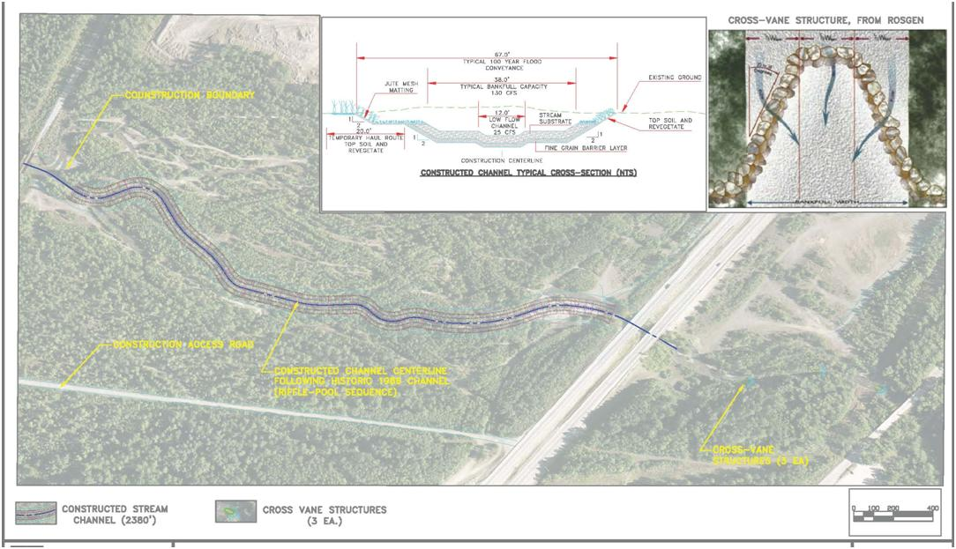

Figure 14. Alternative 3 – Constructed Channel with Upstream Cross-Vane Weirs

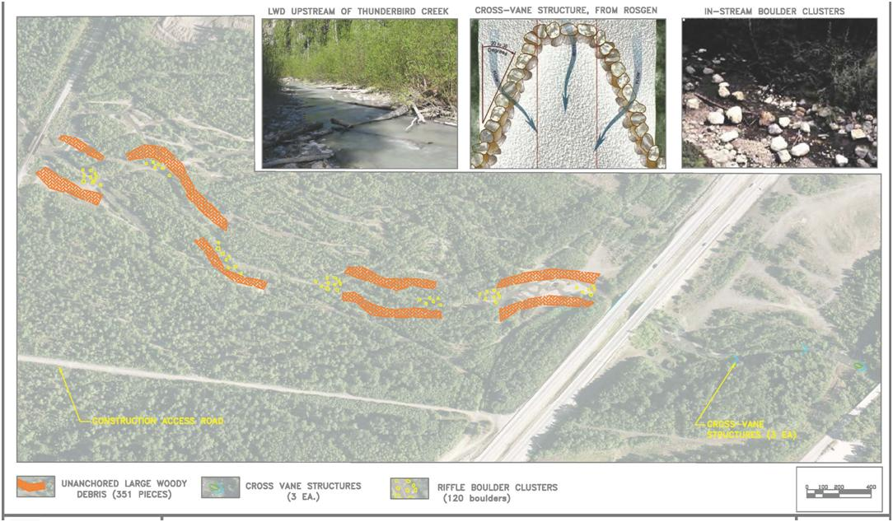

Figure 15. Alternative 4- Large Wood Debris, Boulder Clusters and Upstream Cross-Vane Weirs

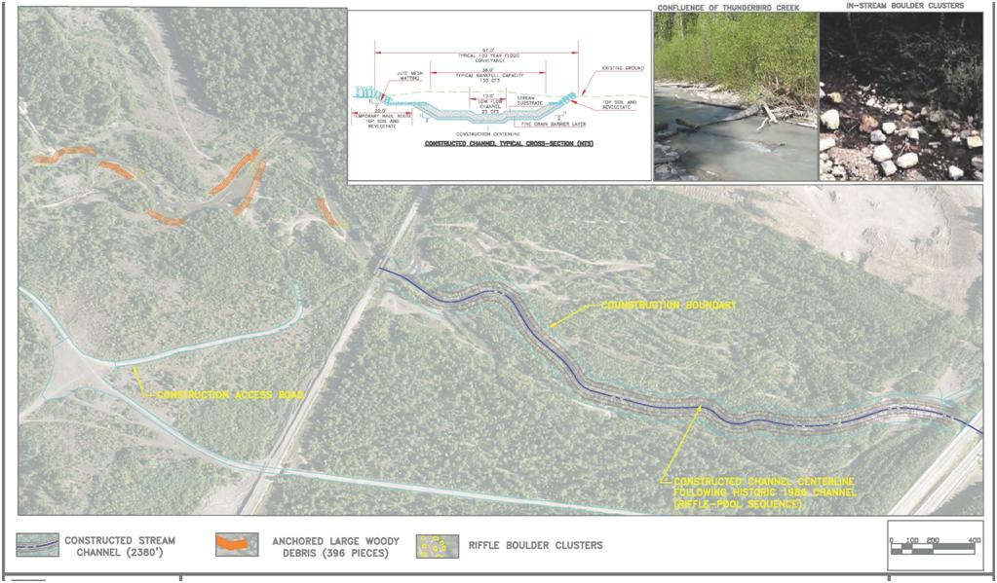

Figure . Alternative 5- Constructed Channel with Downstream Large Woody Debris and Boulder Clusters

Table . Habitat Components of Alternatives 2-5

|  |  |  |  |
| --- | --- | --- | --- |
| **Habitat Components** | | | |
| **Alternative 2** | **Alternative 3** | **Alternative 4** | **Alternative 5** |
| 2,380 feet of channel constructed | 2,380 feet of channel constructed |  | 2,380 feet of channel constructed |
| 12-foot low flow channel | 12-foot low flow channel | 12-foot low flow channel | 12-foot low flow channel |
| 38-foot bankfull channel | 38-foot bankfull channel | 38-foot bankfull channel | 38-foot bankfull channel |
| 67’ 100 year channel | 67’ 100 year channel | 67’ 100 year channel | 67’ 100 year channel |
| Deeper average depth | Deeper average depth |  | Deeper average depth |
| Single flow channel | Single flow channel |  | Single flow channel |
| Slope 0.12 ft/mile | Slope 0.12 ft/mile |  | Slope 0.12 ft/mile |
| Pool/shelter LWD* – 191 pieces |  | Pool/shelter LWD – 191 pieces | Pool/shelter LWD – 296 pieces |
| Riparian corridor protection LWD – 150 pieces |  | Riparian corridor protection LWD – 150 pieces | Riparian corridor protection LWD – 100 pieces |
| Stream substrate | Stream substrate |  | Stream substrate |
|  | Cross vane structures | Cross vane structures |  |
|  |  | Riffle Boulder Clusters & scour pool | Riffle Boulder Clusters & scour pool |
| 12-inch Diam LWD |  | 12-inch Diam LWD | 12-inch Diam LWD |
|  | 1,600-foot upstream channel enhancement | 1,600-foot upstream channel enhancement |  |
|  |  |  | 1300-foot downstream channel enhancement |
| Top Soil | Top Soil | Top Soil | Top Soil |
| Riparian Re-veg | Riparian Re-veg | Riparian Re-veg | Riparian Re-veg |
| 1986 Channel Alignment | 1986 Channel Alignment |  | 1986 Channel Alignment |

*Note:* LWD is large woody debris

## Description of Recommended Plan

### Recommended Plan

The recommended plan is the construction of any one or combination of alternatives 2, 3, 4 or 5 as described in Section 3.7 after completing the public and interagency comment, review and effects analysis process. This study did not reach the point at which habitat units (acres) per species and habitat units per species life stages would have been calculated. This study did not reach the point at which a cost effectiveness/incremental cost analysis would have been completed. Therefore, the recommendations are based on the environmental engineering, ecological, and biological analyses done by the team members to date.

### Recommended Plan Components

The text in Section 3.7 and Table 5 defines the components for each alternative that would have to be constructed for each alternative.

### Monitoring and Adaptive Management

Regardless of which alternative or combination of alternatives is constructed, a monitoring plan, adaptive management plan, and maintenance plan will have to be developed to ensure that expected habitat outputs and enhancement of salmonid species recruitment and survival are occurring.

## Conclusions

### Conclusions

The recommended habitat restoration strategy would seek to restore degraded salmonid habitat between the highway and railroad bridges. This strategy would include replacing the braided channels between the highway and railroad bridges with a single meander confined within an engineered floodplain benched to accommodate natural flood events of up to 100-year magnitude and returning the partially restored reach back to a less anthropogenically damaged condition. The various alternatives available to enact this restoration are presented in Section 3.7.

This analysis assumes that in-stream flow from Thunderbird Creek will be maintained because Thunderbird Creek has become the principal source of in-stream flow for the lower reaches of the Eklutna River and is necessary for the production of salmonid fish in the ecosystem. Success of any of the other alternatives would depend on maintenance of in-stream flow from Thunderbird Creek at current or higher discharges unless Eklutna Lake flows are restored in part or whole.

**5.2 POST STUDY ACTIVITIES**

The Natural Resources Conservation Service (NRCS) will use the contents of this study to assist them in permitting and constructing some restoration project for the Eklutna River. Accordingly, activities and products of this study were coordinated with NRCS and the Sponsor. The Corps effort was performed at 100% Federal Cost. If the project was to continue as a Corps activity, then the study and the restoration construction would both be cost shared 65% federal – 35% non-federal. With NRCS, the Sponsor would only have to pay 10% of the construction cost. Obviously, the Sponsor has decided to use the NRCS grant program.

The Point of Contact with the NRCS is Bill Woods of the Palmer office (907)761-7761, [bill.wood@ak.usda.gov](mailto:bill.wood@ak.usda.gov). Also in strong support of the project is the National Marine Fisheries Service. Eric Rothwell (907)271-1937, [eric.rothwell@noaa.gov](mailto:eric.rothwell@noaa.gov) was their representative from their Anchorage Field Office.

## Literature Cited

Administration. 1988. Glenn Highway: Eklutna to Parks Highway. Draft Environmental Statement.

“A.[E](http://vilda.alaska.edu/cdm4/results.php?CISOOP1=any&CISOFIELD1=CISOSEARCHALL&CISOROOT=/cdmg2&CISOBOX1=E).[C](http://vilda.alaska.edu/cdm4/results.php?CISOOP1=any&CISOFIELD1=CISOSEARCHALL&CISOROOT=/cdmg2&CISOBOX1=C). [G25](http://vilda.alaska.edu/cdm4/results.php?CISOOP1=any&CISOFIELD1=CISOSEARCHALL&CISOROOT=/cdmg2&CISOBOX1=G25).” An [Alaska](http://vilda.alaska.edu/cdm4/results.php?CISOOP1=any&CISOFIELD1=CISOSEARCHALL&CISOROOT=/cdmg2&CISOBOX1=Alaska) [Engineering](http://vilda.alaska.edu/cdm4/results.php?CISOOP1=any&CISOFIELD1=CISOSEARCHALL&CISOROOT=/cdmg2&CISOBOX1=Engineering) [Commission](http://vilda.alaska.edu/cdm4/results.php?CISOOP1=any&CISOFIELD1=CISOSEARCHALL&CISOROOT=/cdmg2&CISOBOX1=Commission) photo. [Photographer’s](http://vilda.alaska.edu/cdm4/results.php?CISOOP1=any&CISOFIELD1=CISOSEARCHALL&CISOROOT=/cdmg2&CISOBOX1=Photographer's) [number](http://vilda.alaska.edu/cdm4/results.php?CISOOP1=any&CISOFIELD1=CISOSEARCHALL&CISOROOT=/cdmg2&CISOBOX1=number) [G25](http://vilda.alaska.edu/cdm4/results.php?CISOOP1=any&CISOFIELD1=CISOSEARCHALL&CISOROOT=/cdmg2&CISOBOX1=G25). [Aug](http://vilda.alaska.edu/cdm4/results.php?CISOOP1=any&CISOFIELD1=CISOSEARCHALL&CISOROOT=/cdmg2&CISOBOX1=Aug). [1916](http://vilda.alaska.edu/cdm4/results.php?CISOOP1=any&CISOFIELD1=CISOSEARCHALL&CISOROOT=/cdmg2&CISOBOX1=1916).

Alaska, Department of Commerce, Department of Consumer and Regulatory Affairs, Community Database Online. <http://www.commerce.state.ak.us/dca/commdb/CF_BLOCK.cfm>

Alaska Department of Education and Early Development Assessment and Accountability. *Enrollment by School and Grade as of Oct. 1, 2007, FY2008*. <http://www.eed.state.ak.us/stats/SchoolEnrollment/2008SchoolEnrollment.pdf>

Alaska Department of Environmental Conservation, Division of Air Quality, Air Pollution in Alaska Communities. <http://www.dec.state.ak.us/air/anpms/comm/comm.htm>

Alaska Department of Fish and Game. Anchorage/Mat-Su/Kenai Nonsubsistence Area #92-25-JB. (1992). <http://www.boards.adfg.state.ak.us/fishgame/regs/9225jb.pdf>

Alaska Department of Labor, Research and Analysis Section, Table 4.3 Alaska Population by Place 2000-2007. <http://www.labor.state.ak.us/research/pop/estimates/07T4.3.xls>

Alaska Department of Natural Resources (ADNR). 2007.

Alaska Department of Transportation and Public Facilities, and The Federal Highway Administration. 1988. Glenn Highway: Eklutna to Parks Highway. Draft Environmental Statement.

Alaska Division of Community and Regional Affairs, Office of the State Assessor, “Alaska Taxable”. <http://www.commerce.state.ak.us/dca/osa/assessor.cfm>

Alaska Railroad Corporation. [www.alaskarailroad.com](http://www.alaskarailroad.com)

Alaska: To Serve 25% of All Alaskans. Alaska Investigations Office: Juneau, AK.

Alex, Dan. 2007. Personal communication.

Anchorage Area, Alaska. Annual Project Summaries, Pacific Northwest, vol. 40. Award No. 1434-HI-96-GR-02743.

Anchorage Daily News. 1999. “Gravel for growth, Mine near anchorage is an economic boon for Eklutna and CIRI,” <http://www.adn.com/179/story/199958.html>

Anchorage Quadrangle, Alaska. Geologic Report No. 18. Division of Mines and Minerals, Department of Natural Resources, Alaska.

Anchorage Water and Wastewater Utility (AWWU). 2006.

Brabets, T.P., Glacier Runoff and Sediment Transport and Deposition Eklutna Lake Basin, Alaska. U.S. Geological Survey Water Resources Report 92-4132, 1993.

Bruhn, R. L. 1998. Earthquake hazard of the Upper Cook Inlet Fold Belt, Greater Anchorage Area, Alaska. Annual Project Summaries, Pacific Northwest, vol. 40. Award No. 1434-HI-96-GR-02743.

Chandonnet, Anne. 1985. Municipality of Anchorage, Finance Department, Property Appraisal Division, *On the Trail of Eklutna*, User-Friendly Press: Anchorage.

Characteristics in the Fire Lakes-Eklutna Area, Anchorage, Alaska. Open-File Report 83-479. Department of the Interior, United States Geological Survey.

Curran, J.H., Meyer, D.F., and Tasker, G.D., 2003, Estimating the Magnitude and Fequency of Peak Streamflos for Ungaged Sites on Streams in Alaska and Conterminous Basins in Canada: U.S. Geological Survey Water-Resources Investigations Report 03-4188, 101 p.

Davis, Jeffrey C. and Muhlberg, Gay A. (2001). Technical Report No. 01-7 Chester Creek Stream Condition Evaluation. Alaska Department of Fish and Game Habitat Restoration Division.

Eklutna, Incorporated. [www.eklutnainc.com](http://www.eklutnainc.com)

Goff, J.R. and P. Ashmore. 1994. Gravel Transport and Morphologic Change in Braided Sunwapta River, Alberta, Canada. Earth Surface Processes and Landforms, 19:195-212.

Interagency Advisory Committee on Water Data, 1982, Guidelines for determining flood flow frequency: Hydrology Subcommittee Bulletin 17B, 28 p., 14 app.

Knik Arm Bridge Project: Phase 1. Cultural Resources and Subsistence. <http://www.knikarmbridge.com/Tech_Reports/Boiler%20QC/KA-DataGap9.pdf>

Lamoreaux, Marc. Personal communication.

Lane, S.N., K.S. Richards, and J.H. Chandler, 1995. Morphological Estimation of Time-Integrated Bed Load Transport Rate. Water Resources Research, 31(3):761-772.

Lee, Stephan. 2004. Personal communication.

Leopold, L.B., and Wolman, M.G. (1957). River channel patterns: braided, meandering and straight. U.S. Geol. Surv. Prof. Paper 282-B, Washington, DC.

Lesondak, G.R. (ed), The Early Electrification of Anchorage, Prepared by: Center for Environmental Management of Military Lands, Colorado State University, Fort Collins, CO, 2002.

Letter to Knik Bridge Authority from the Native Village of Eklutna. <http://www.knikbridgefacts.org/NVOE.pdf>

Lobdell, John E. 1984. An Archaeological Assessment of the Eklutna Water Project, Phase II: Staging Areas, Material Sources, and Route Modifications, Upper Cook Inlet, Alaska. For the Municipality of Anchorage Water and Wastewater Utility.

Municipal Light & Power – Utility Profile. <http://www.mlandp.com/new%20paint/utilityprofile2004.pdf>

National Climatic Data Center data, via Weatherbase.com.

National Marine Fisheries Service (NMFS). 2005.

Native Village of Eklutna. <http://www.eklutna-nsn.gov/TribalGov.htm>

Perterson, P.N., L.M. Reid, 1984. Wall-based channels: Their evolution, distribution, and use by juvenile coho salmon in the Clearwater River, Washingtion. Proceedings of the Olympic Wild Fish Conference.

Prince of Wales Tribal Enterprise Consortium (POWTEC). 2007. Habitat Assessment of the Lower Eklutna River, May 14, 2007.

Reagan. Personal communication.

Rickman, Ron, USGS. Personal communication.

Rose, A. W. 1966. Geology of Chromite-Bearing Ultramafic Rocks near Eklutna,

Anchorage Quadrangle, Alaska. Geologic Report No. 18. Division of Mines and Minerals, Department of Natural Resources, Alaska.

Rutz, D. Alaska Department of Fish and Game. Personal communication.

Simonds, Wm Joe, *The Eklutna Project* (1995). <http://www.usbr.gov/history/eklutna.html>.

Schmoll, H. R. and R. P. Emanuel. 1983. Geologic Materials and Hydrogeologic

Characteristics in the Fire Lakes-Eklutna Area, Anchorage, Alaska. Open-File Report 83-479. Department of the Interior, United States Geological Survey.

University of Alaska Anchorage/Cook Inlet Region, Inc. (UAA/CIRI). 1987.

University of Alaska Fairbanks, Alaska Native Knowledge Network. *Athabascans of Interior Alaska* <http://www.ankn.uaf.edu/Curriculum/Athabascan/Athabascans/alaskanathabascans.html>

University of Alaska Fairbanks, Alaska Native Knowledge Network. *Athabascans of Interior Alaska.* Walter W. Hodge Papers, ca. 1925-1948, Alaska and Polar Regions Collections, Elmer E. Rasmuson Library, University of Alaska Fairbanks.

Updike, R. G. and H. R. Schmoll. 1985. A brief resume of the geology of Anchorage and vicinity. Alaska Division of Geological and Geophysical Survey, Fairbanks, Alaska.

US Army Corps of Engineers, Section 905(b) (WRDA 86) Analysis, Eklutna Watershed Study.

US Bureau of Reclamation, and the Department of the Interior (USBR). 1948. Eklutna Project, Alaska: To Serve 25% of All Alaskans. Alaska Investigations Office: Juneau, AK.

US Bureau of Reclamation (USBR). No Date.

US EPA Region 10, Air page, State Implementation Plans, Air Quality Control Plan Summaries: <http://yosemite.epa.gov/R10/AIRPAGE.NSF/webpage/SIP+-+General+Page>.

US Geological Survey (USGS). 2005.

1. The gravel pit is clearly marked on the USGS Anchorage B-7 NE, 1:25,000 scale; 1979 topographic map.
2. Reaches defined by USACE Alaska District Hydrology Section staff
3. The USGS maintains a lake elevation gage at Eklutna Lake. Real-time data from this gage, 15278000 Eklutna Lake near Palmer, AK, is available from the local USGS web page, <http://waterdata.usgs.gov/ak/nwis>.