ADF&G Fish Collection Permit SF2007-131 Report

Data Collected by U.S. Army Corps of Engineers
Alaska District

Alaska District biologists collected fisheries data on the Eklutna River and its major tributary, Thunderbird Creek, during 2007 as part of a study on restoration potential. The goal of these collections was to determine which species of fish were present in the Eklutna River at various times of the year and to determine where these fish were located.

Figures of the sample locations are presented at the end of this report. All minnow trap and ground based visual survey data is presented in the attached table.

This report is divided into three sections based on survey methods used and also includes a conclusion and recommendation section.

A. Minnow Trap Survey

1. Minnow traps with ¼-inch mesh were used at all 28 sample locations. Twenty-seven summer locations were sampled plus one opportunistic location, 9A, which was only sampled in winter because it was deep and there was enough open water for a minnow trap. All minnow traps were baited with salmon roe disinfected in a betadine solution.

2. Traps were soaked for approximately 24 hours, usually in pools or near undercut banks and in side channels.

3. Juvenile fish were enumerated, measured (fork length in millimeters) and released. For larger catches, a sub-sample was measured to reduce processing time and minimize stress on the fish.

4. At times Dolly Varden were caught that were too large to fit through the trap entrance. These fish were removed, apparently unharmed, but their presence certainly reduced the trap efficiency and could also have deterred smaller juvenile fish from entering the trap.

5. Evidence of recent black bear activity was common near the confluence of the Eklutna River and Thunderbird Creek.

B. Eklutna River Salmon Index Survey

1. At 0815 Friday, 17 August 2007 Corps biologists Larry Bartlett and Chris Hoffman met at the Eklutna Tribal office in Eklutna, Alaska, approximately 20 miles north of Alaska District headquarters to index adult salmon in the Eklutna River. We spoke briefly with Mr. Dan Alex, Tribal Administrator who told us of his plans to turn a borrow pit on Eklutna Inc. land that is being excavated by Alaska Aggregates Inc. into a future fish pond. Mr. Alex also told us of a program he intended to initiate during the summer of 2008 that would employ young people from the Eklutna Native Village. He indicated that the young people might be available gather data on the Eklutna River.

2. Larry and Chris positioned their personal vehicles, one at the Old Glenn Highway Bridge and one at the Alaska Railroad bridge (ARR), and hiked to the lower river to begin the survey. The river was divided into four reaches: (1) Start to the ARR bridge, (2) ARR bridge to the Glenn Highway bridges, (3) Glenn highway bridges to the Old Glenn Highway bridge, and (4) the Old Glenn Highway bridge to Thunderbird Creek. The survey was conducted from a downstream to upstream direction starting at the tail of the first deep hole downstream of the gravel ponds.

3. The river was normal in flow, but slightly turbid from recent rains. The river bottom in holes deeper than about 2 feet was not visible, but these areas are few and roughly 98 percent of the river was visible. The lower reach was surveyed in full sun. Clouds came from the east and occasionally clouded the sun by the time we surveyed the upper reaches, but it did not significantly affect the visibility. Water temperature was not taken, but the water was cool and there was no indication that temperature might have been affecting the activity of fish in the river.

4. Mr. Alex told us that coho salmon would be the most abundant salmon species in the river this time of year, but we saw only pink, chum, and two Chinook salmon. There should have been coho salmon in at least the lower reach but none were seen. Recent articles in the Anchorage Daily News reported higher than usual catches of coho salmon in the Central Cook Inlet drift net fishery and this might be affecting the return of coho to the upper Cook Inlet streams including the Eklutna River. Counts by reach are reported in the tables following this report.

5. Few carcasses were seen.

6. Pink salmon were spawning. Chums appear fresh and there was no sign of spawning among the chum salmon seen. One pair of Chinook was seen. The female had a flagged tail and was spawned out, but the fish with her appeared relatively fresh. Fresh redds were evident in reach 2. Areas where fish were observed spawning is marked on the figure following this report.

7. We did not finish Reach 4 between the Old Glenn Highway bridge and Thunderbird Creek. Within about 200 yards of entering the Eklutna River canyon at the Old Glenn Highway bridge we came across the fresh tracks of a large, mature brown bear. A short distance after seeing the tracks, we noticed something unusual lying on a low, grass covered bench a few feet from the river. We investigated and found a large fragment of a mammal femur that had been chewed and broken, apparently to extract marrow. Large chunks of flesh on the bone suggested it was very fresh. The grass was matted down around the bone suggesting that a bear had recently lain there to feed. The canyon is very narrow at this point and the likelihood of a brown bear lying on a fresh kill in the immediate vicinity was high, so we silently retreated back downstream and left the area.

Reach | Pink | Chum | Chinook | Coho | Sockeye
1 | 62 | 6 | 2 | 0 | 0
2 Right side braids | 0 | 0 | 0 | 0 | 0
2 Left side braids | 13 | 2 | 0 | 0 | 0
2 Single | 20 | 0 | 0 | 0 | 0
2 Total | 33 | 3 | 0 | 0 | 0
3 | 51 | 3 | 0 | 0 | 0
4 | 20 | 10 | 0 | 0 | 0
Total Counted | 199 | 24 | 2 | 0 | 0
Table 1. Counts of live adult salmon in the Eklutna River, 17 August 2007.
Notes:
1) 2nd reach is braided into left and right channels before coalescing into a single channel about 90 yards downstream of the Glenn Highway Bridge.
2) Reach 4 was not completed due to bear activity.

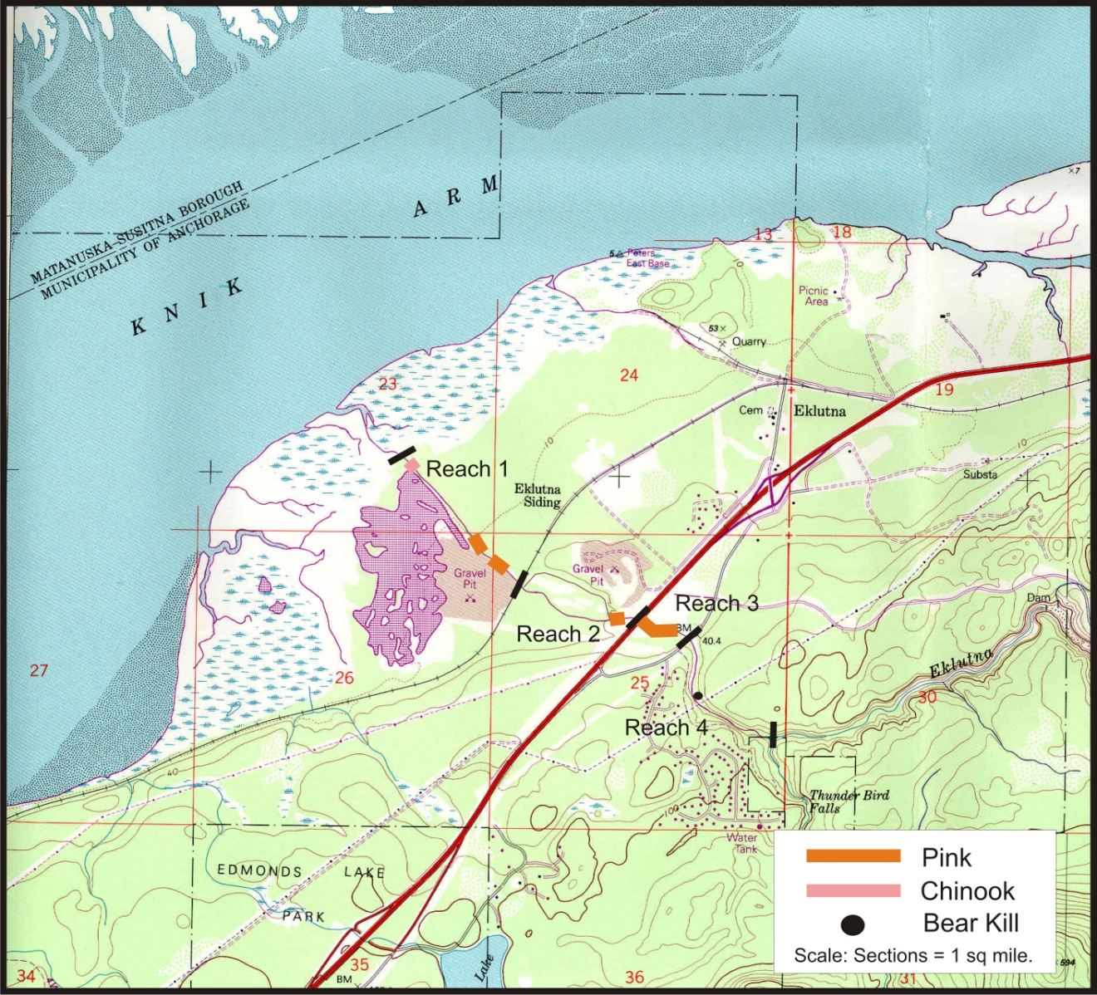
Map 1. Areas of the Eklutna River where spawning was observed during August 2007 count of adult salmon.

C. Conclusions and Recommendations

1. The Eklutna River has a viable population of resident Dolly Varden. This is not surprising because this species becomes benthic during winter and can survive well by wriggling down between large cobbles where it is protected from ice, and entering a torpid state.

2. The Dolly Varden in the Eklutna are of sufficient size to eat salmon fry during emergence and the fry’s first year of rearing, but they likely subsist on mostly aquatic insect larvae and salmon flesh from adult carcasses. Mortality of salmon fry by this species would likely be insignificant compared to mortality caused by factors such as stranding, starvation, and freezing and other causes of winter kill.

3. Minnow traps used for this study had 1/4 inch mesh and will not consistently retain fry that would now be about 30 to 40 mm in length. It would be worthwhile to invest in some 1/8 inch mesh traps that would retain fry to the exclusion of larger Dolly Varden and coho smolt.

4. It is important to know the freshwater age of coho and Chinook salmon produced by the Eklutna River. This record is carried on the scales of the returning adults. This information would allow the habitat restoration to be engineered to the maximum benefit of these species while benefiting other salmonid species and aquatic insects. Age from scales can be collected from angler creels or by placing a weir across the river and sampling the adults. Data from angler creels is biased because of angler selection while weir samples give a truer representation of the population.

5. It would be beneficial to find out how and where the coho smolt caught in the traps overwinter in the Eklutna River and consider engineering additional habitat of this type during the restoration. Also, studies should focus on the requirements of summer rearing habitat of Chinook and coho fry in the Eklutna River and consider engineering additional habitat of this type during the restoration.

6. ATV and vehicle crossings should be repaired during the restoration to minimize riparian and channel damage due to vehicles.

Question on this report should be directed to Chris Hoffman, biologist, USACE, AK District at 907-753-5524 or Christopher.A.Hoffman@usace.army.mil

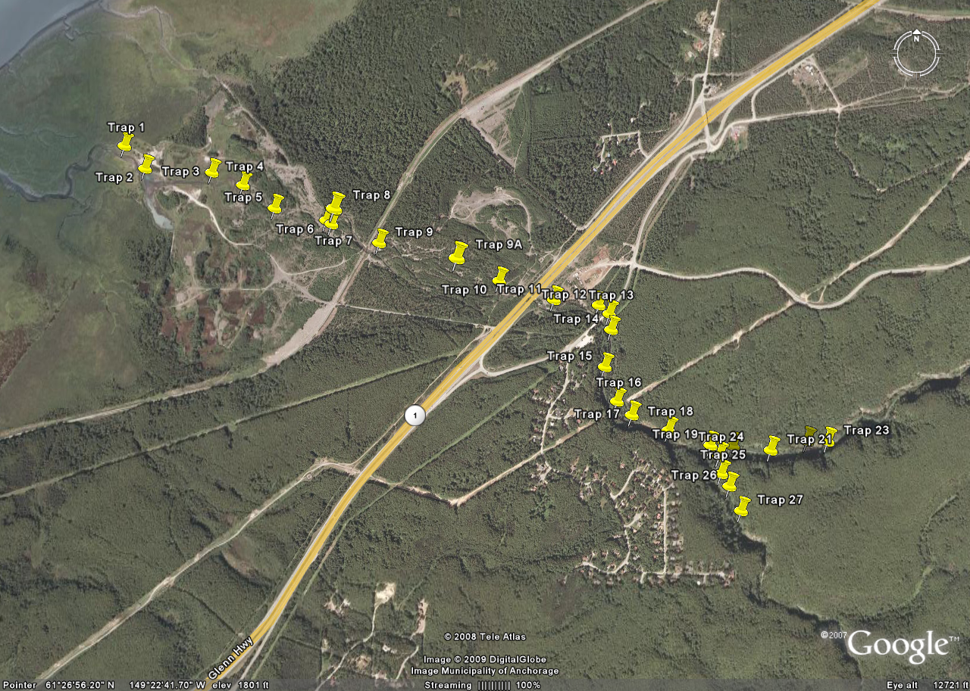
Knik Arm
Eklutna River
Eklutna River
Thunderbird Creek
Reach 1 (RCH1)
Reach 2 (RCH2)
Reach 3 (RCH3)
Reach 4 (RCH4)
Figure 1. Overview of Eklutna River Drainage and sample sites.

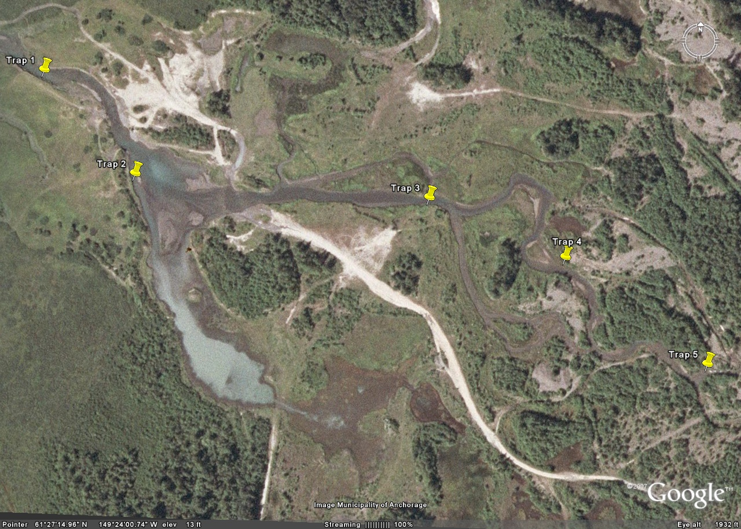
Figure 2. Sample sites 1-5 on Eklutna River.
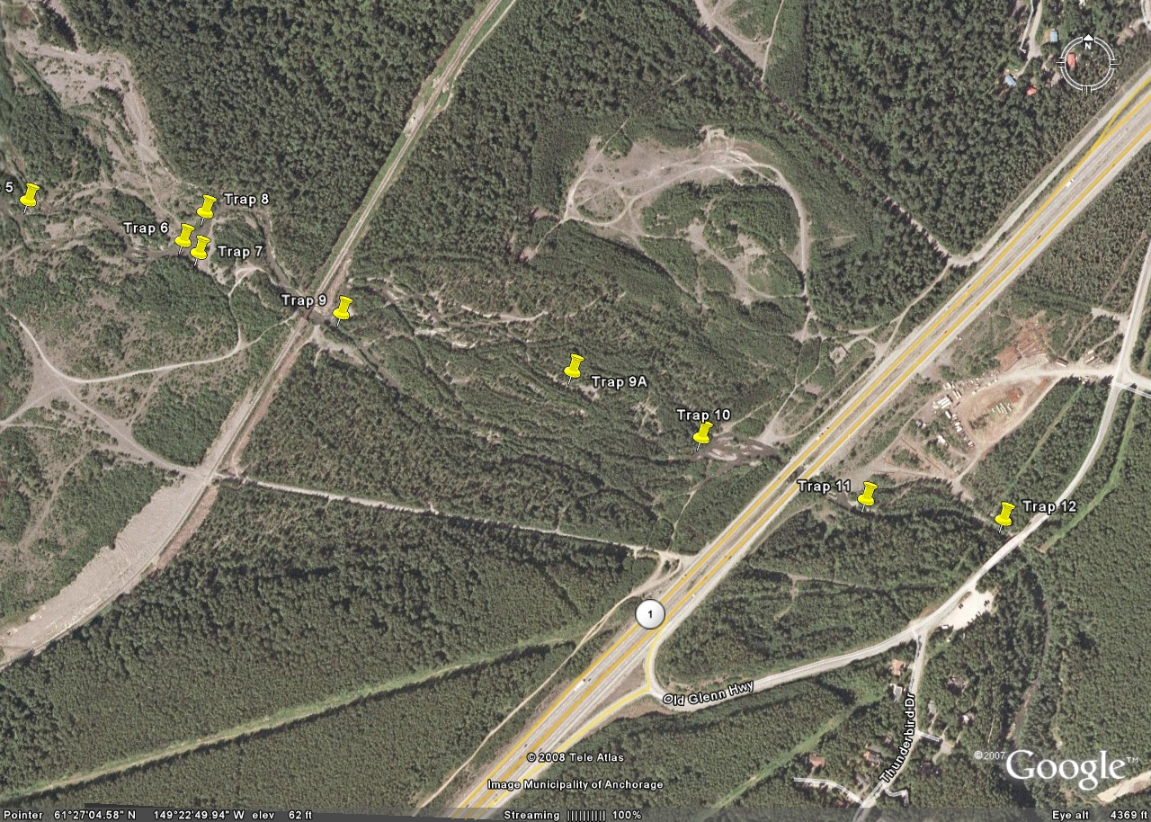
Figure 3. Sample sites 5-12 on Eklutna River.
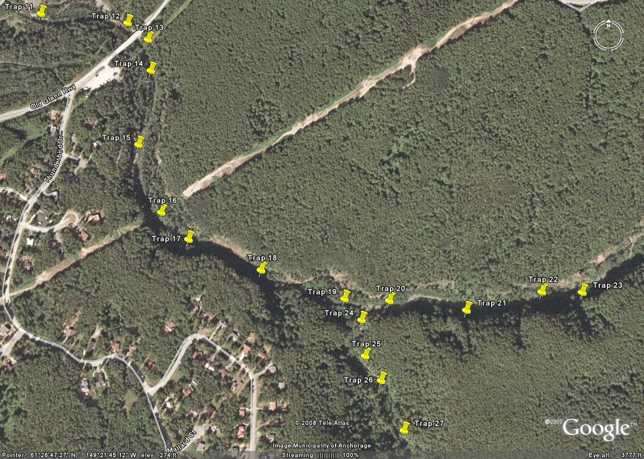
Figure 4. Sample sites 11-27 on Eklutna River and Thunderbird Creek.

