ADF&G Fish Collection Permit SF2011-206 Report

Data Collected by U.S. Army Corps of Engineers
Alaska District

Alaska District biologists collected fisheries data on the Eklutna River and its major tributary, Thunderbird Creek, during 2011 as part of a study on restoration potential. The goal of these collections was to determine which species of fish were present in the Eklutna River at various times of the year and to determine where these fish were located.

Figures of the sample locations are presented at the end of this report. All minnow trap data is presented in the attached table.

This report is divided into three sections based on survey methods used and also includes a conclusion and recommendation section.

A. Minnow Trap Survey

1. Minnow traps with ¼-inch mesh were used at all 8 sample locations. All minnow traps were baited with cured salmon roe purchased locally.

2. Traps were soaked for approximately 24 hours, usually in pools or near undercut banks and in side channels.

3. Juvenile fish were enumerated, measured (fork length in millimeters) and released. For larger catches, a sub-sample was measured to reduce processing time and minimize stress on the fish.

4. At times Dolly Varden were caught that were too large to fit through the trap entrance. These fish were removed, apparently unharmed, but their presence certainly reduced the trap efficiency and could also have deterred smaller juvenile fish from entering the trap.

5. Minnow traps provide an indication of juvenile fish in the area, but trapping efficiency is far from 100%. In some cases traps were observed about an hour after being set and found to have 10 juvenile Dolly Varden, but after a 24 hour soak there would be fewer fish. Obviously, plenty of juveniles figured out how to go out through the entrance tunnel. Sometimes ~100 juvenile Dolly Varden were observed in an off channel area, but only a dozen or so were trapped after 24 hours.

5. Fresh black bear adult and cub sign and the risk of surprising a sow with cubs in a canyon where escape opportunity for bears or humans was limited caused us to avoid setting traps at locations 5-8 on 1 August and 11 August. Accordingly, the number of fish recorded for these traps should be viewed in light of the fact that traps were not set on two occasions in August.

6. Traps dates for all traps are provided in the table below,

Trap # | Set dates in 2011
 | 30 June | 13 July | 1 August | 10 August | 29 August
1 | X | X | X | X | X
2 | X | X | X | X | X
3 | X | X | X | X | X
4 | X | X | X | X | X
5 | X | X |  |  | X
6 | X | X |  |  | X
7 | X | X |  |  | X
8 | X | X |  |  | X

B. Conclusions and Recommendations

1. The Eklutna River has a viable population of resident Dolly Varden. This is not surprising because this species becomes benthic during winter and can survive well by wriggling down between large cobbles where it is protected from ice, and entering a torpid state.

2. The Dolly Varden in the Eklutna are of sufficient size to eat salmon fry during emergence and the fry’s first year of rearing, but they likely subsist on mostly aquatic insect larvae and salmon flesh from adult carcasses. Mortality of salmon fry by this species would likely be insignificant compared to mortality caused by factors such as stranding, starvation, and freezing and other causes of winter kill.

3. Minnow traps used for this study had 1/4 inch mesh and will not consistently retain fry that would now be about 30 to 40 mm in length. It would be worthwhile to invest in some 1/8 inch mesh traps that would retain fry to the exclusion of larger Dolly Varden.

4. It is important to know the freshwater age of coho and Chinook salmon produced by the Eklutna River. This record is carried on the scales of the returning adults. This information would allow the habitat restoration to be engineered to the maximum benefit of these species while benefiting other salmonid species and aquatic insects. Age from scales can be collected from angler creels or by placing a weir across the river and sampling the adults. Data from angler creels is biased because of angler selection while weir samples give a truer representation of the population.

5. It would be beneficial to find out how and where the coho smolt caught in the traps overwinter in the Eklutna River and consider engineering additional habitat of this type during the restoration. Also, studies should focus on the requirements of summer rearing habitat of Chinook and coho fry in the Eklutna River and consider engineering additional habitat of this type during the restoration.

6. Restoration in Eklutna River is primarily limited by lack of flow and therefore lack of power to make the system dynamic in any way. Although gaining additional flow on a permanent or sporadic basis is unlikely in the short term, there appears to be room for improvement with some low impact techniques. Pool habitat is lacking between the Old Glenn Highway and the confluence with Thunderbird Creek and seems to be a prudent focus for future restoration.

7. The current restoration focus currently appears limited to the reach between the Old Glenn Highway and the confluence with Thunderbird Creek. Given the steep canyon configuration of this reach and the difficulty of access by heavy equipment, restoration efforts should focus on small scale projects that can be done with chainsaws, come-alongs, and other low impact means. In this manner, pools and other features can be created without damaging surrounding habitat. Care should be given to protect the exiting habitat that is valuable for juvenile Dolly Varden, so it might be prudent to proceed with a few small scale projects, monitor their success and proceed based on the monitoring results.

Question on this report should be directed to Chris Hoffman, USACE, AK District at 907-753-5524 or Christopher.A.Hoffman@usace.army.mil

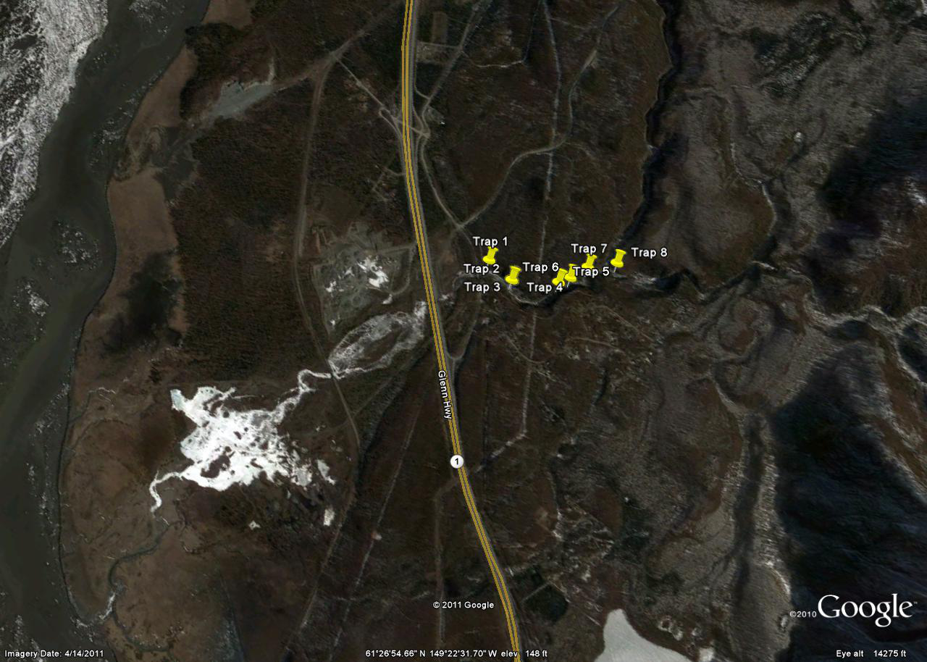
Figure 1. Overview of Eklutna River Drainage and sample sites.

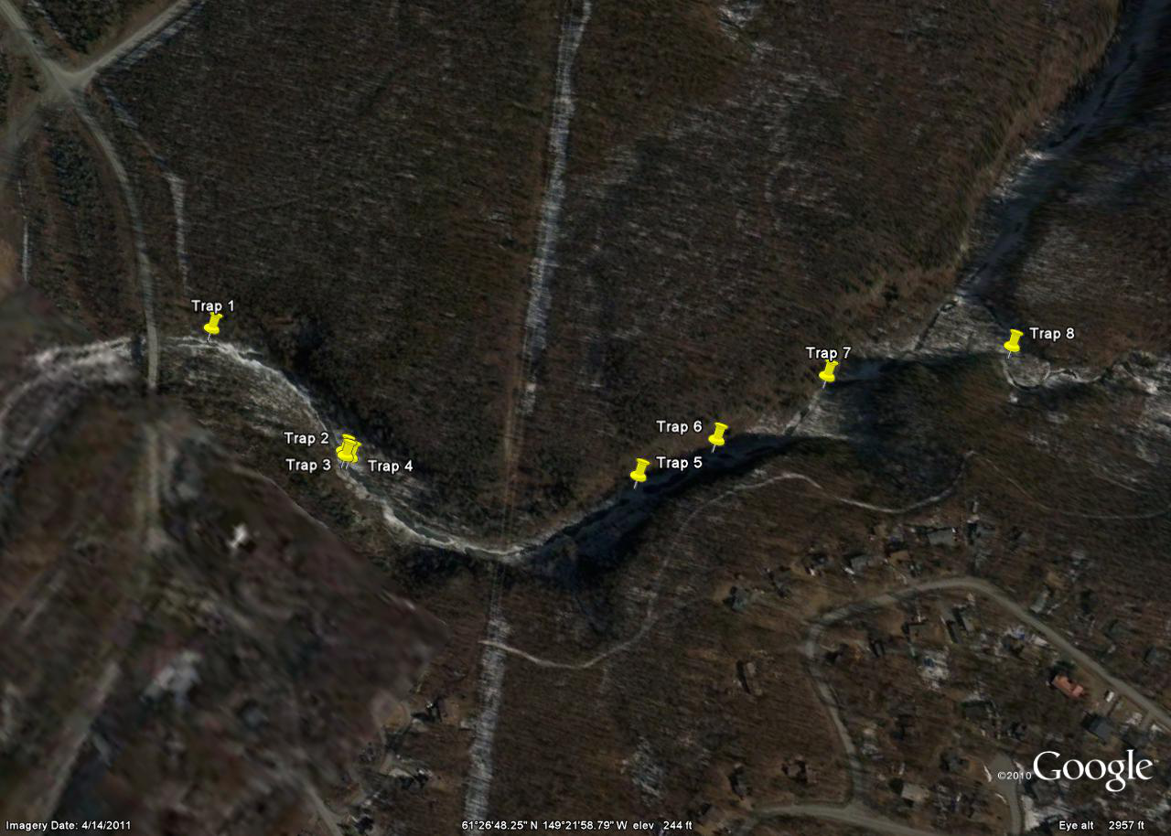
Figure 2. Close up of trap locations above the Old Glenn Highway bridge.

