REACH 6: Segment 25 to Segment 60.
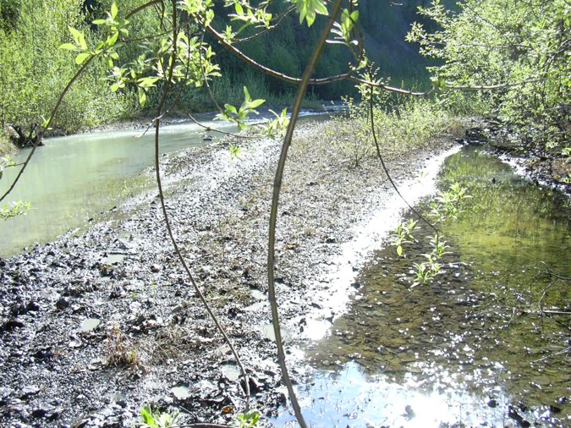 | 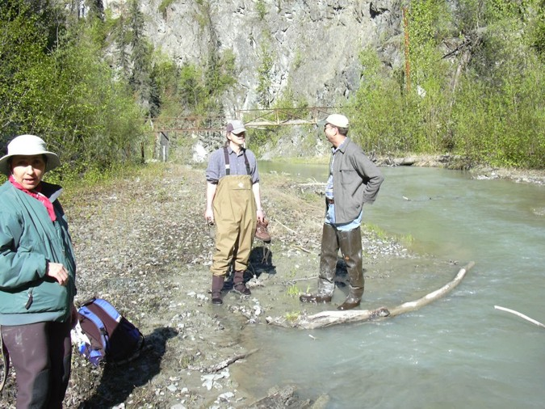
Reach 6-Segment 25 / upstream / photo 189 | Reach 6-Segment 25 / downstream / photo 198
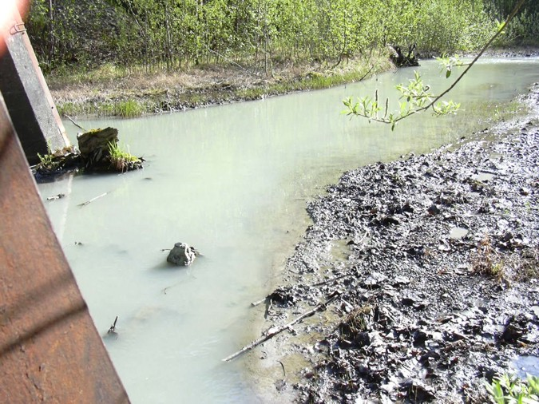 | 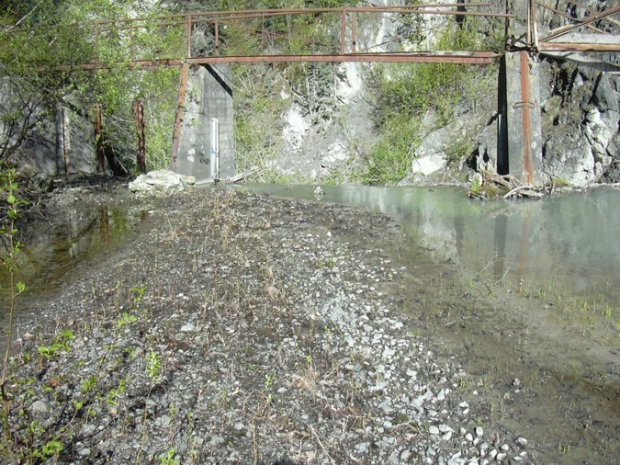
Reach 6-Segment 25 / upstream / photo 188 | Reach 6-Segment 25 / downstream / photo 195
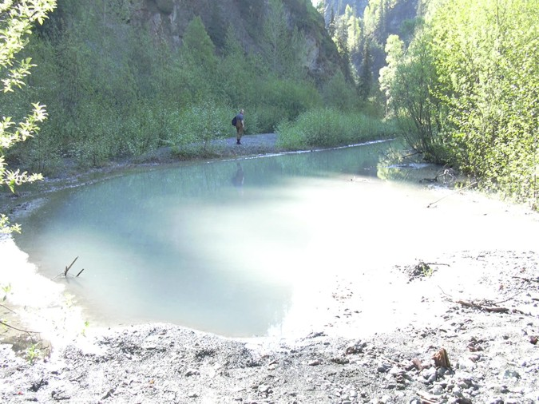 | 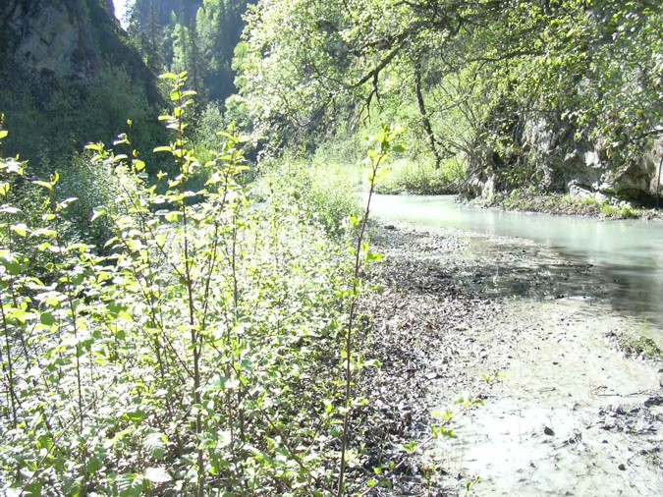
Reach 6-Segment 26 / upstream / photo 201 | Reach 6-Segment 26 / downstream / photo 208
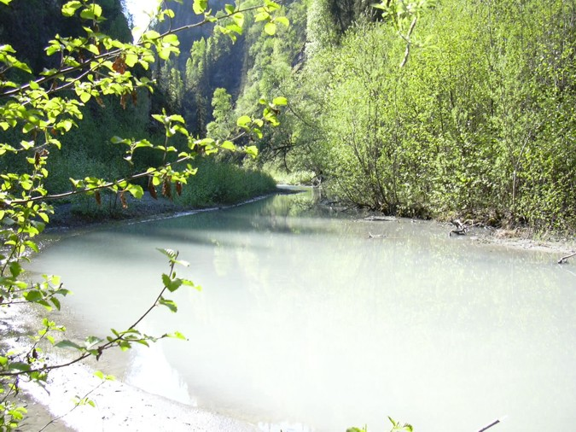
Reach 6-Segment 26 / upstream / photo 205
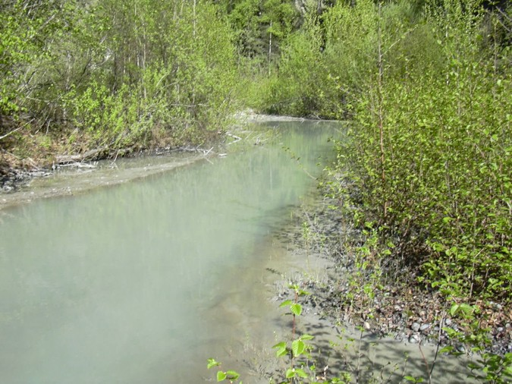 | 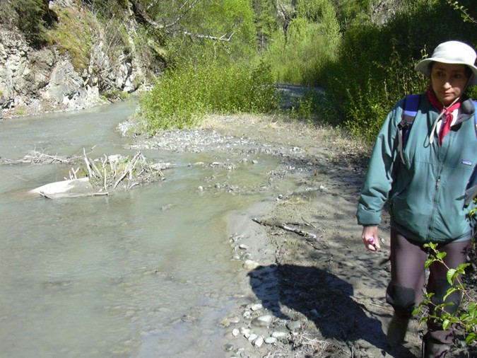
Reach 6-Segment 27 / upstream / photo 207 | Reach 6-Segment 27 / downstream / photo 209
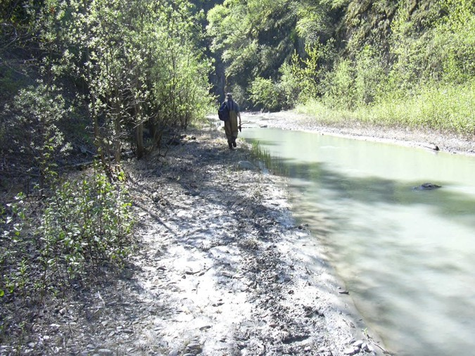 | 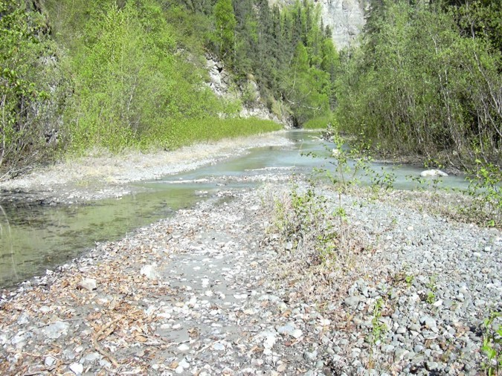
Reach 6-Segment 28 / upstream / photo 210 | Reach 6-Segment 28 / downstream / photo 212
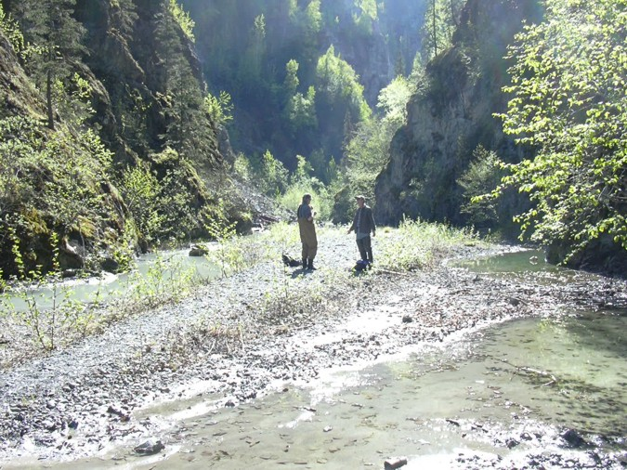
Reach 6-Segment 29 / upstream / photo 211
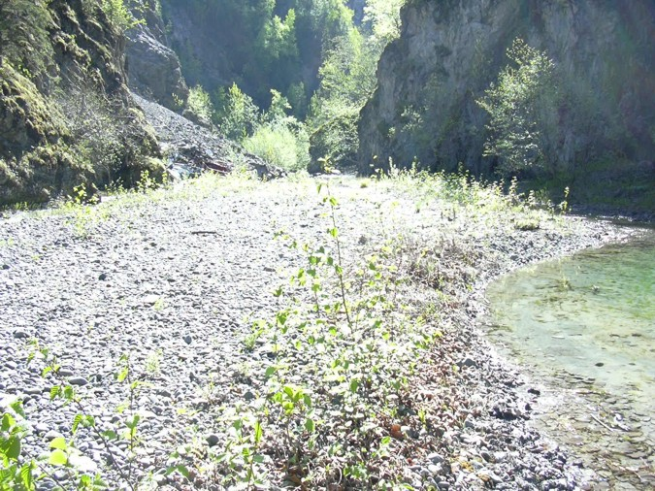 | 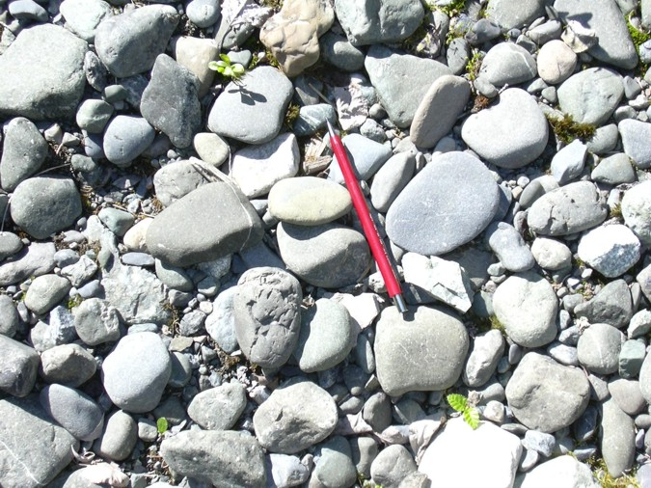
Reach 6-Segment 30 / upstream / photo 213 | Reach 6-Segment 30 / gravel / photo 215
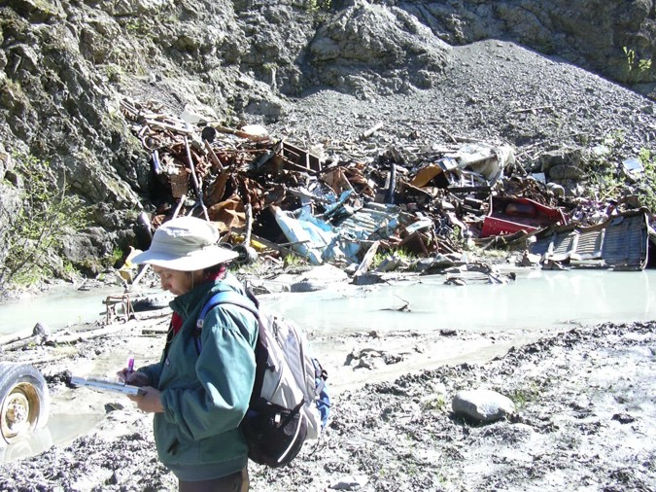 | 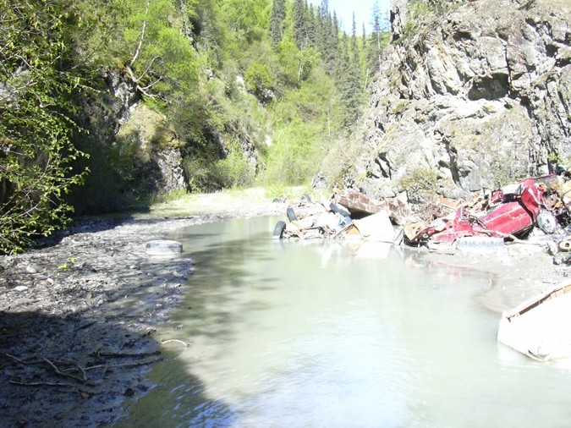
Reach 6-Segment 31 / upstream / photo 216 | Reach 6-Segment 31 / downstream / photo 218
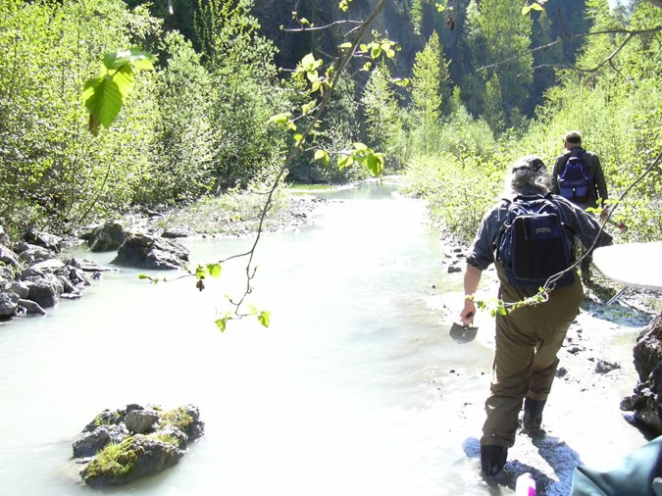 | 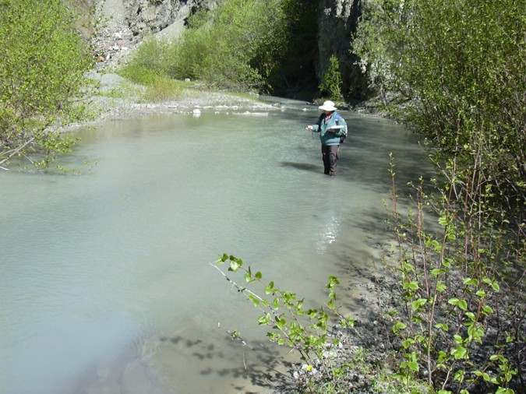
Reach 6-Segment 32 / upstream / photo 219 | Reach 6-Segment 32 / downstream / photo 221
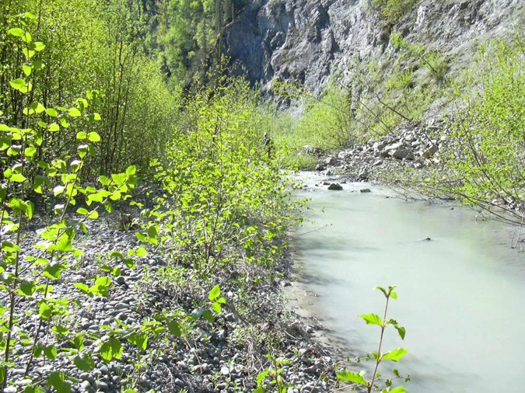 | 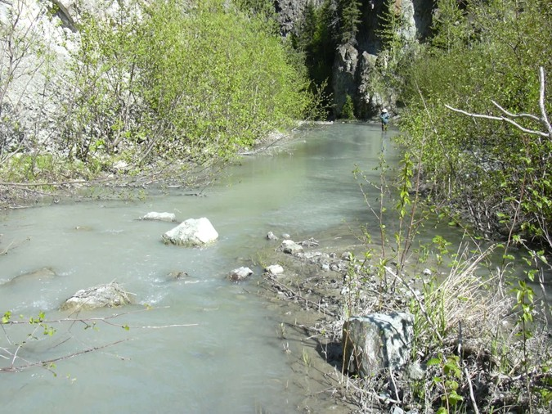
Reach 6-Segment 33 / upstream / photo 222 | Reach 6-Segment 33 / downstream / photo 223
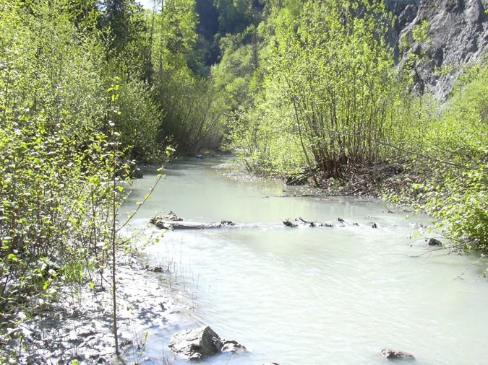 | 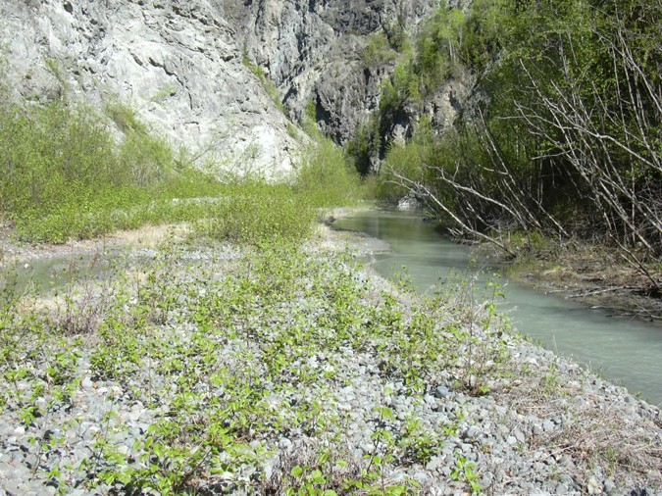
Reach 6-Segment 34 / upstream / photo 224 | Reach 6-Segment 34 / downstream / photo 228
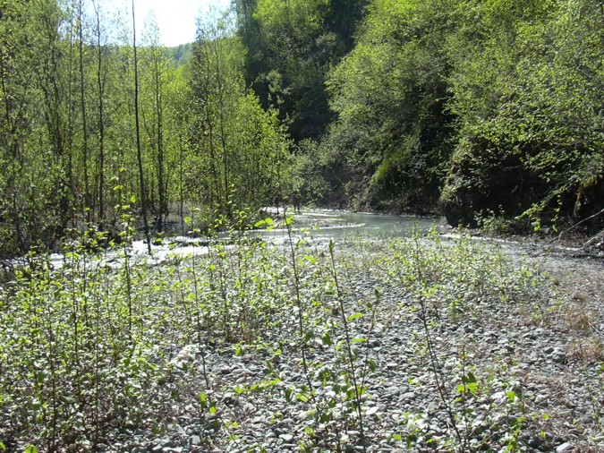 | 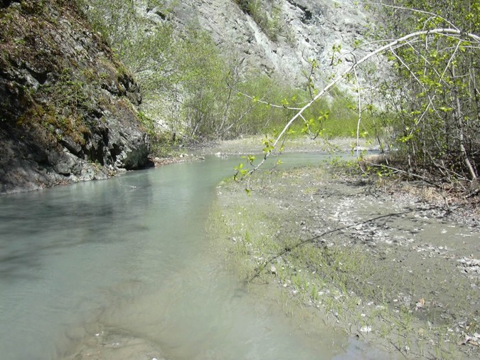
Reach 6-Segment 35 / upstream / photo 229 | Reach 6-Segment 35 / downstream / photo 230
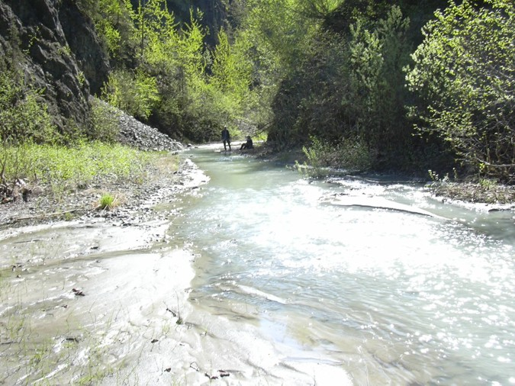 | 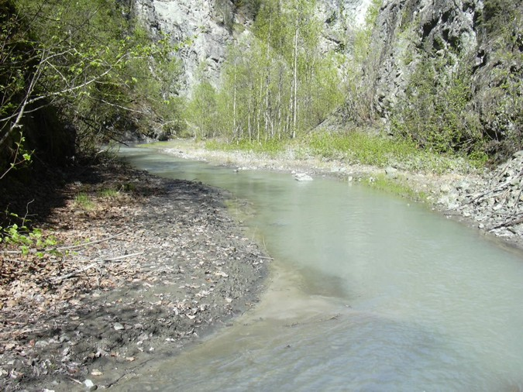
Reach 6-Segment 36 / upstream / photo 231 | Reach 6-Segment 36 / downstream / photo 232
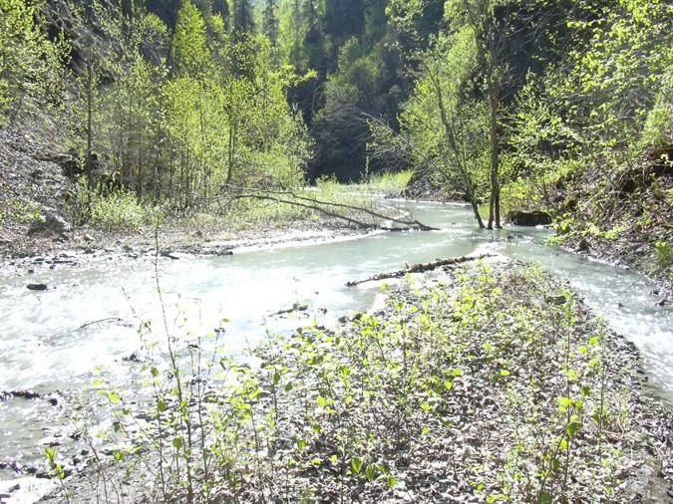 | 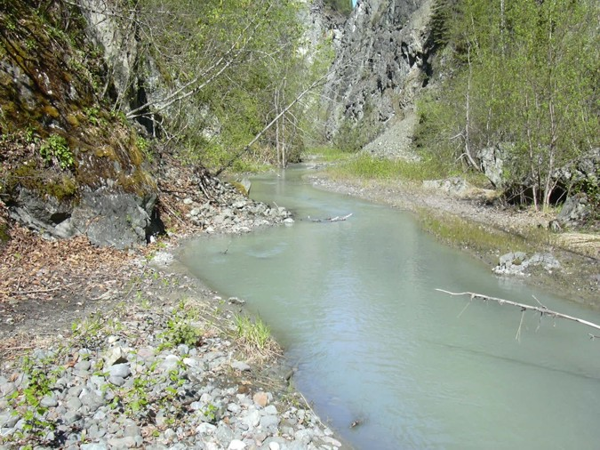
Reach 6-Segment 37 / upstream / photo 233 | Reach 6-Segment 37 / downstream / photo 234
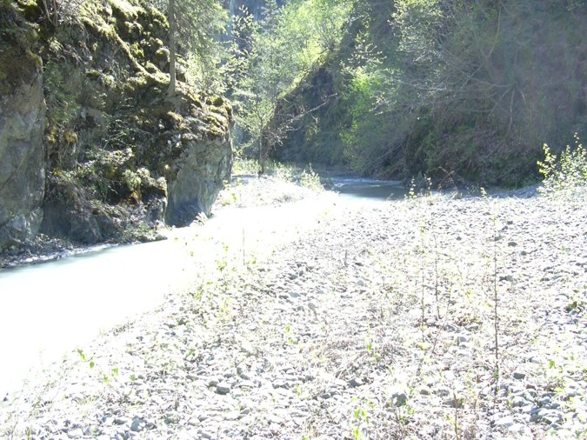 | 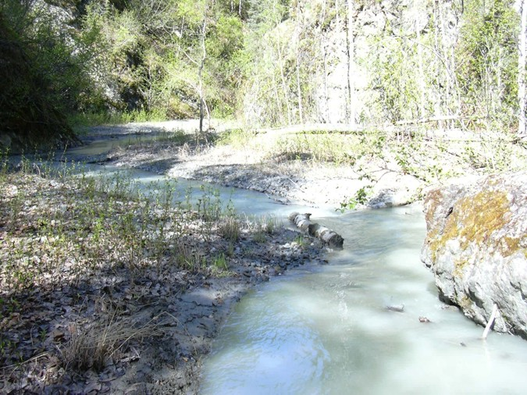
Reach 6-Segment 37 / upstream / photo 235 | Reach 6-Segment 37 / downstream / photo 236
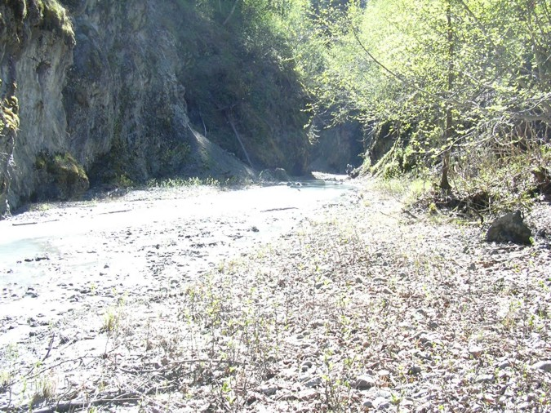 | 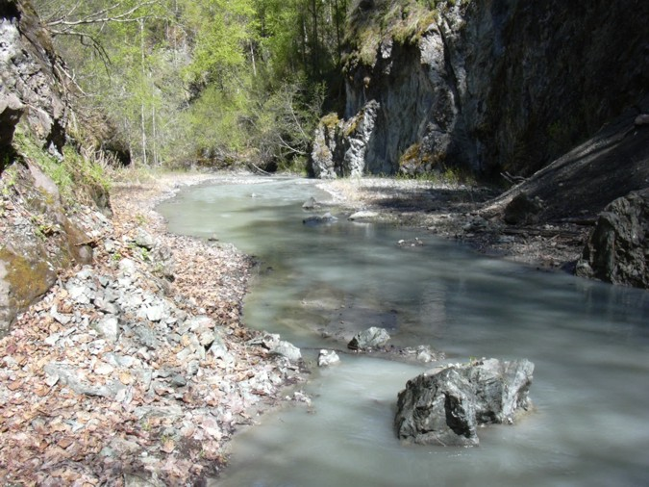
Reach 6-Segment 38 / upstream / photo 237 | Reach 6-Segment 38 / downstream / photo 238
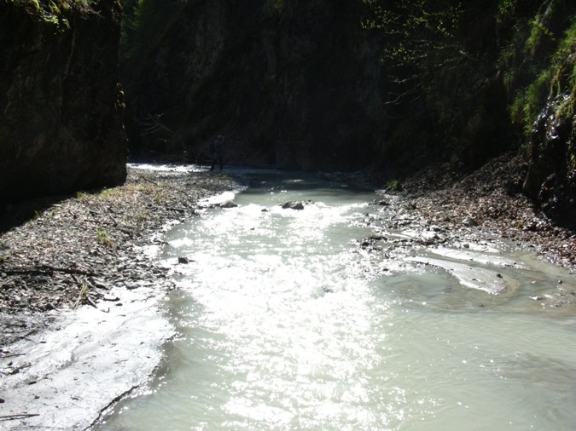 | 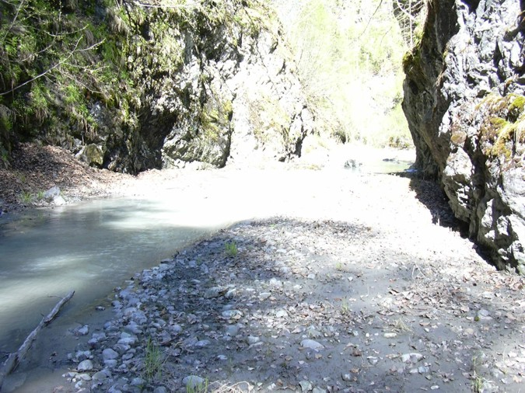
Reach 6-Segment 39 / upstream / photo 239 | Reach 6-Segment 39 / downstream / photo 241
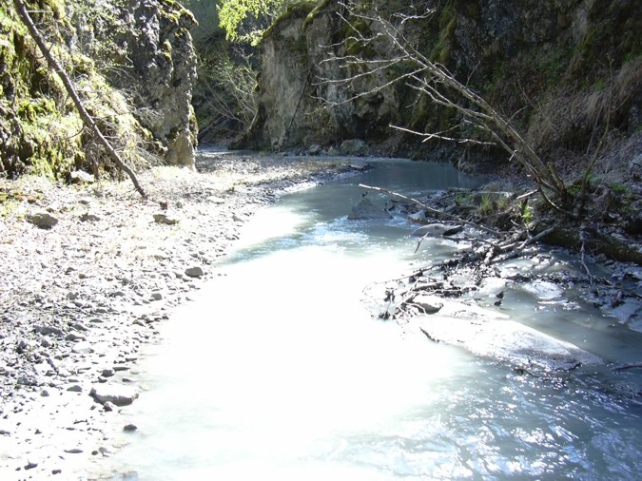 | 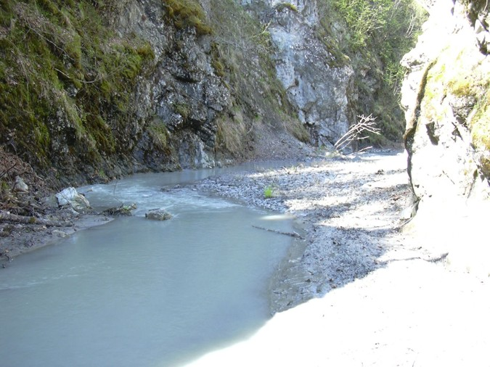
Reach 6-Segment 40 / upstream / photo 242 | Reach 6-Segment 40 / downstream / photo 243
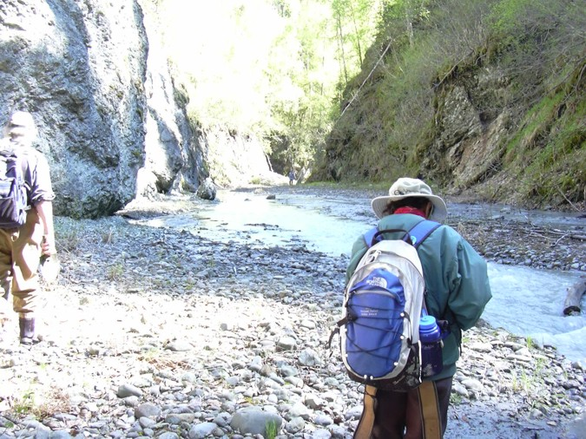 | 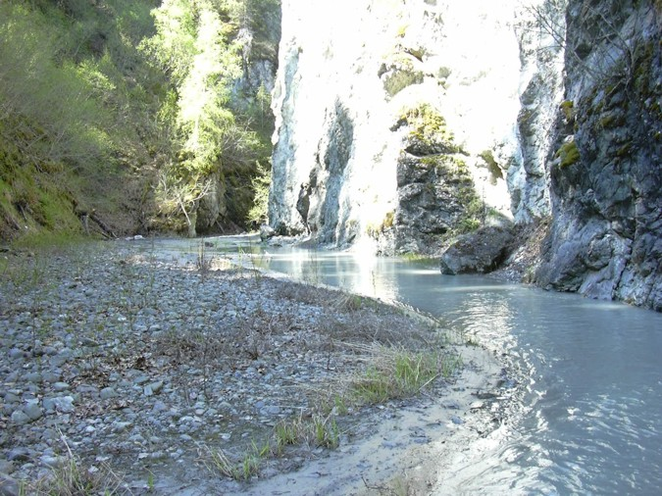
Reach 6-Segment 41 / upstream / photo 244 | Reach 6-Segment 41 / downstream / photo 247
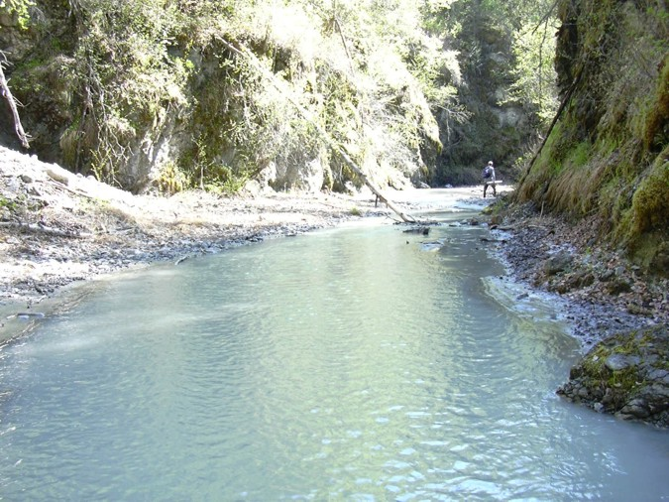 | 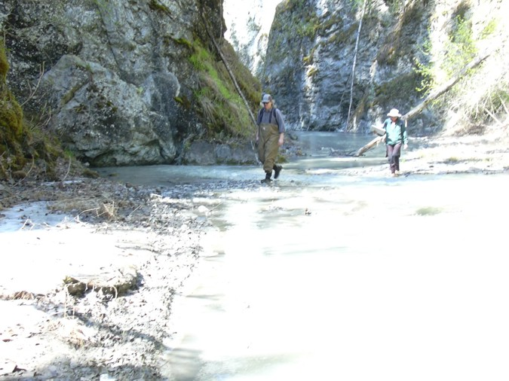
Reach 6-Segment 42 / upstream / photo 248 | Reach 6-Segment 42 / downstream / photo 249
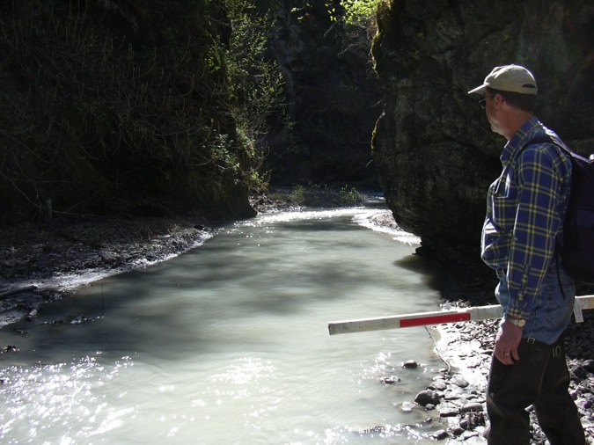 | 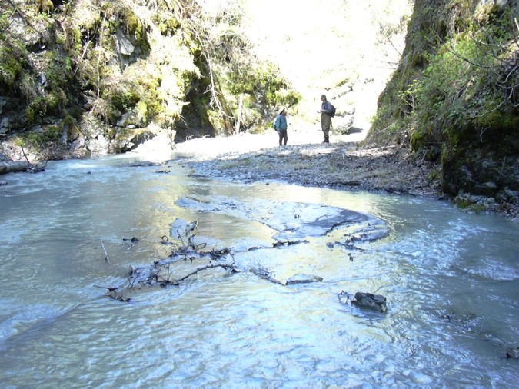
Reach 6-Segment 43 / upstream / photo 252 | Reach 6-Segment 43 / downstream / photo 253
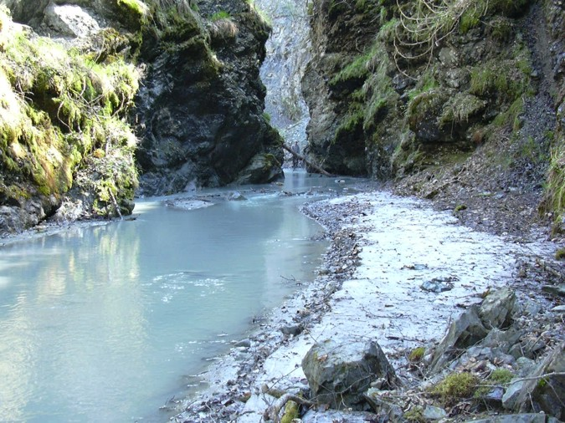 | 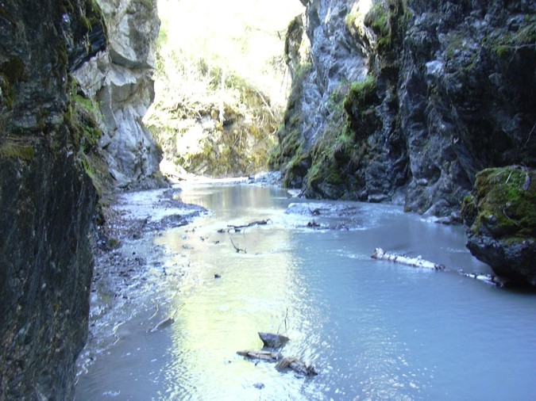
Reach 6-Segment 44 / upstream / photo 254 | Reach 6-Segment 44 / downstream / photo 256
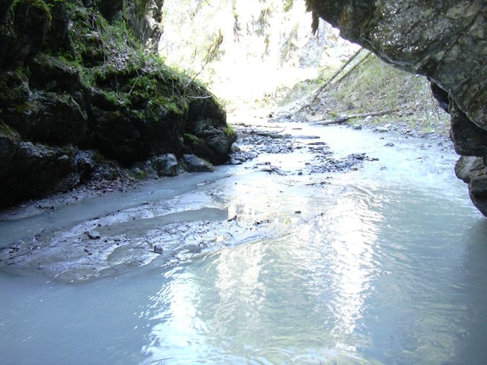 | 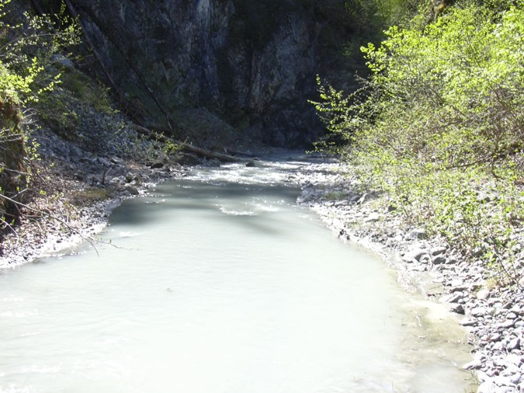
Reach 6-Segment 45 / upstream / photo 257 | Reach 6-Segment 45 / downstream / photo 258
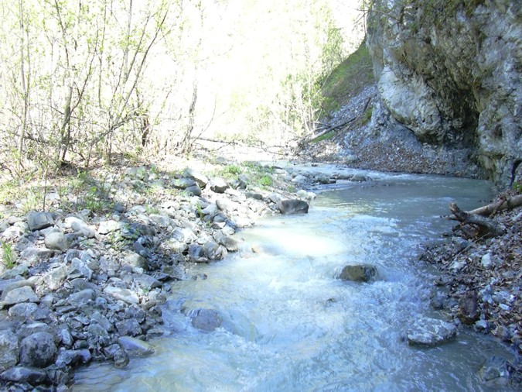 | 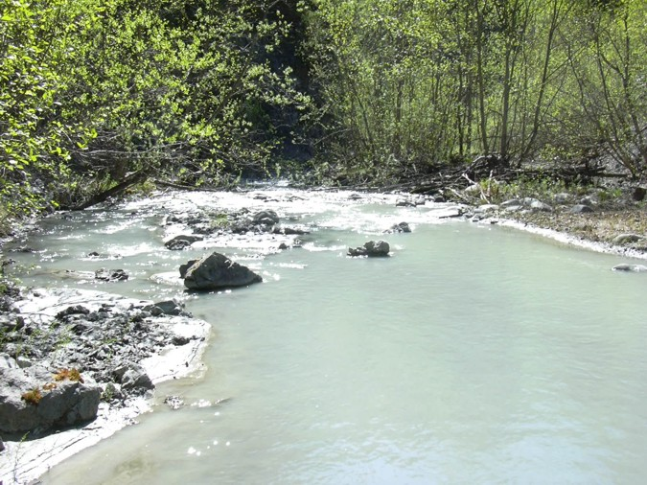
Reach 6-Segment 46 / upstream / photo 259 | Reach 6-Segment 46 / downstream / photo 260
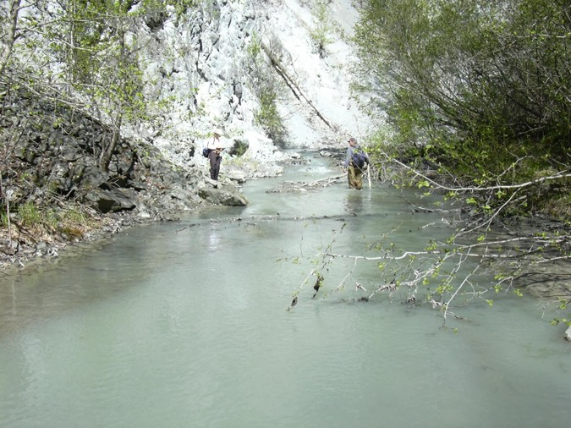 | 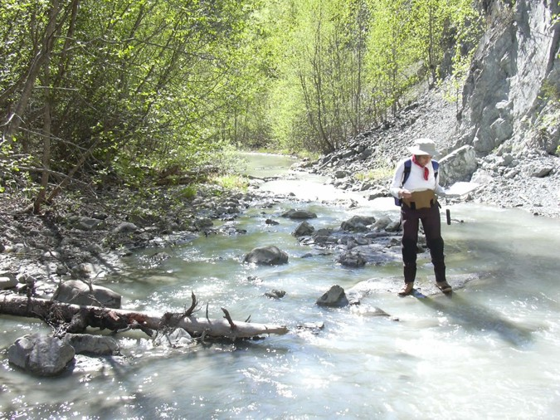
Reach 6-Segment 47 / upstream / photo 261 | Reach 6-Segment 47/ downstream / photo 262
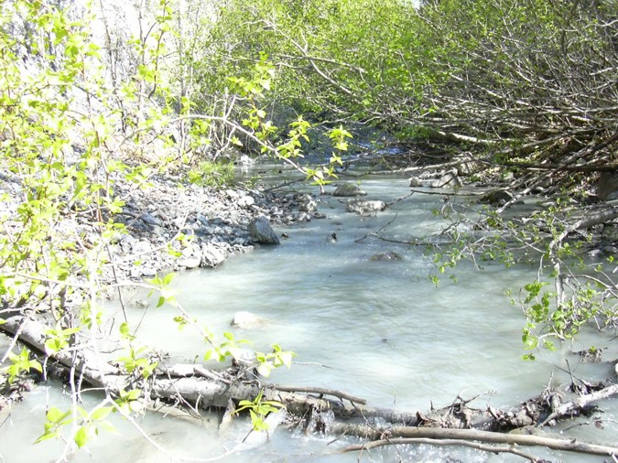 | 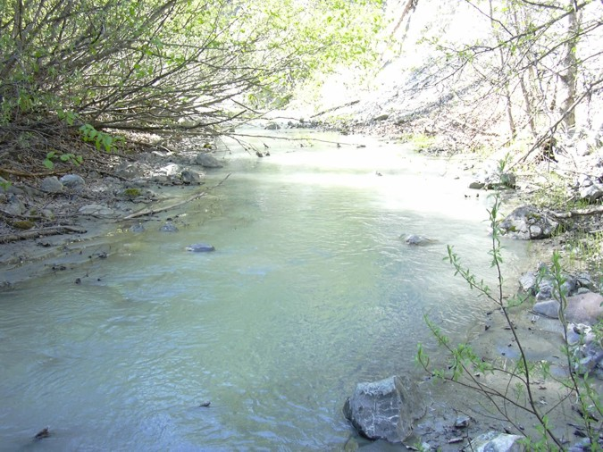
Reach 6-Segment 48 / upstream / photo 263 | Reach 6-Segment 48 / downstream / photo 266
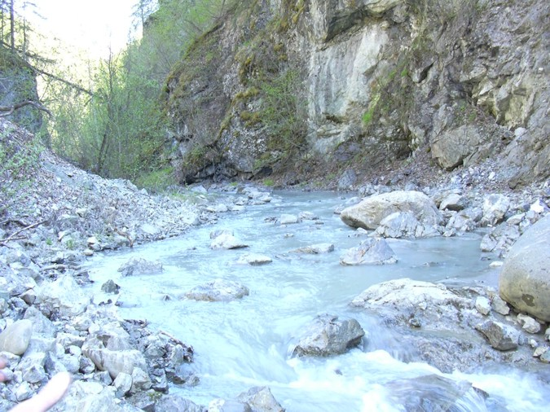 | 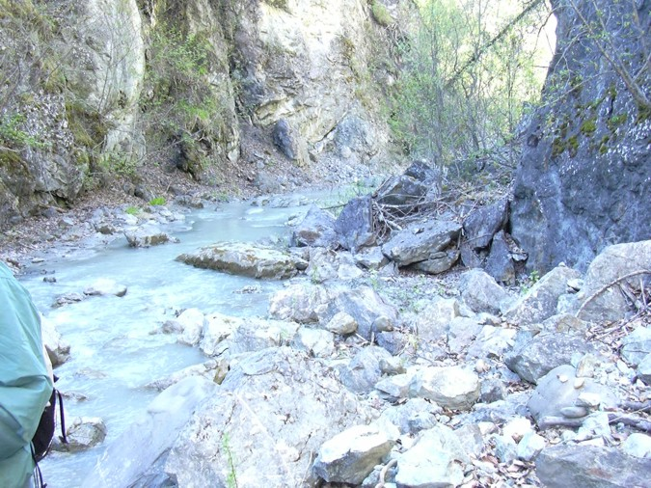
Reach 6-Segment 49 / upstream / photo 267 | Reach 6-Segment 49 / downstream / photo 269
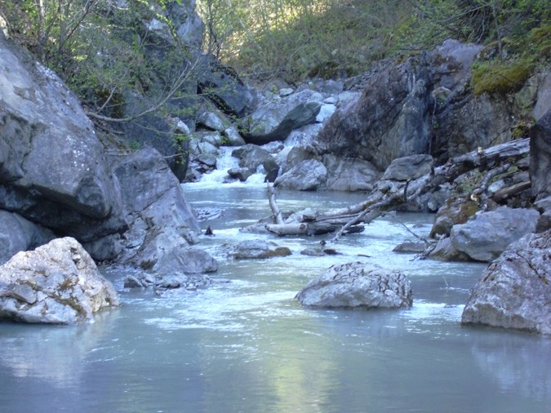 | 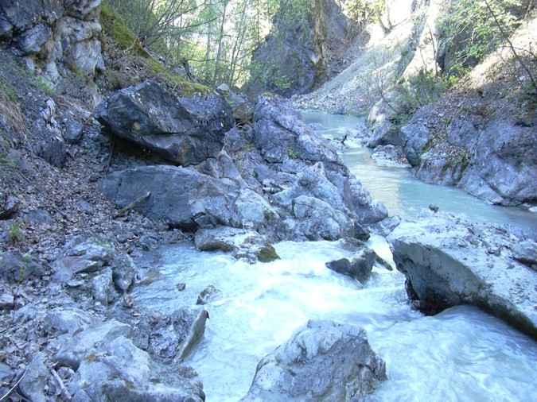
Reach 6-Segment 50 / upstream / photo 268 | Reach 6-Segment 50 / downstream / photo 275
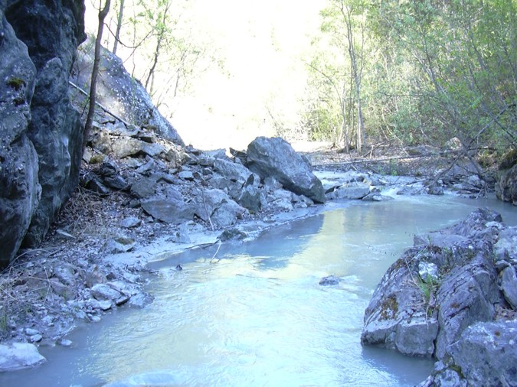 | 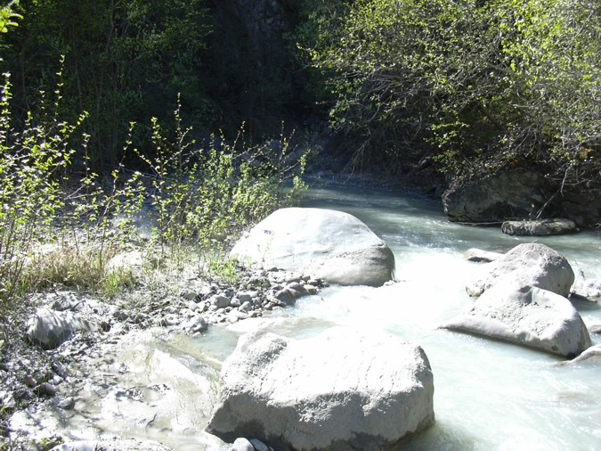
Reach 6-Segment 51 / upstream / photo 276 | Reach 6-Segment 51 / downstream / photo 277
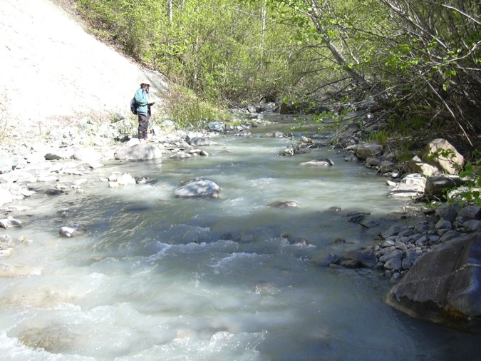 | 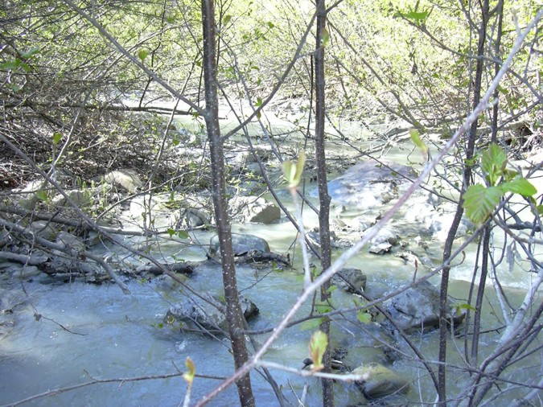
Reach 6-Segment 52 / upstream / photo 278 | Reach 6-Segment 52 / downstream / photo 281
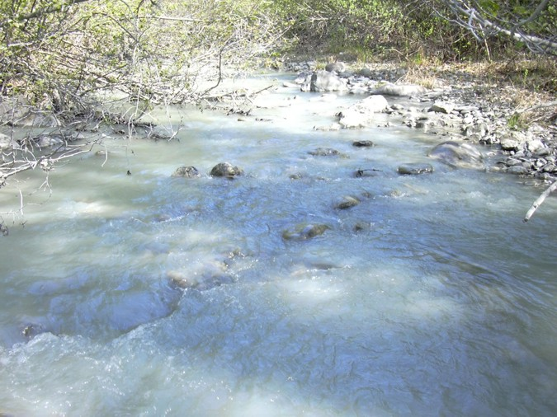
Reach 6-Segment 53 / upstream / photo 280
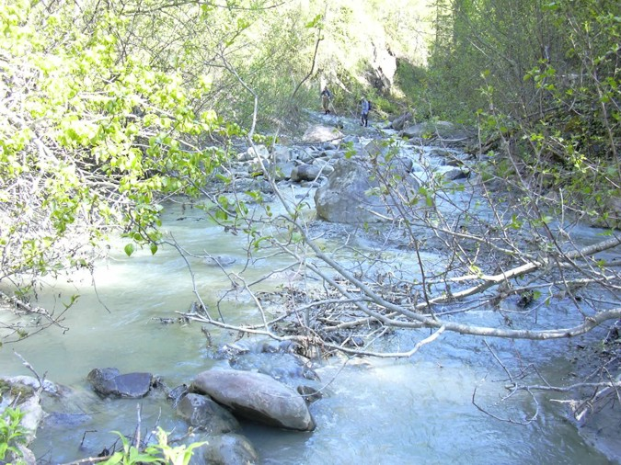 | 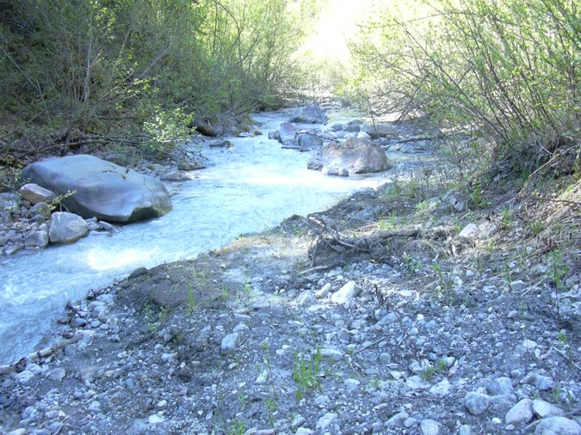
Reach 6-Segment 54 / upstream / photo 282 | Reach 6-Segment 54 / downstream / photo 283
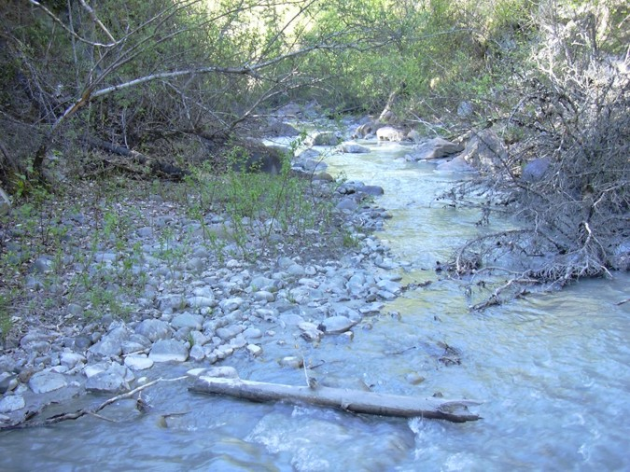 | 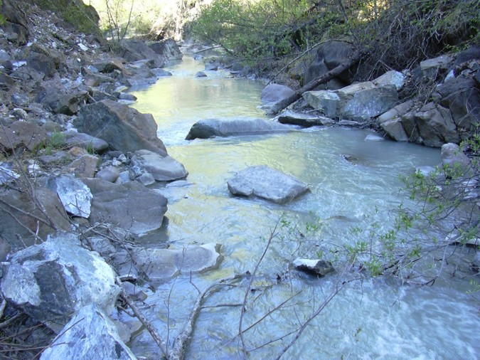
Reach 6-Segment 55 / upstream / photo 287 | Reach 6-Segment 55 / downstream / photo 285
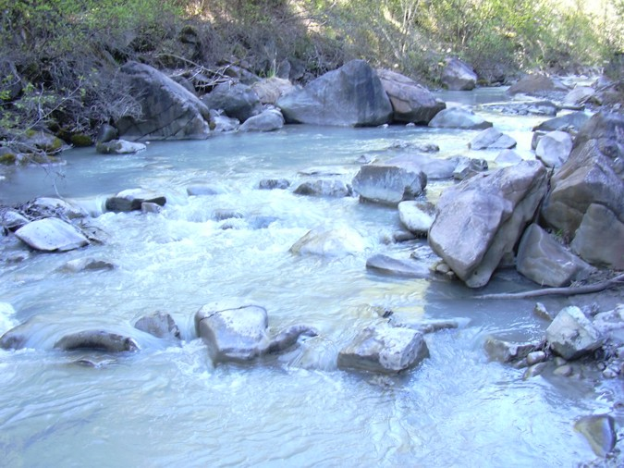
Reach 6-Segment 56 / upstream / photo 286 | Reach 6-Segment 56 / downstream / photo 287
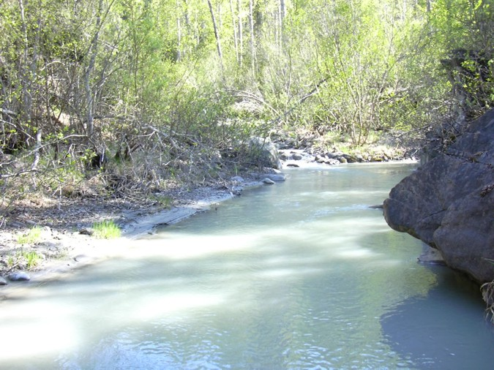 | 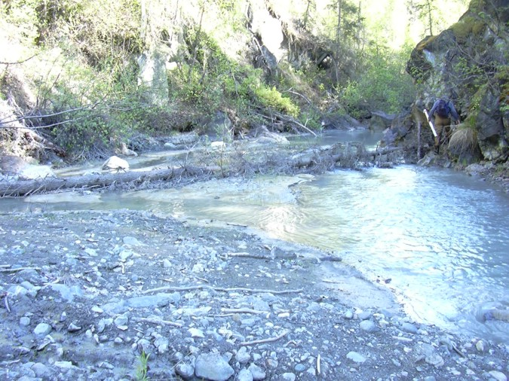
Reach 6-Segment 57 / upstream / photo 288 | Reach 6-Segment 57 / downstream / photo 284
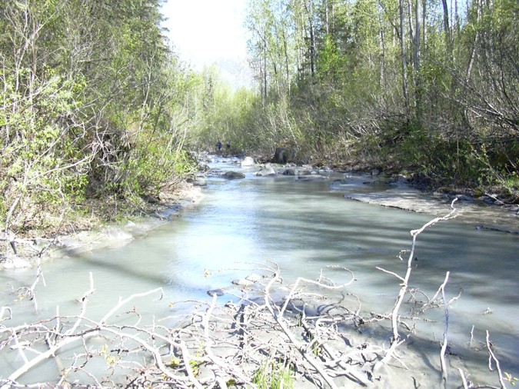 | 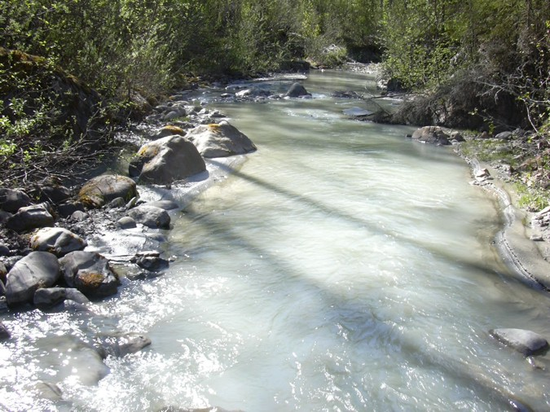
Reach 6-Segment 58 / upstream / photo 291 | Reach 6-Segment 58 / downstream / photo 292
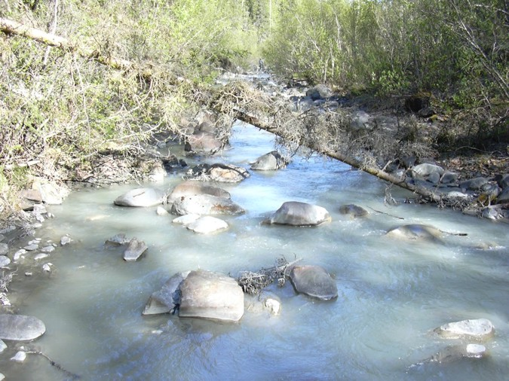 | 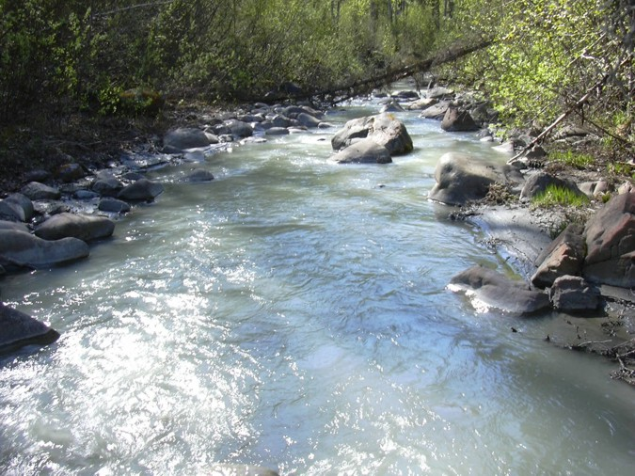
Reach 6-Segment 59 / upstream / photo 293 | Reach 6-Segment 59 / downstream / photo 294
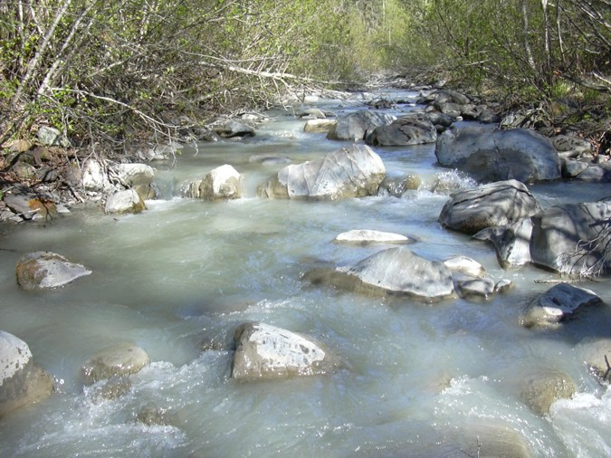
Reach 6-Segment 60 / upstream / photo 295

