REACH 4: Segment 1 to Segment 12.
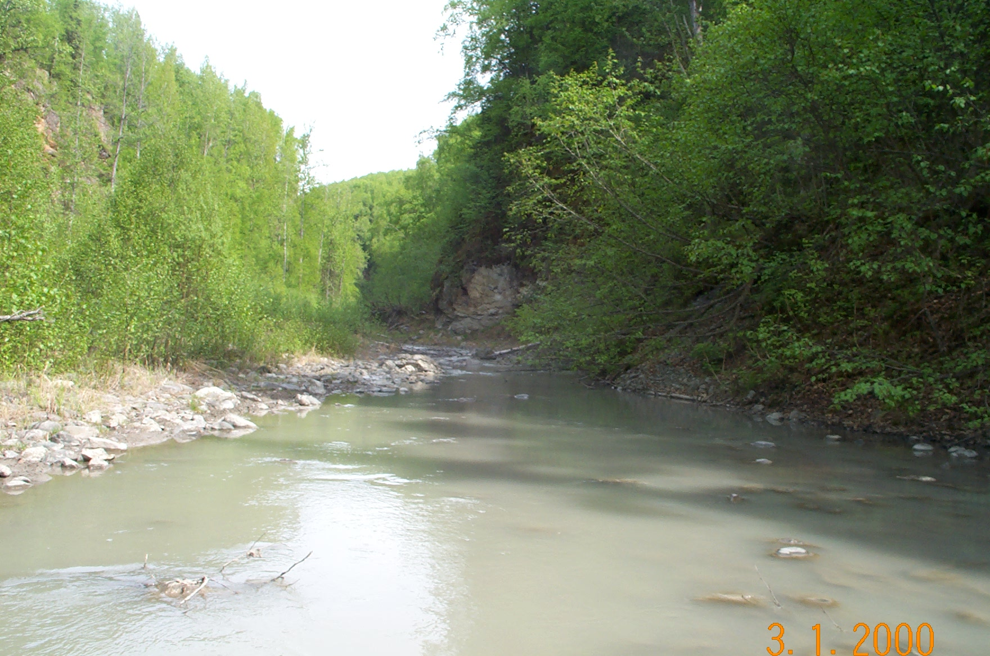 | 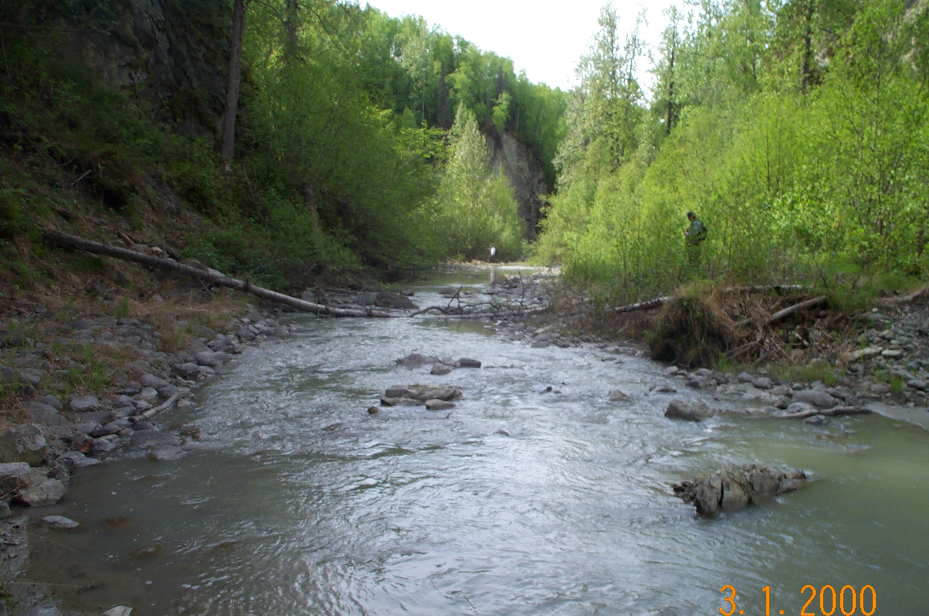
Reach 4- Segment 1/ upstream / photo 1114 | Reach 4-Segment 1/ downstream / photo 1113
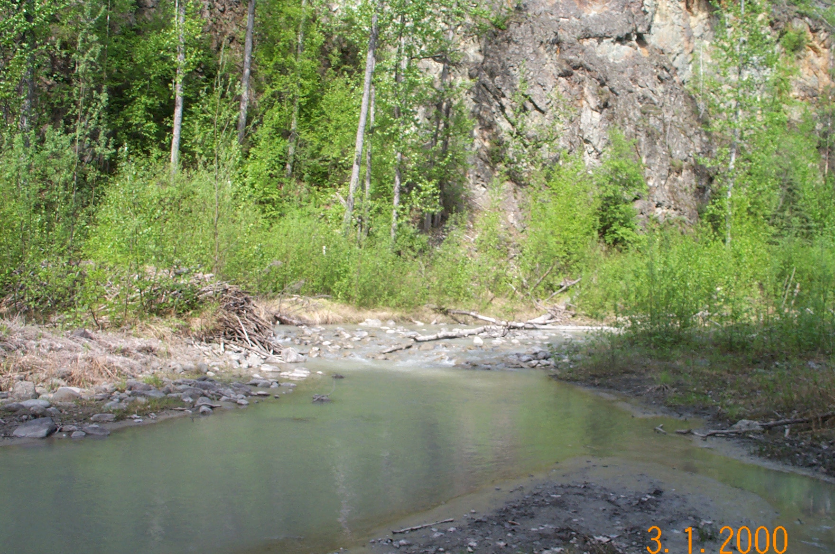
Reach 4-Segment 2/ upstream / photo 1112
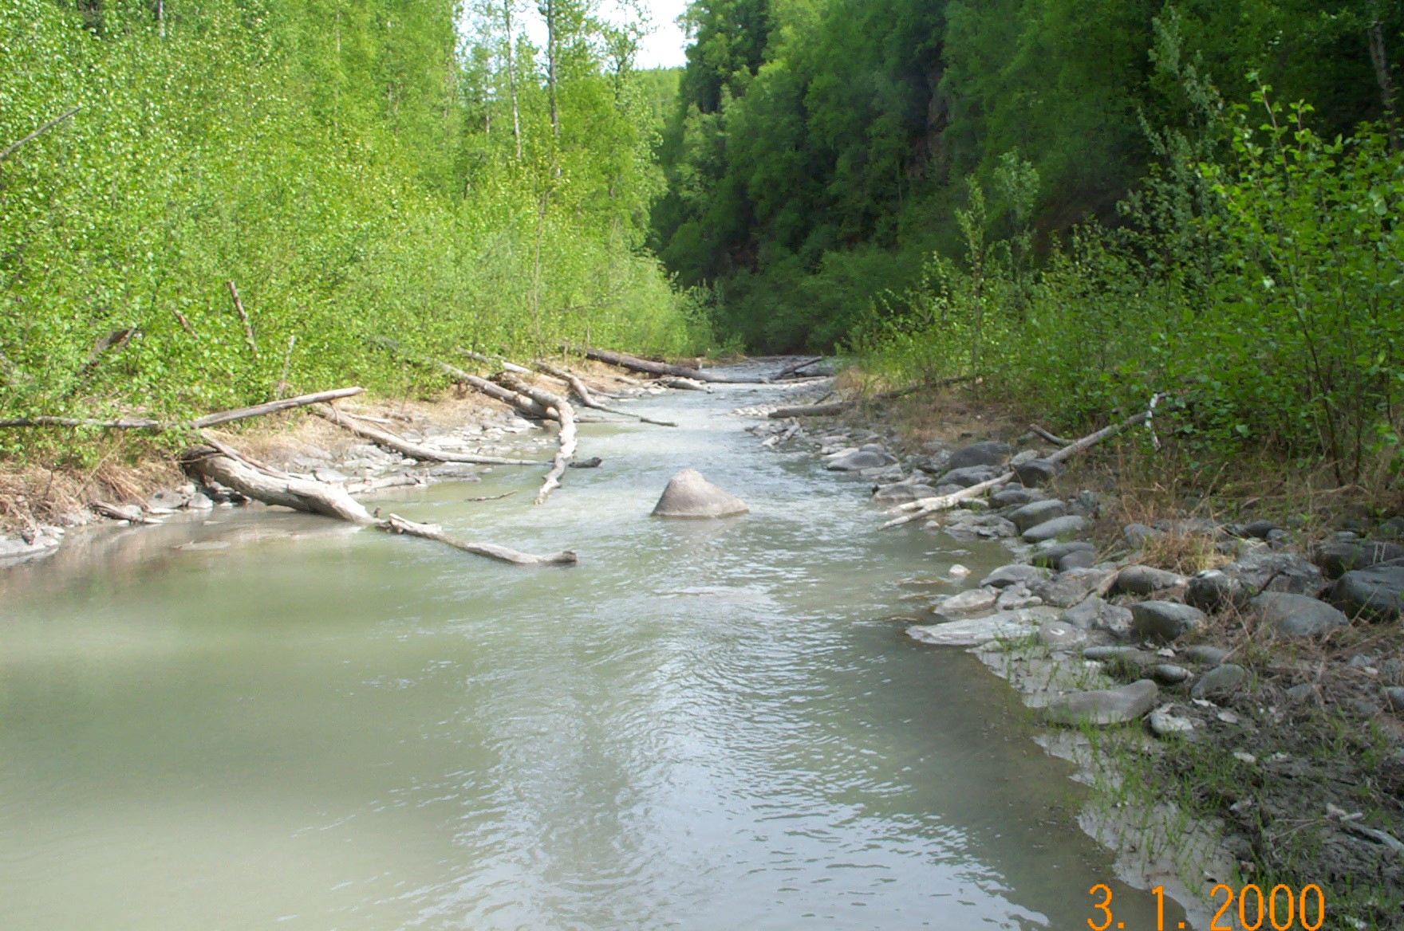 | 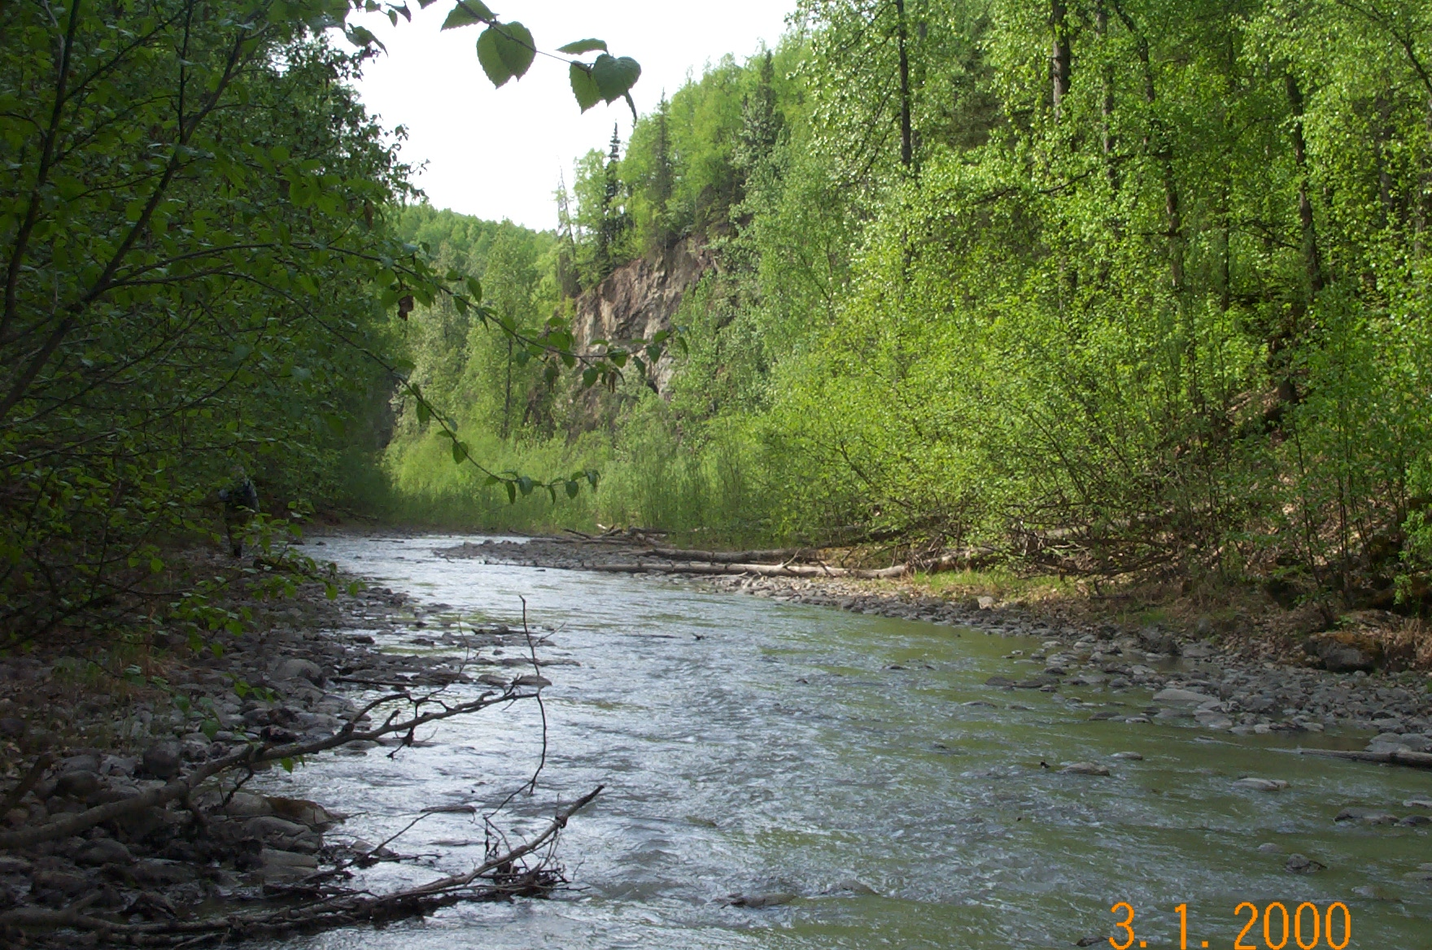
Reach 4-Segment 3/ upstream / photo 1110 | Reach 4-Segment 3/ downstream / photo 1108
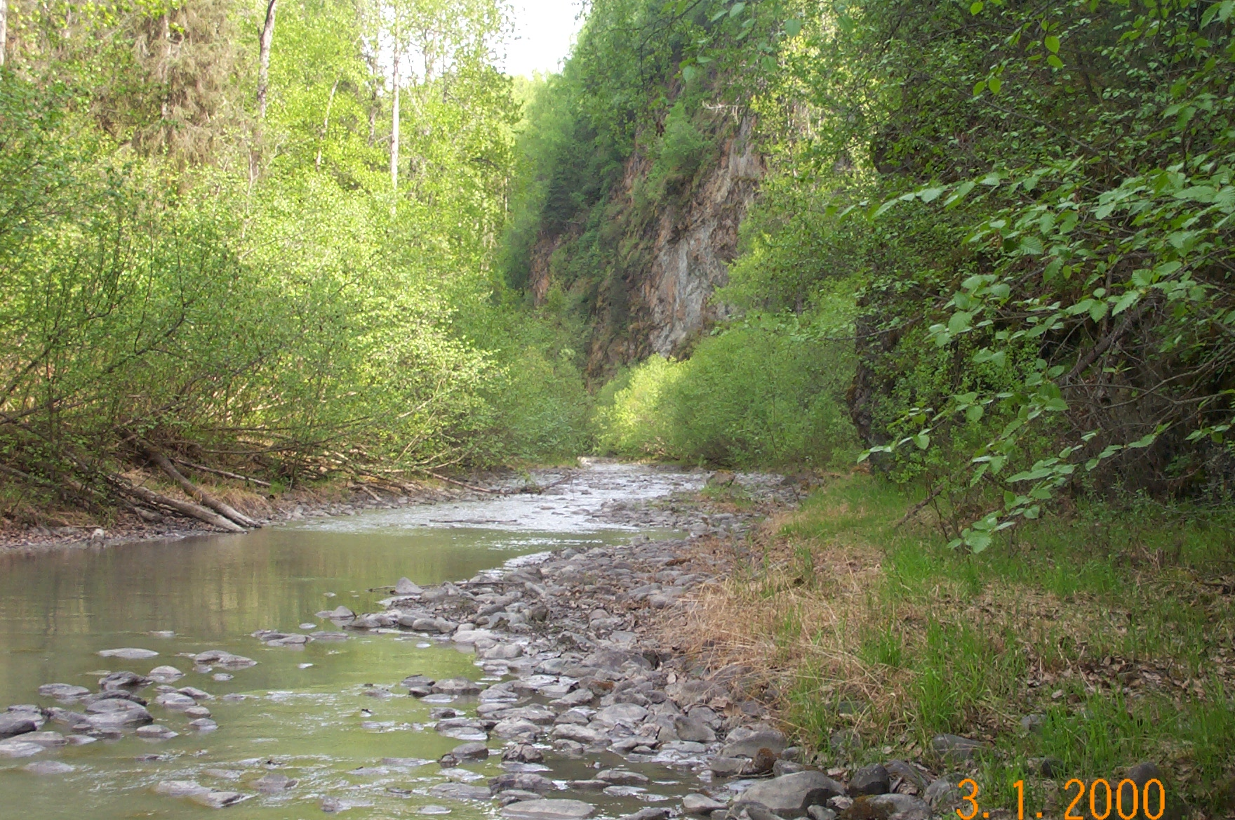 | 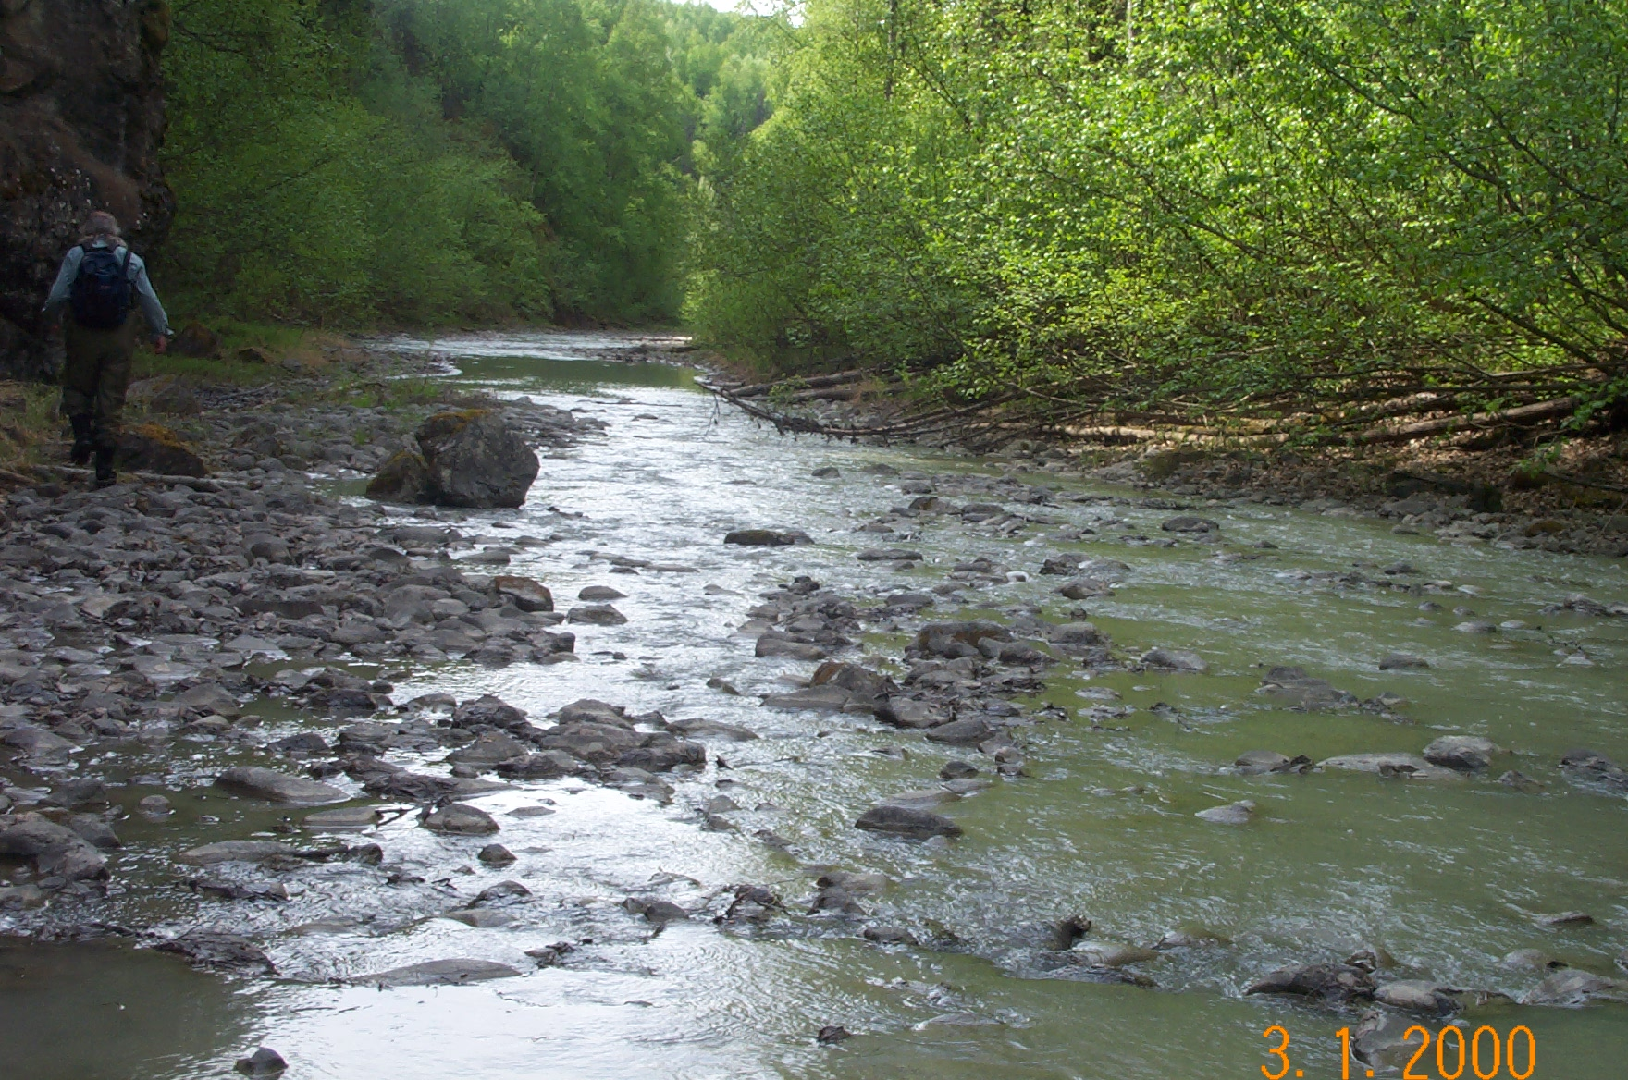
Reach 4-Segment 4/ upstream / photo 1109 | Reach 4-Segment 4/ downstream / photo 1107
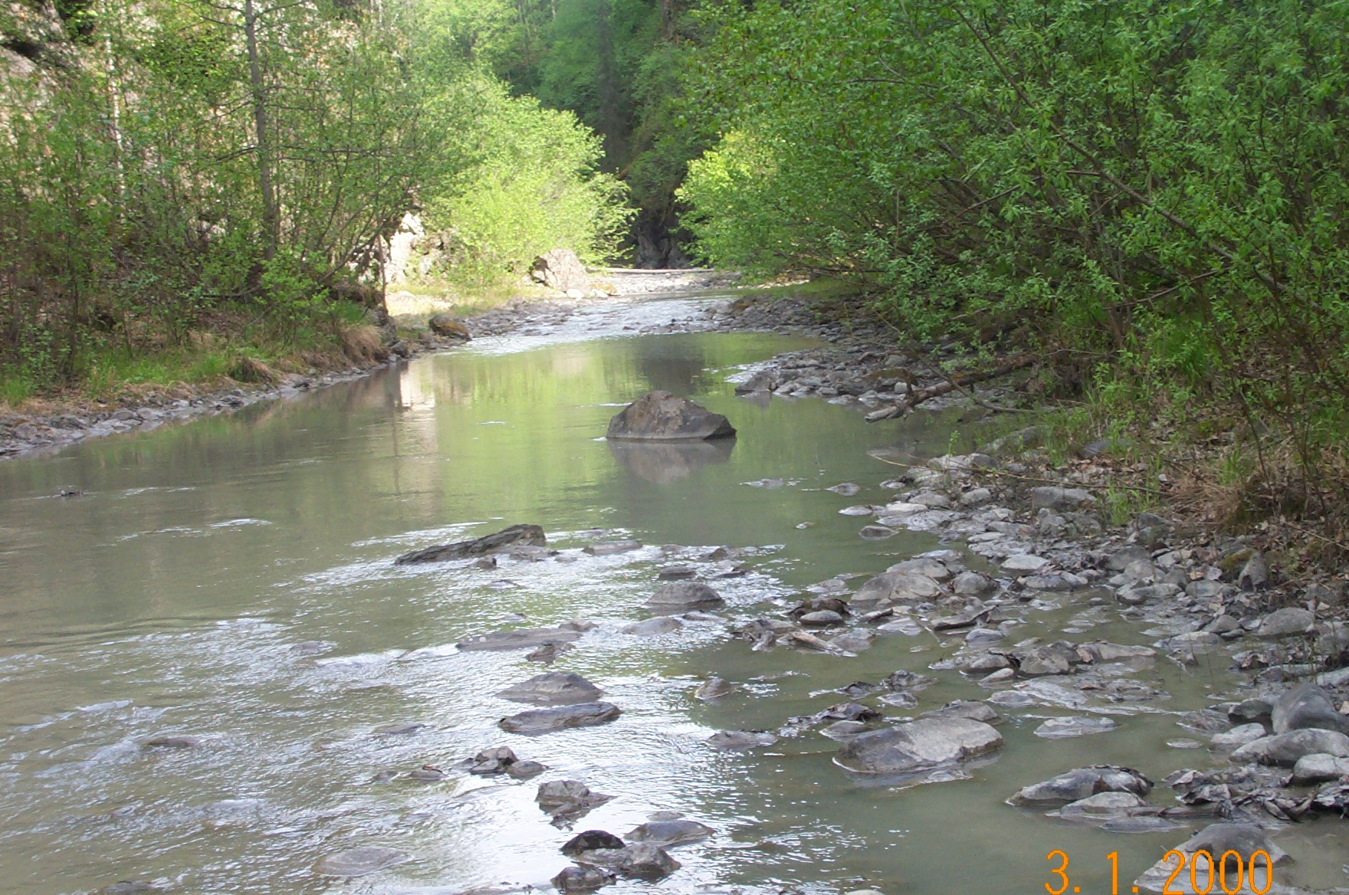 | 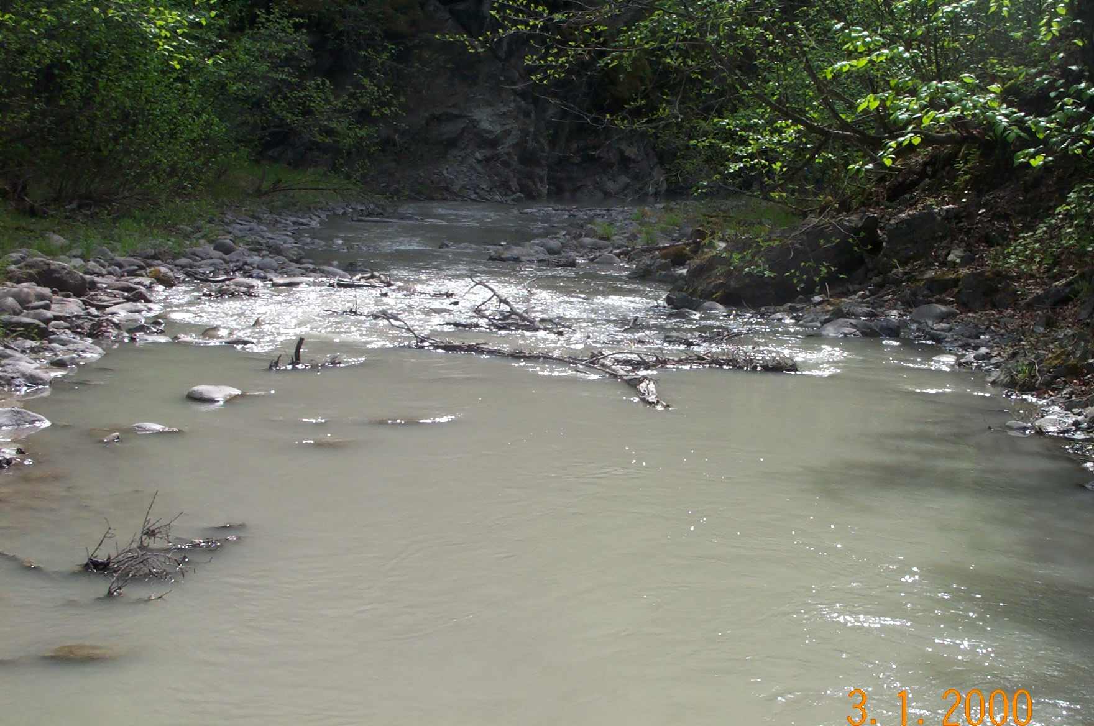
Reach 4-Segment 5/ upstream / photo 1106 | Reach 4-Segment 5/ downstream / photo 1103
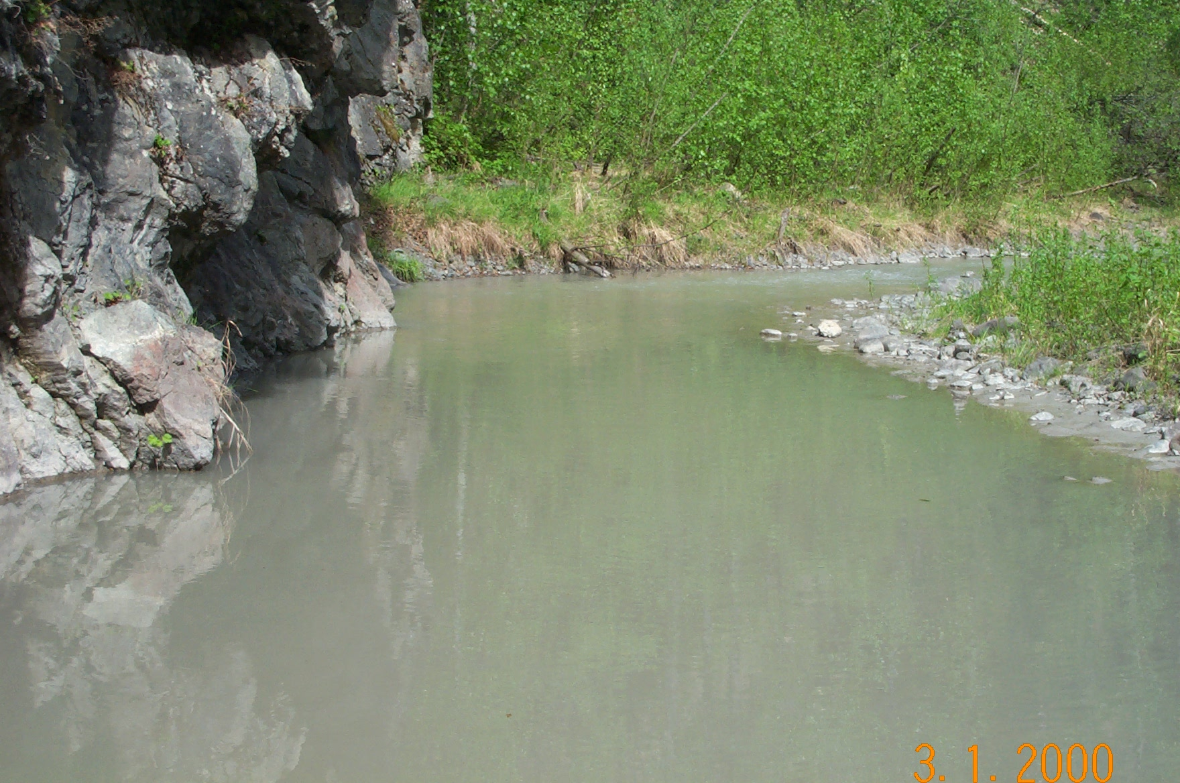 | 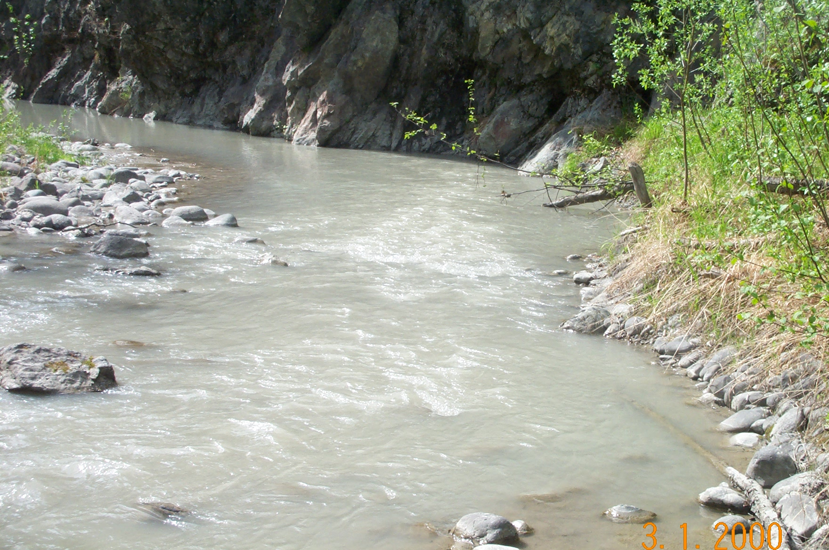
Reach 4-Segment 6/ upstream / photo 1102 | Reach 4-Segment 6/ downstream / photo 1098
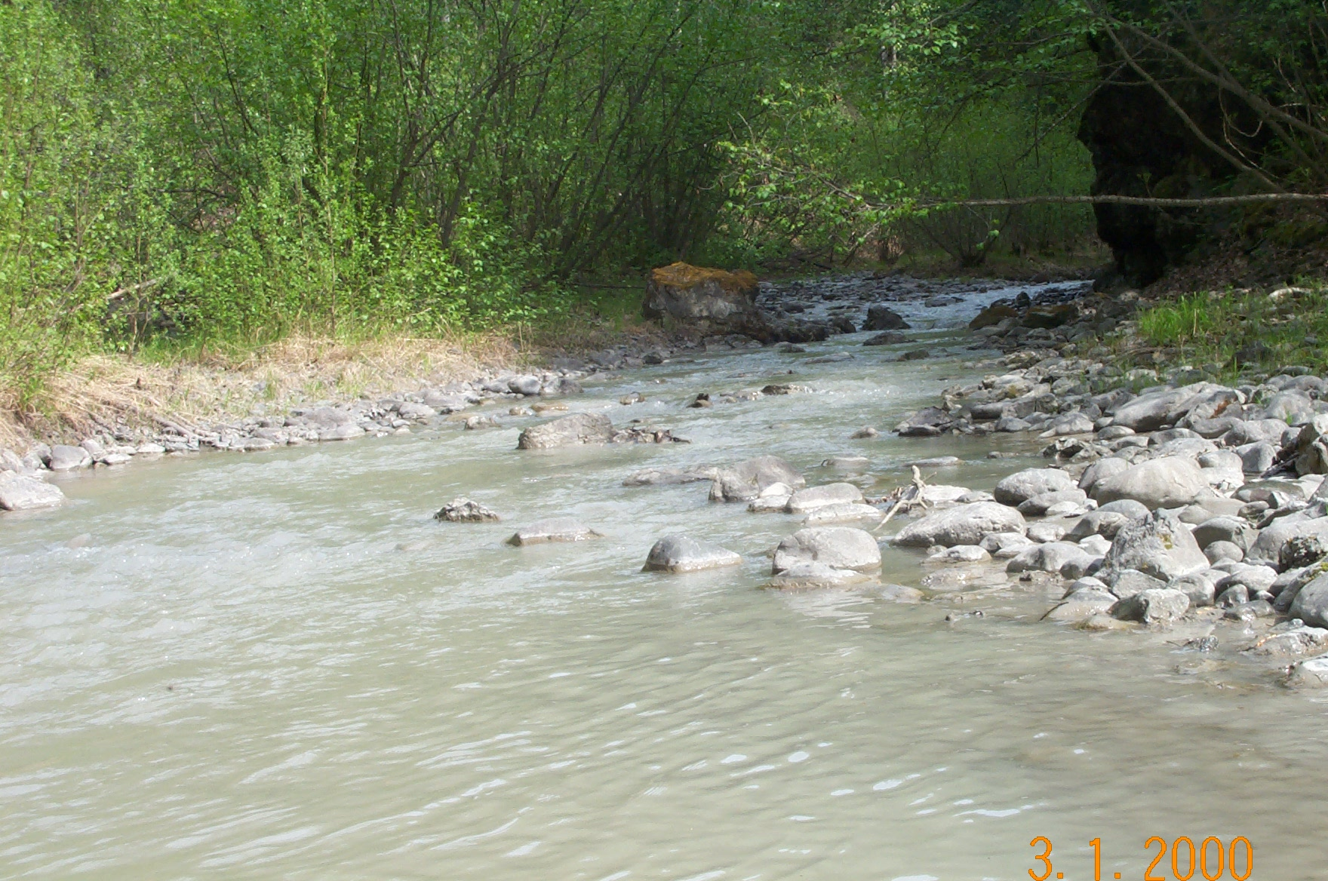 | 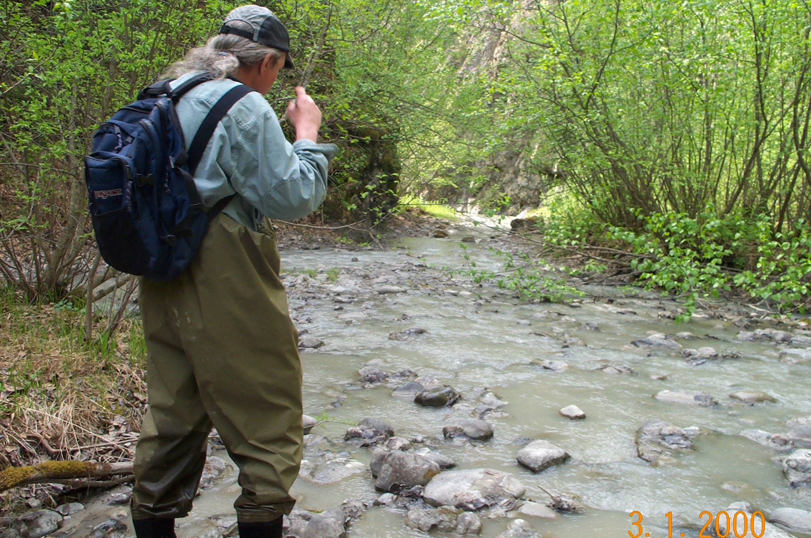
Reach 4-Segment 7/ upstream / photo 1100 | Reach 4-Segment 7/ downstream / photo 1097
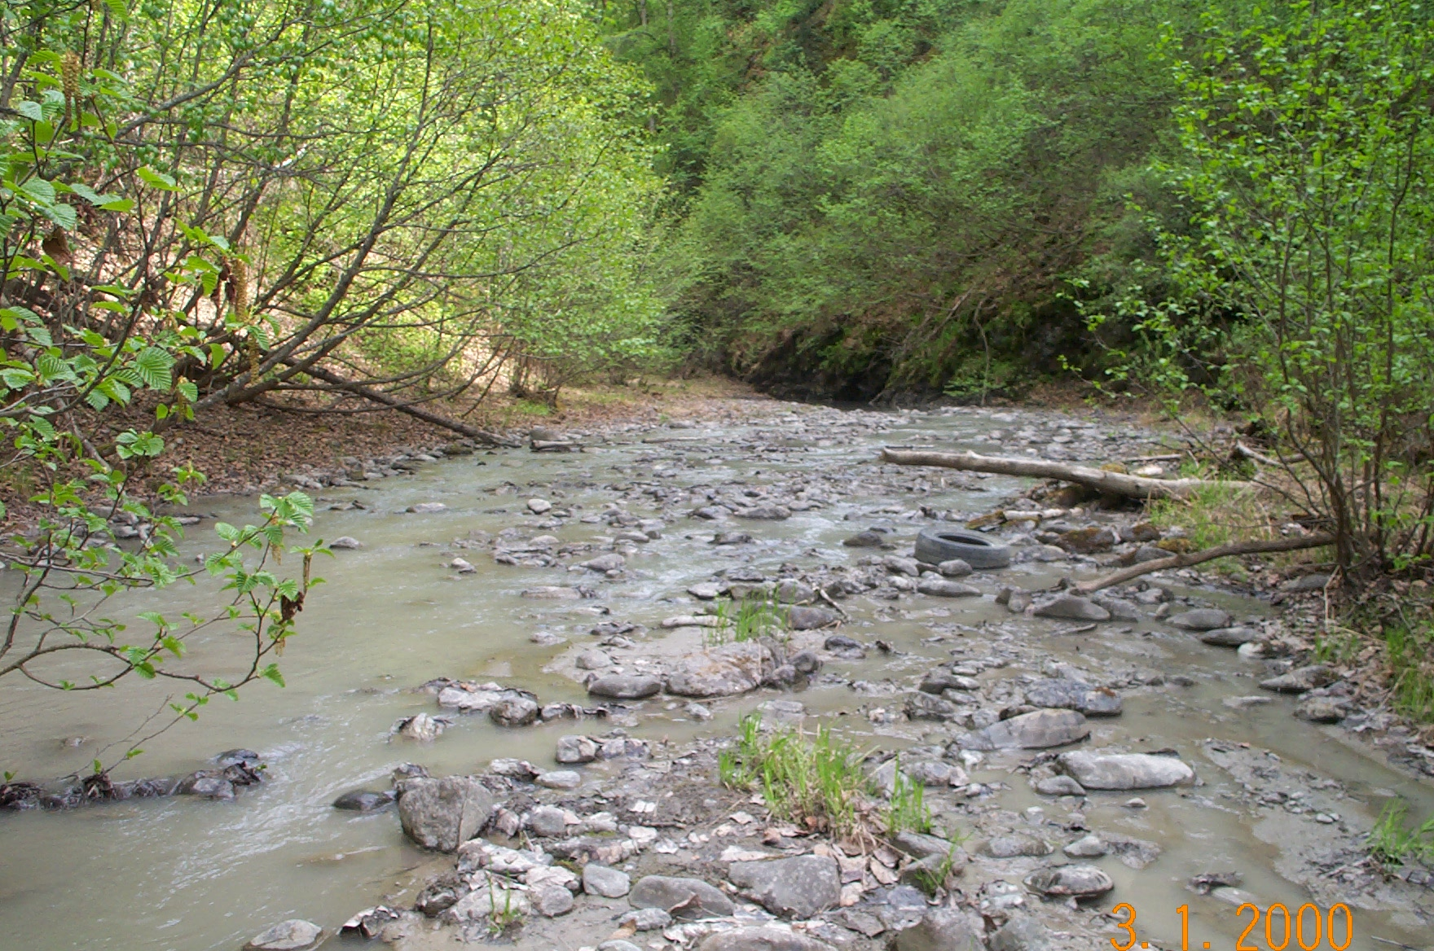
Reach 4-Segment 8/ upstream / photo 1096
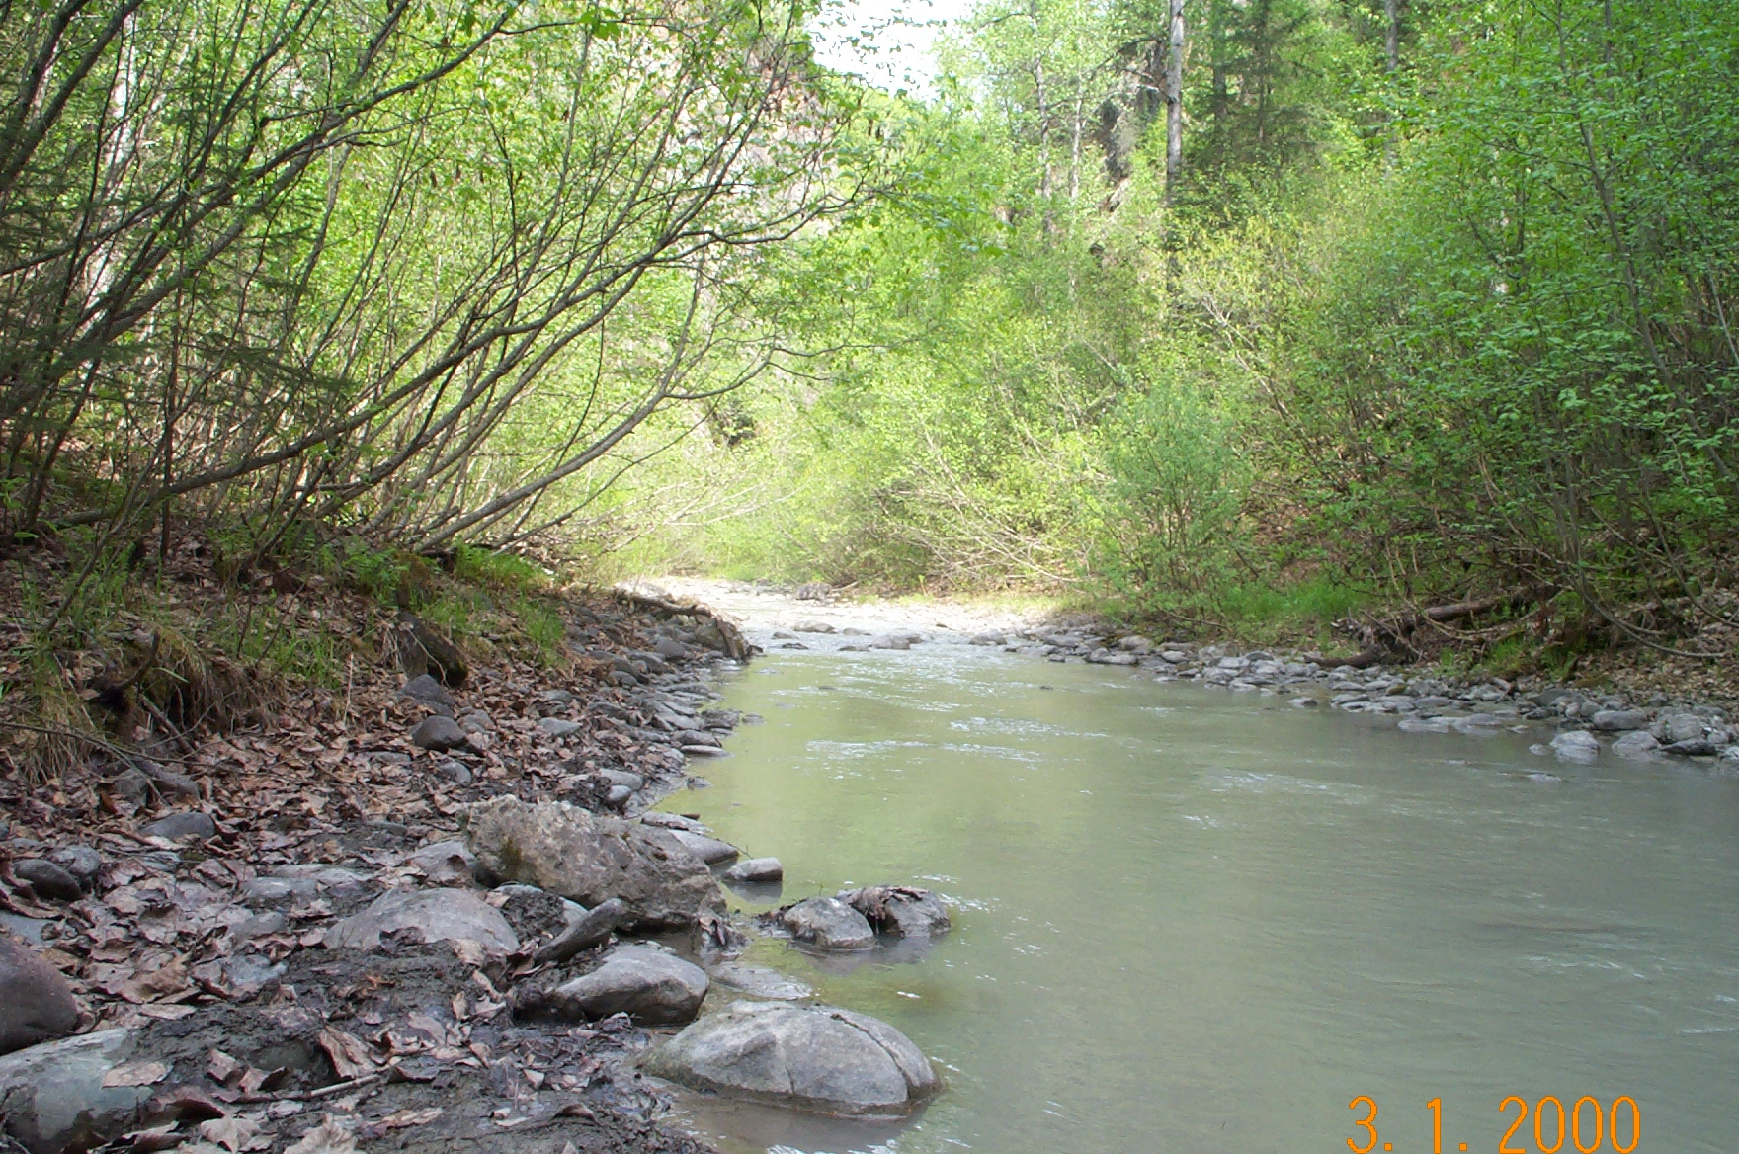 | 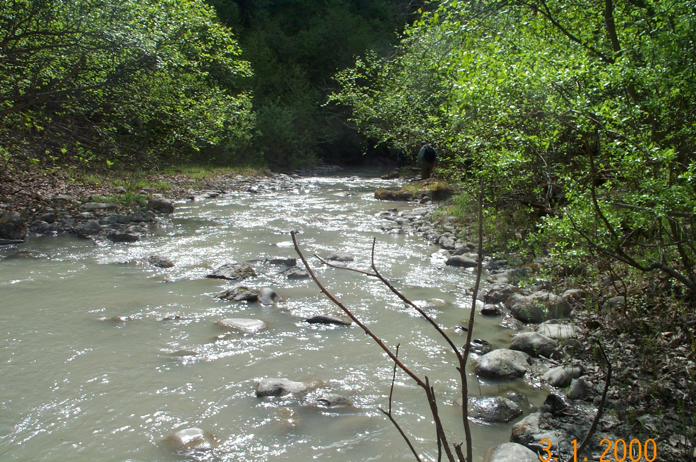
Reach 4-Segment 9/ upstream / photo 1095 | Reach 4-Segment 9/ downstream / photo 1094
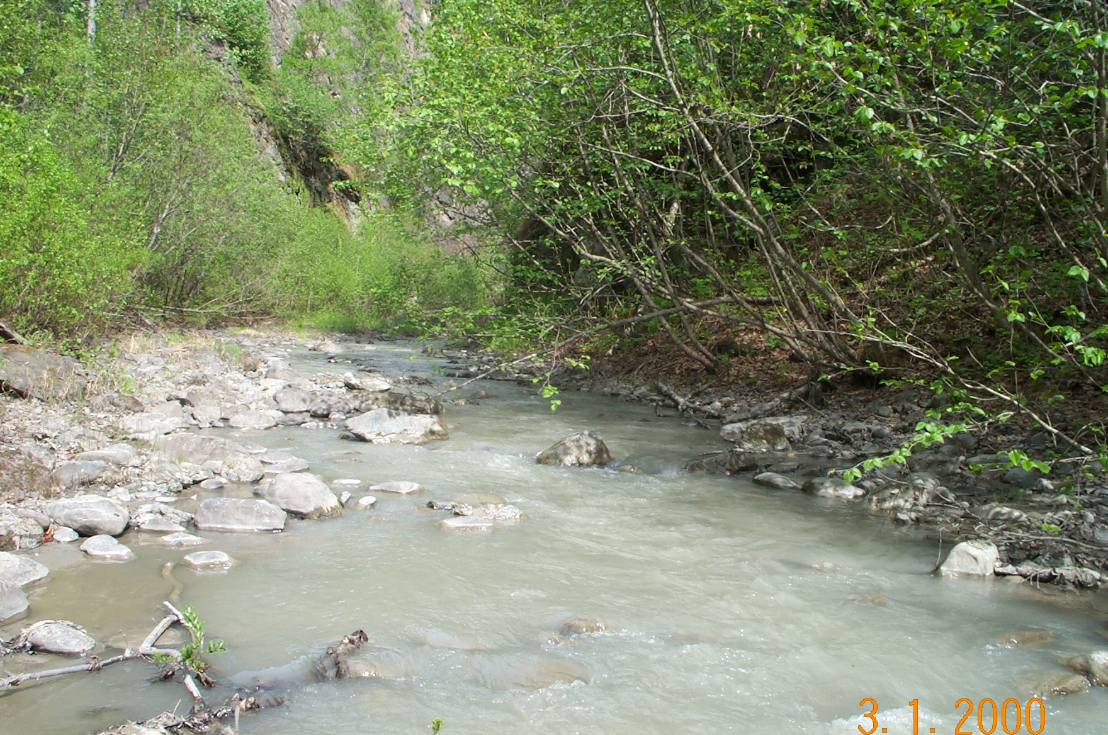 | 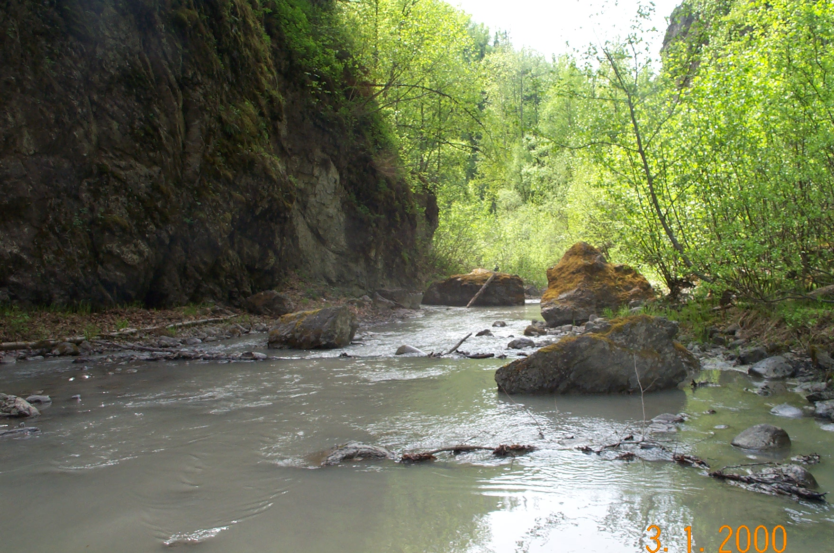
Reach 4-Segment 10/ upstream / photo 1093 | Reach 4-Segment 10/ downstream / photo 1092
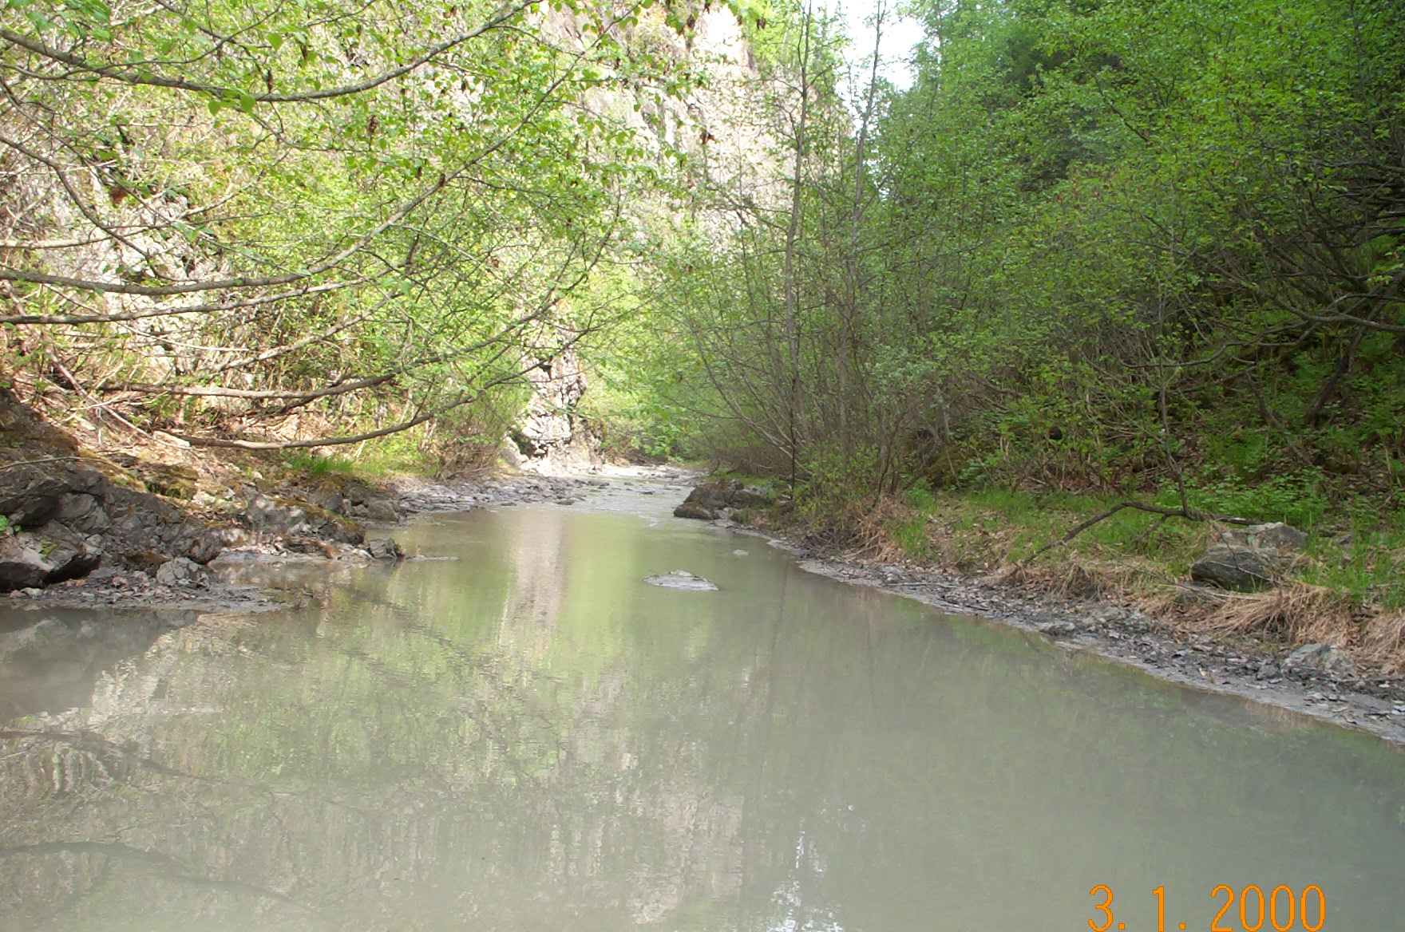 | 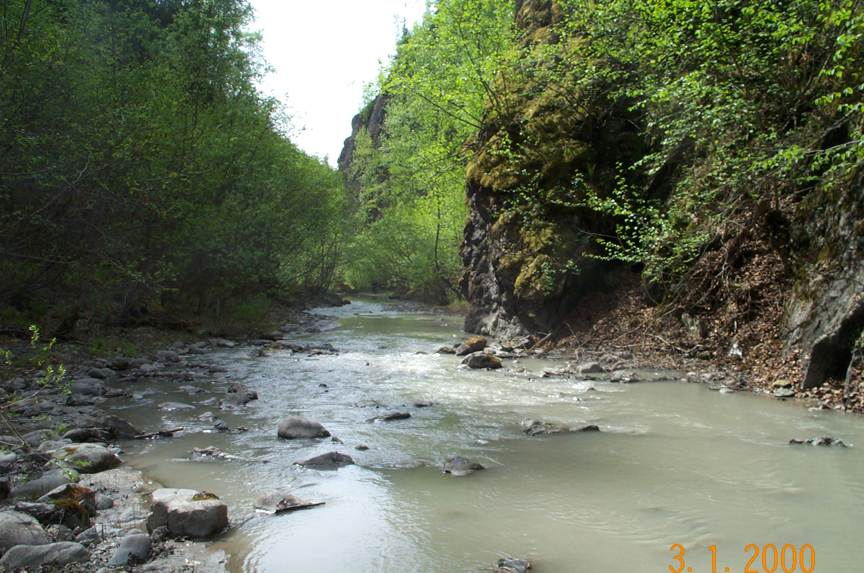
Reach 4-Segment 11/ upstream / photo 1091 | Reach 4-Segment 11/ downstream / photo 1090
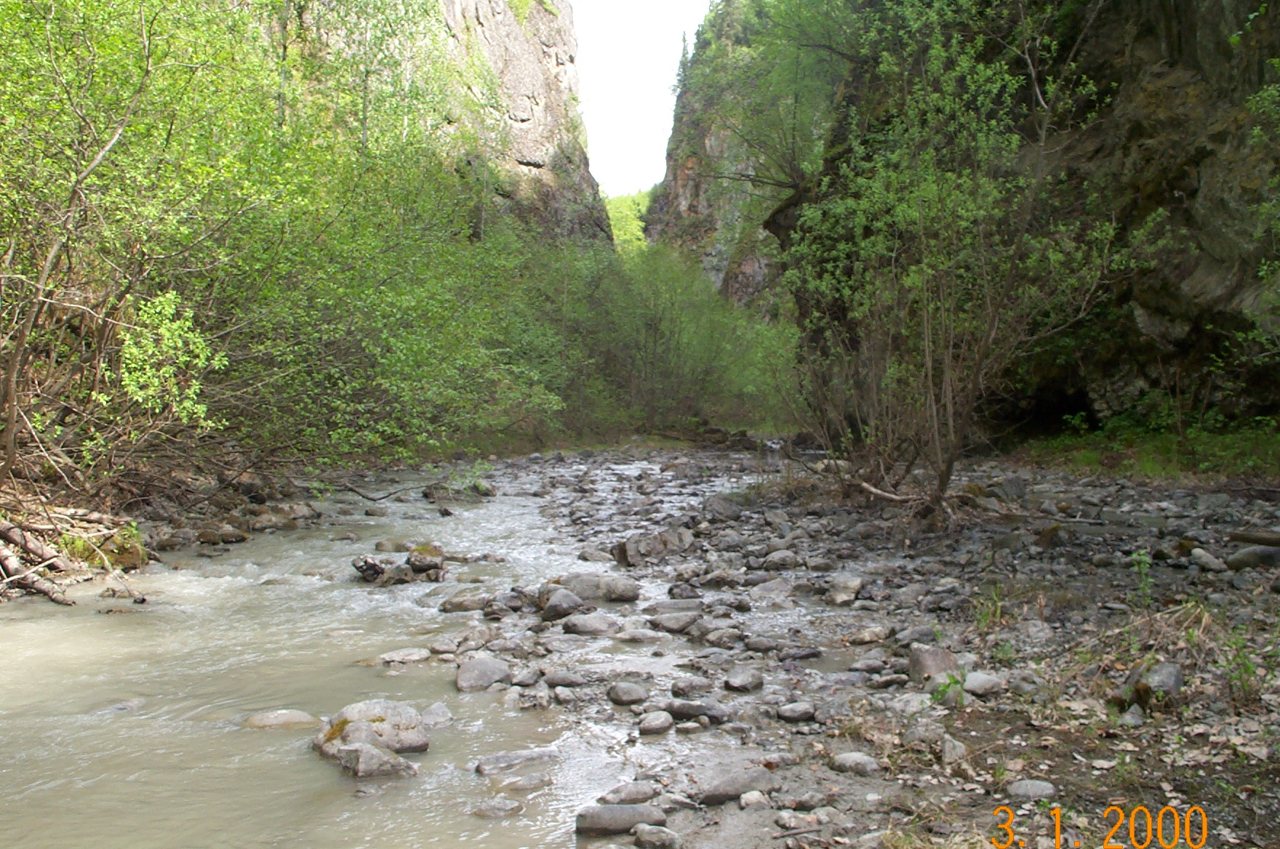
Reach 4-Segment 12/ Upstream / photo 1089
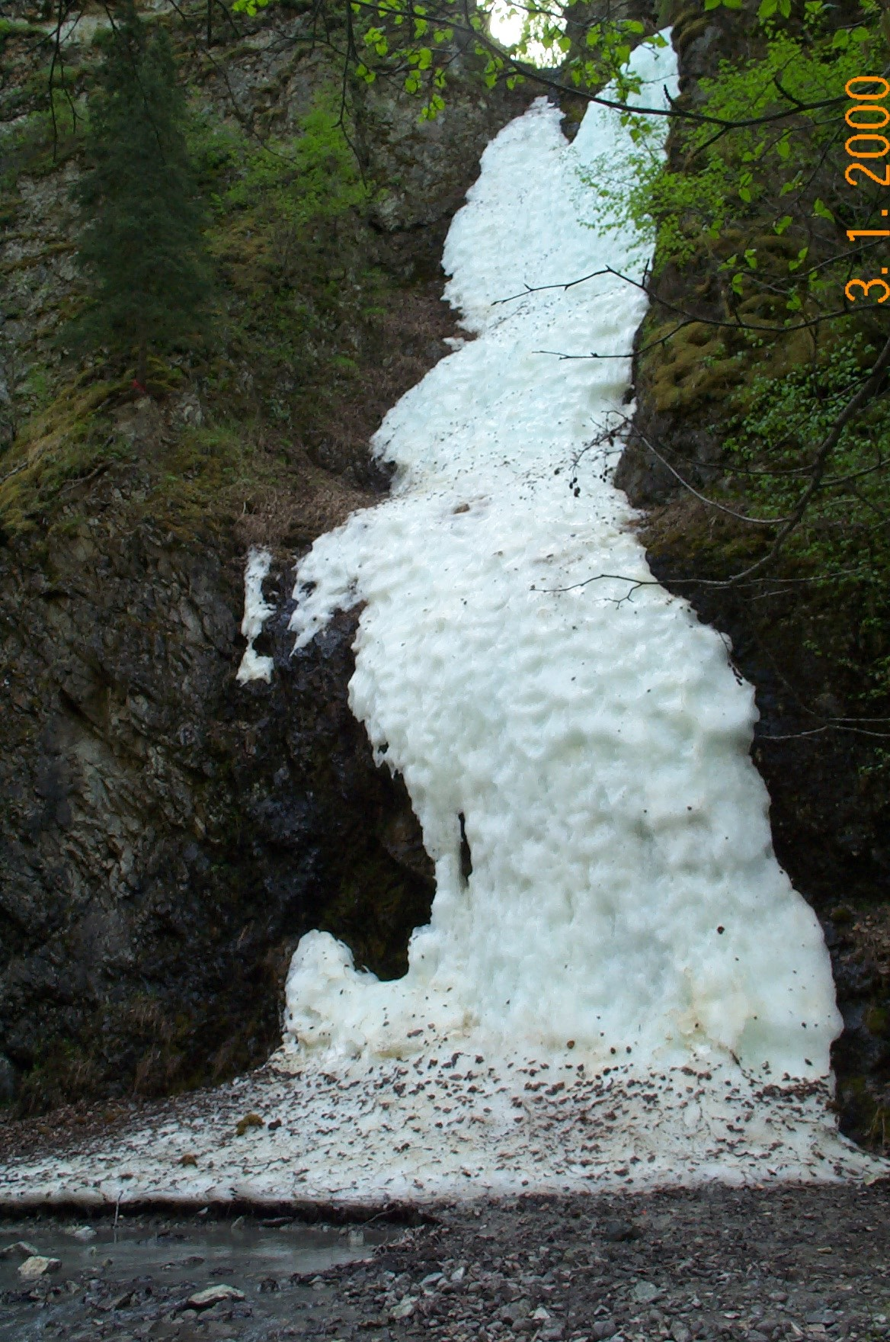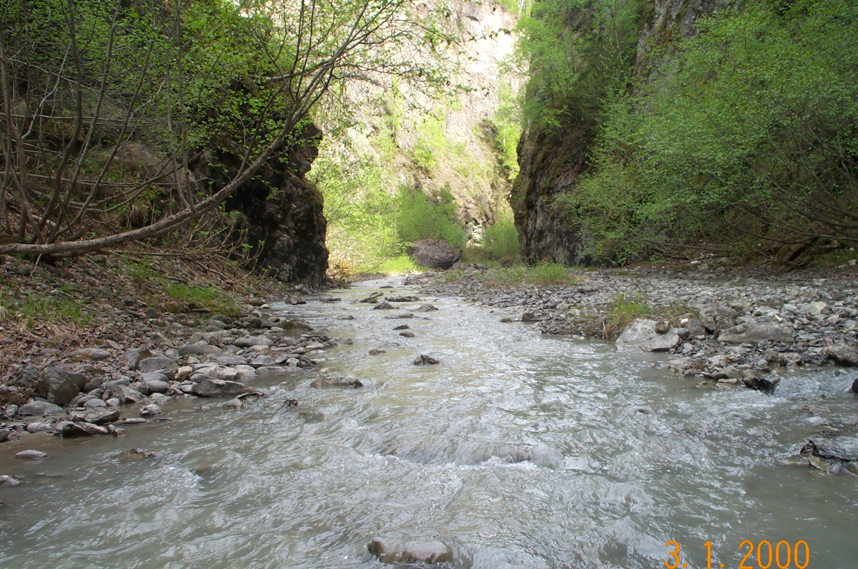
Reach 4-End of Segment 12/ Tributary 2 / photo 1052 | Reach 4-Between Segment 12 and Segment 13 / Upstream / photo 1087
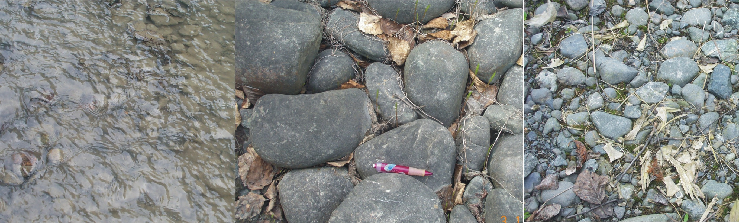

Gravel and cobbles found at the mouth of Tributary 2, between Segment 12 and Segment 13.

REACH 5: Segment 13 to Segment 24.
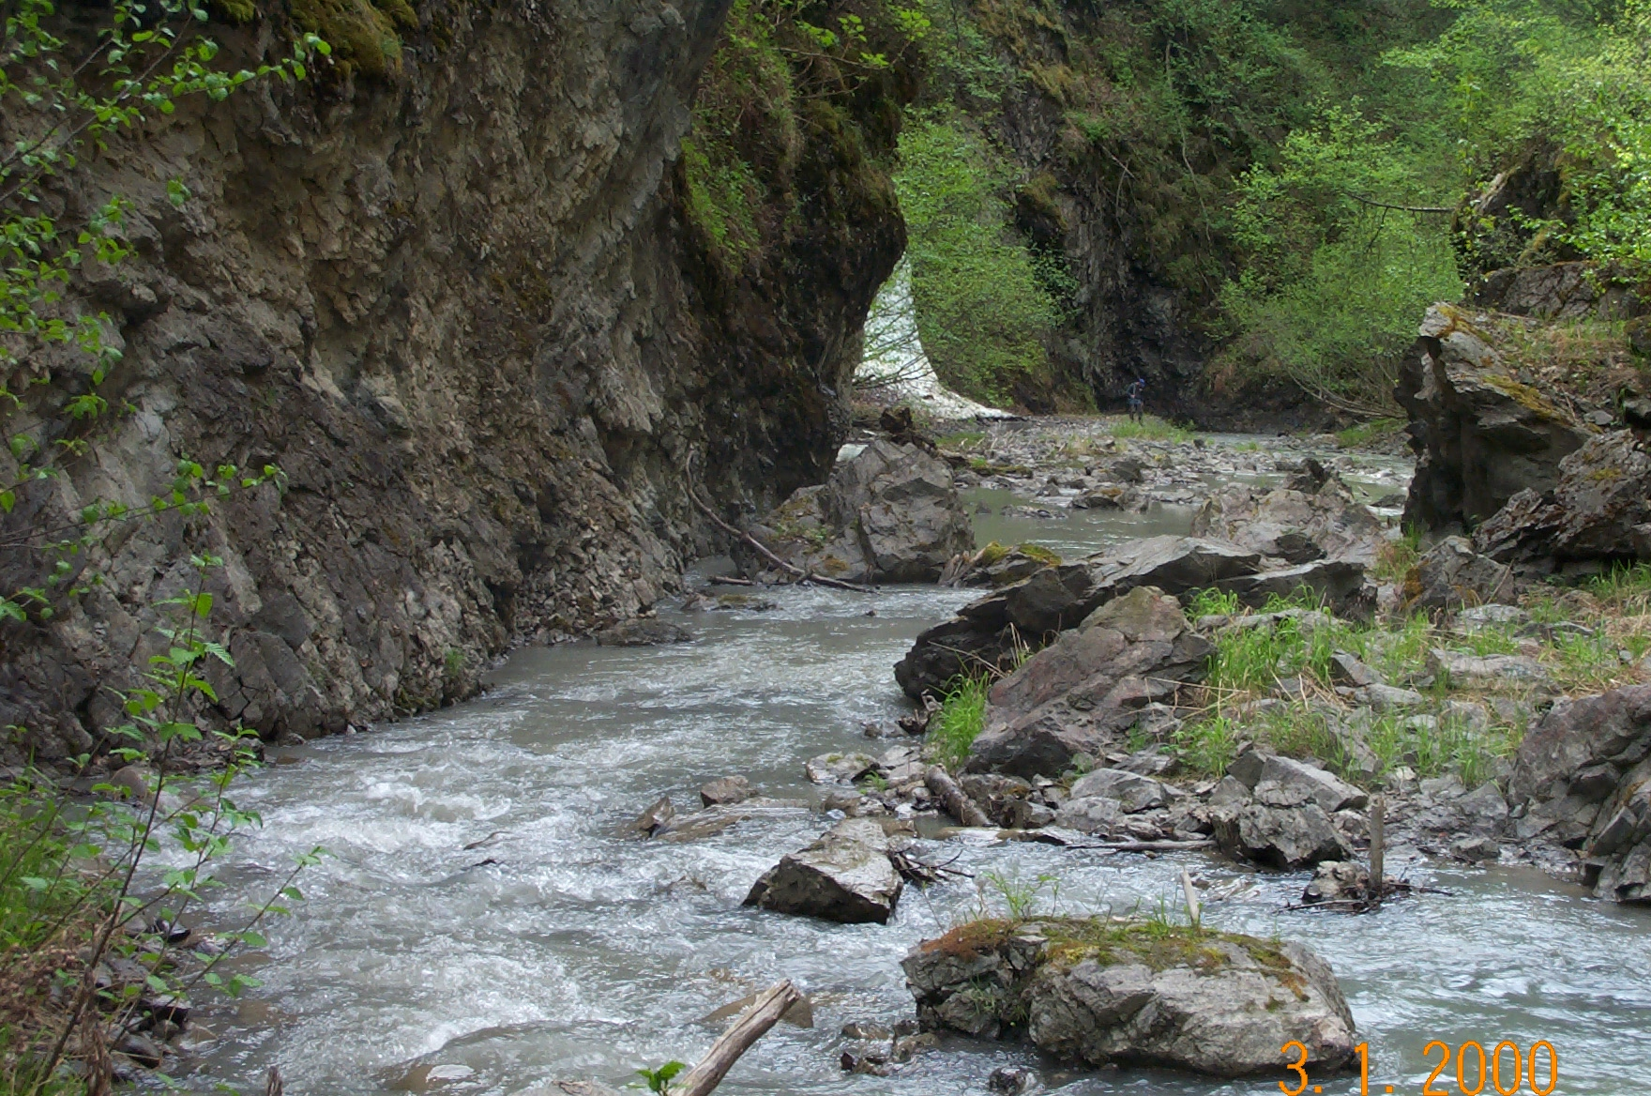 | 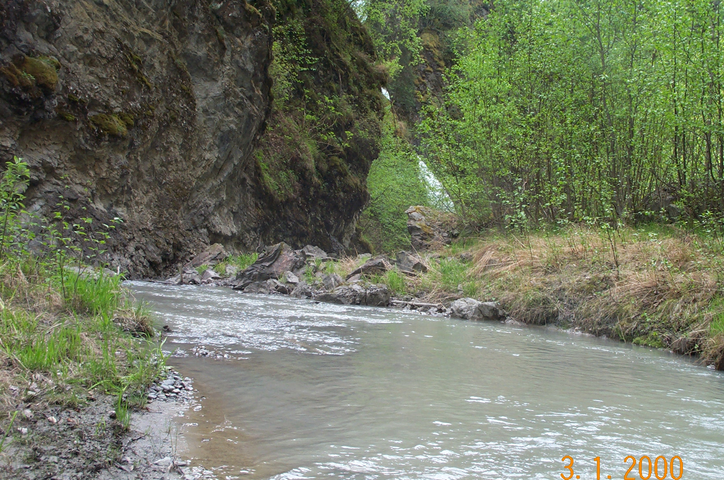
Reach 5-Segment 13 / downstream / photo 1084 | Reach 5-Segment 13 / downstream / photo 1082
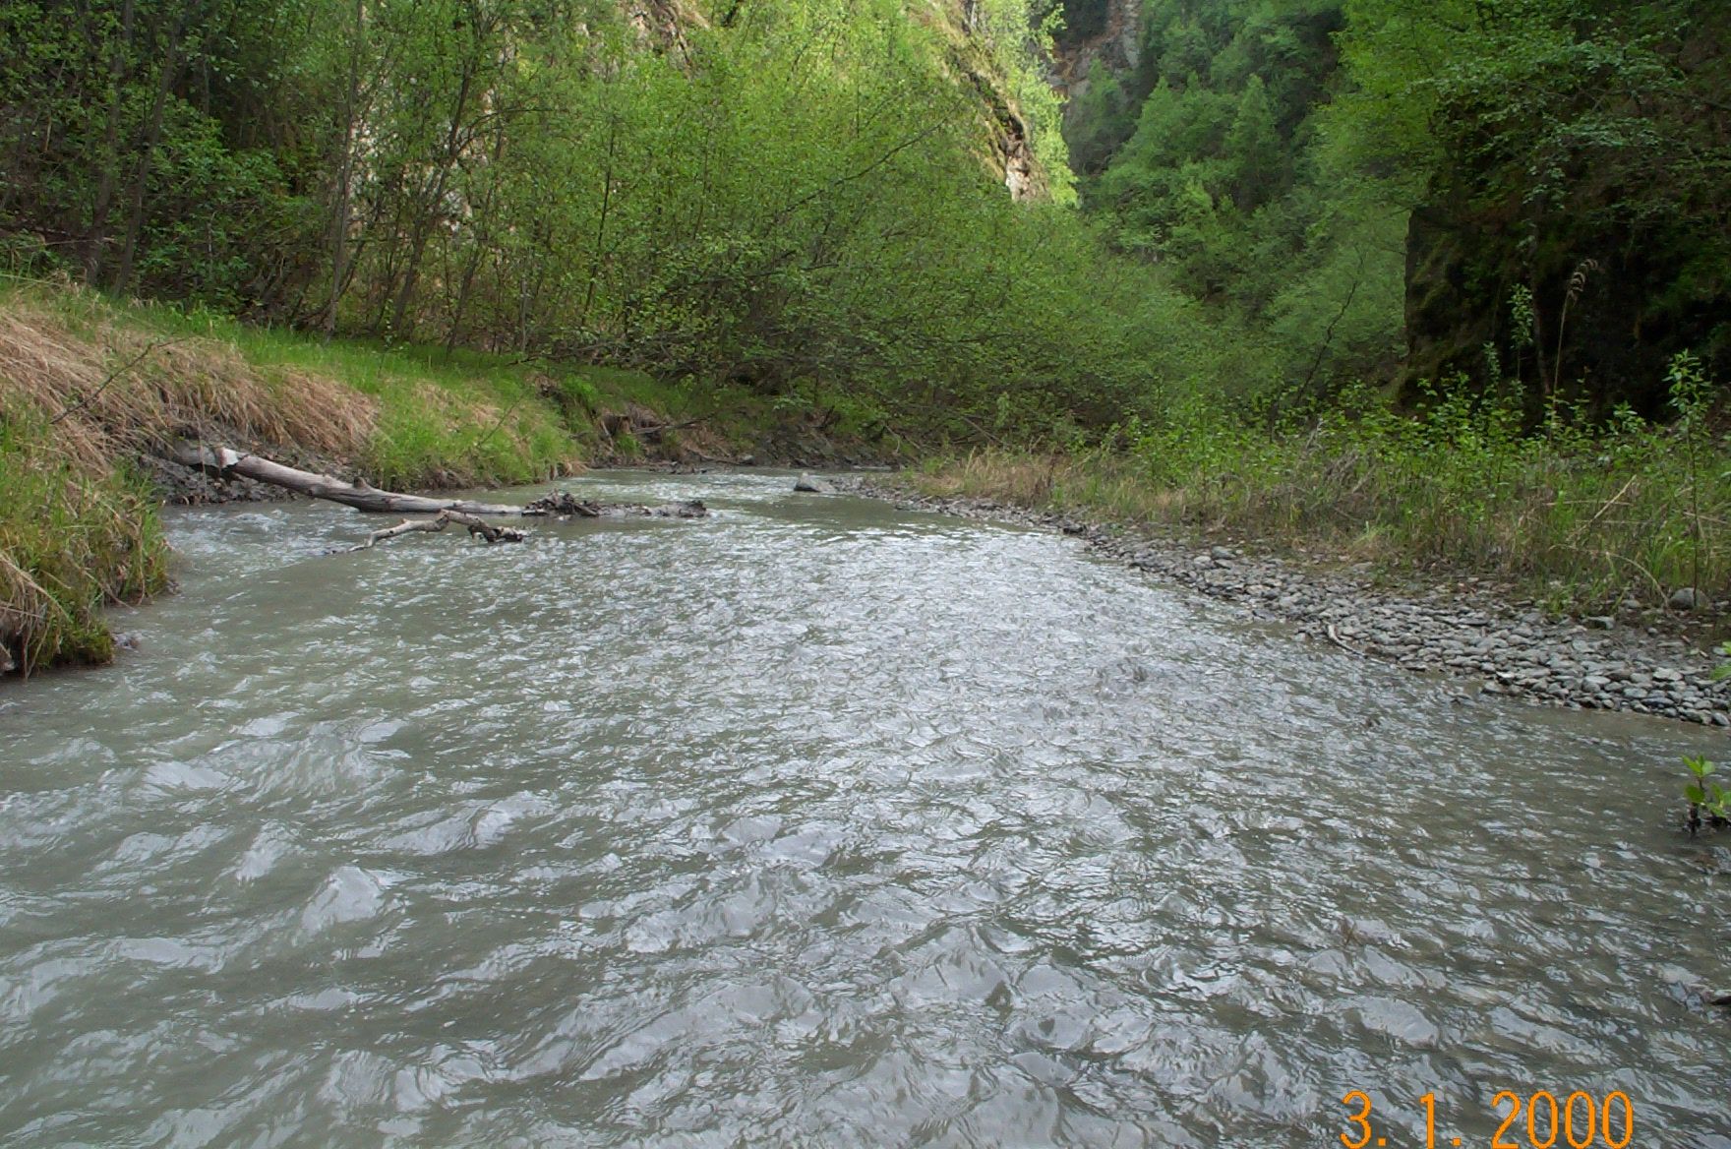 | 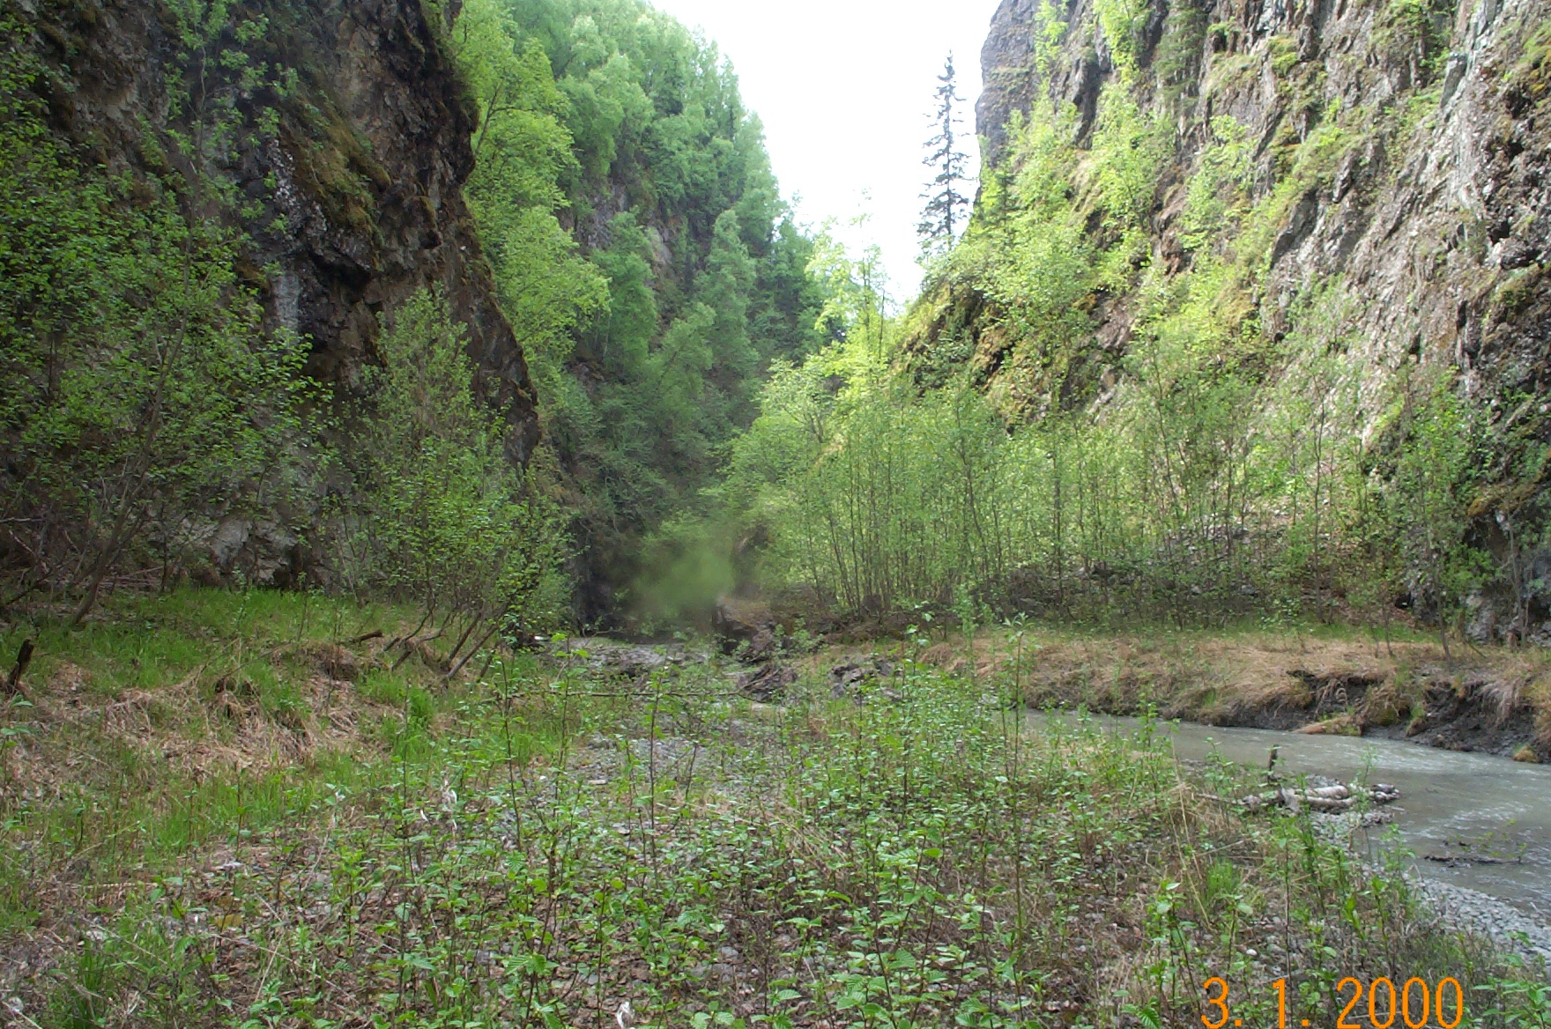
Reach 5-Segment 14 / upstream / photo 1080 | Reach 5-Segment 14 / downstream / photo 1079
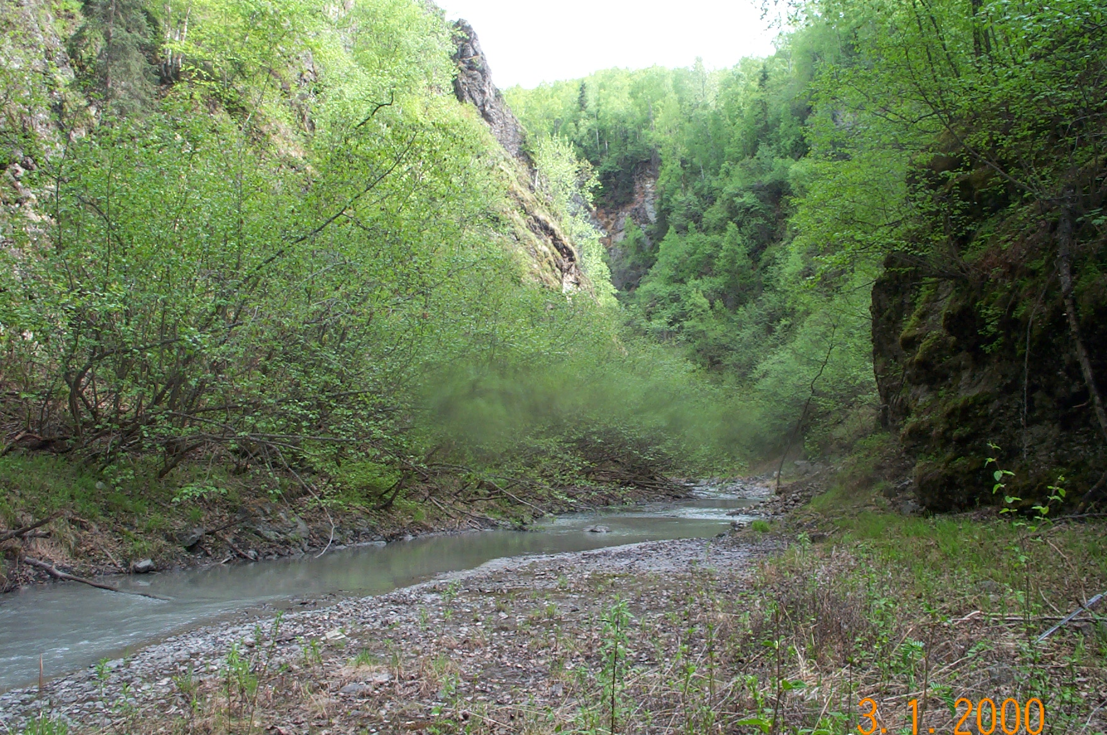 | 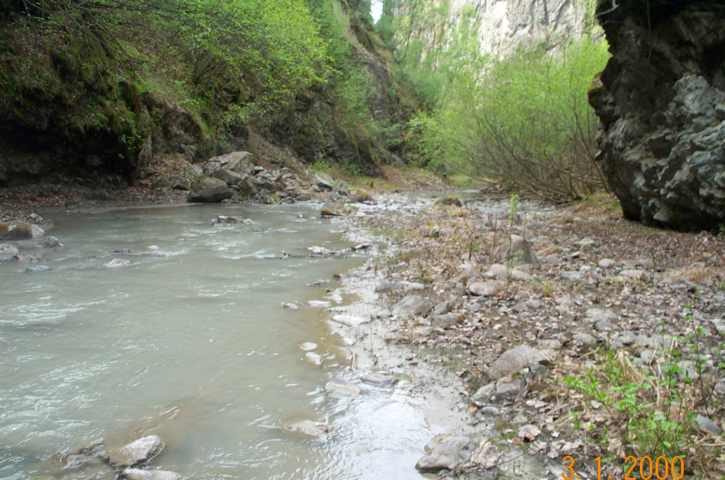
Reach 5-Segment 15 / upstream / photo 1078 | Reach 5-Segment 15 / downstream / photo 1077
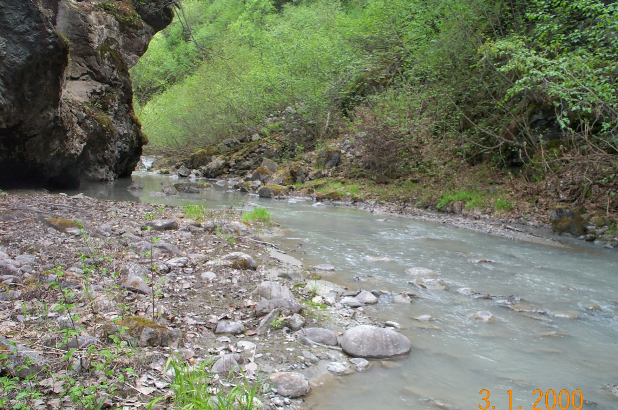
Reach 5-Segment 16 / upstream / photo 1076
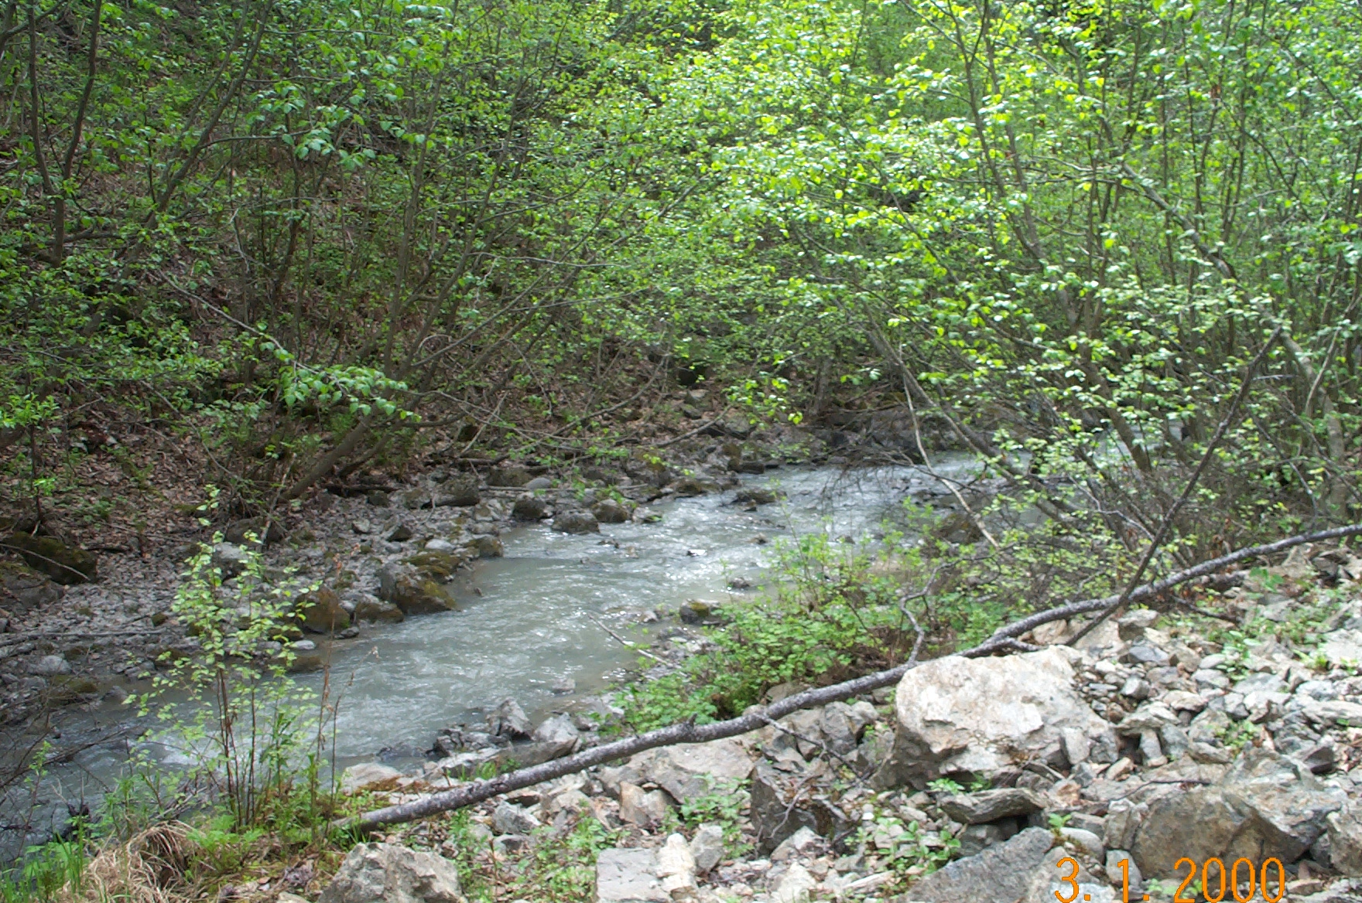 | 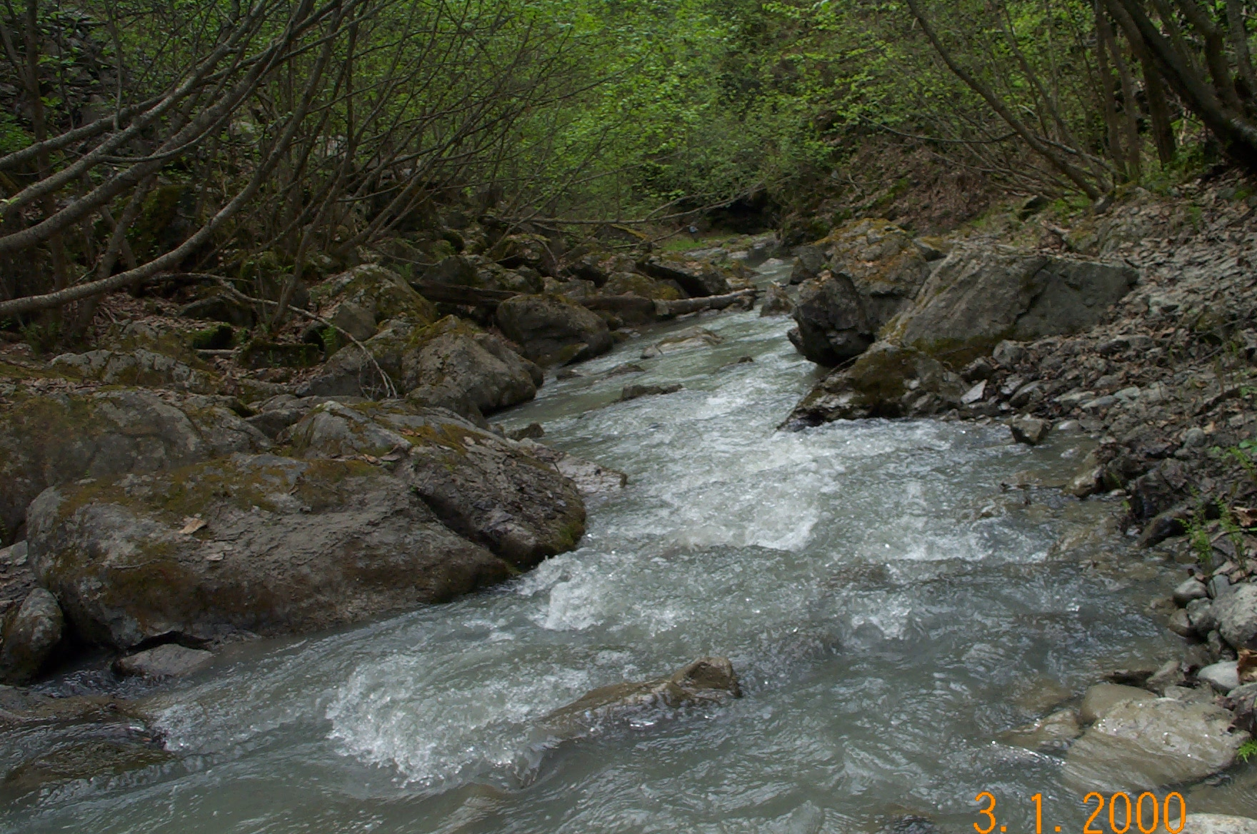
Reach 5-Segment 17 / downstream / photo 1072 | Reach 5-Segment 17 / downstream / photo 1075
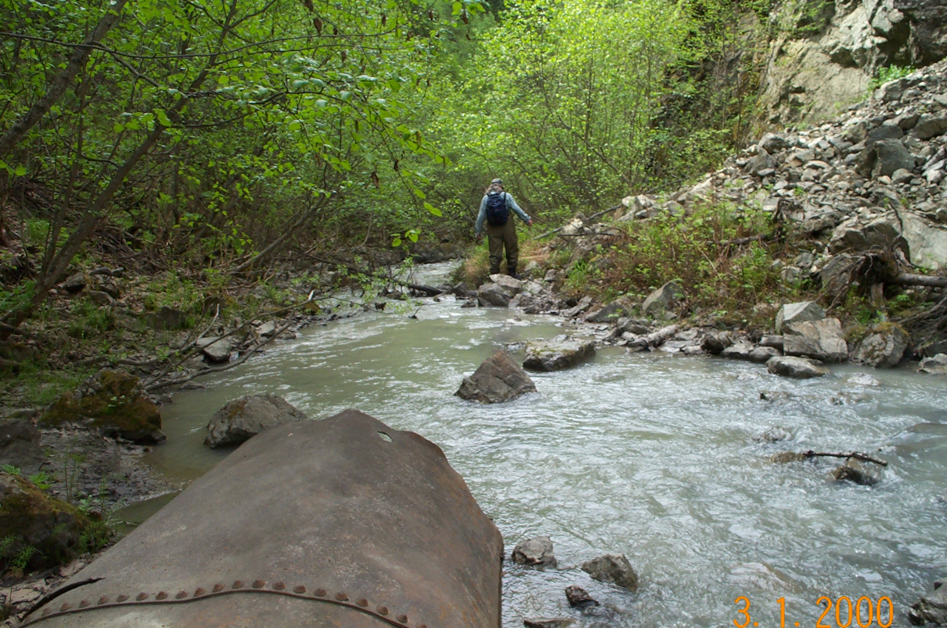 | 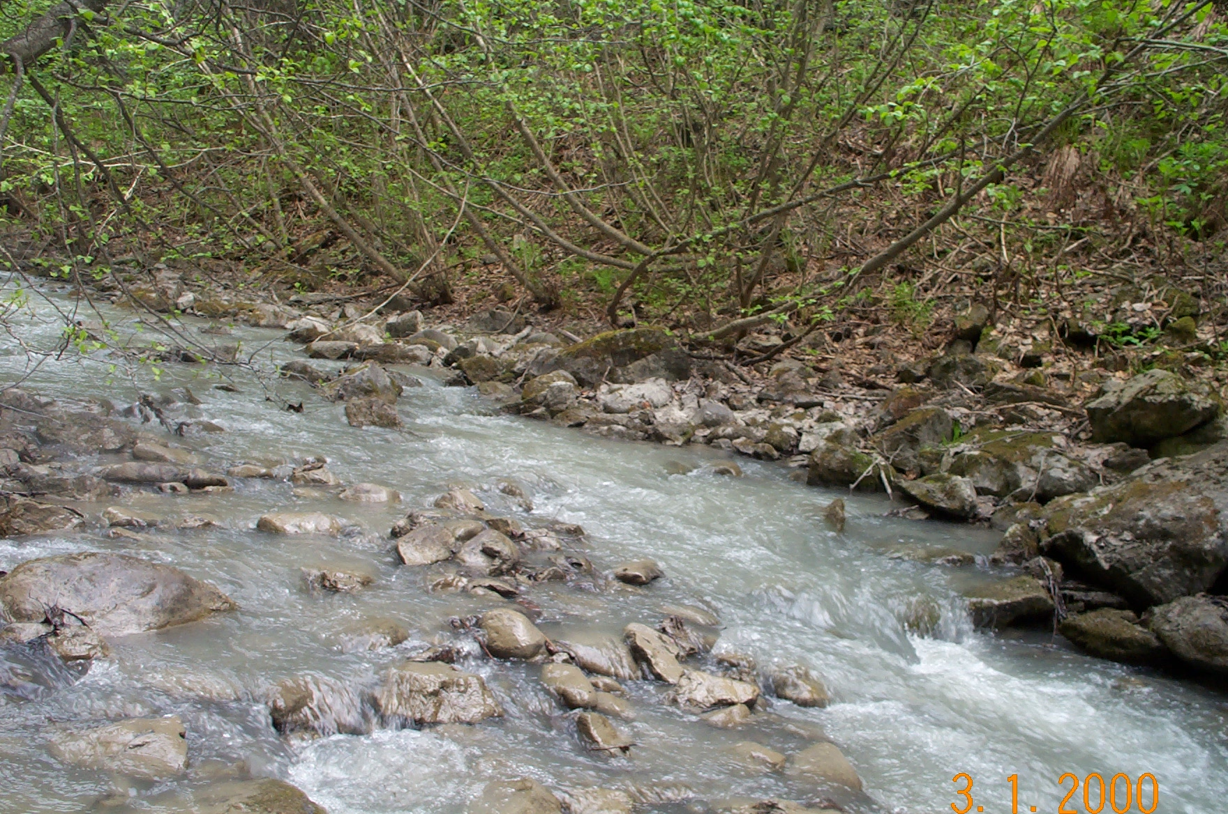
Reach 4-Segment 18 / downstream / photo 1071 | Reach 4-Segment 18 /upstream / photo 1074
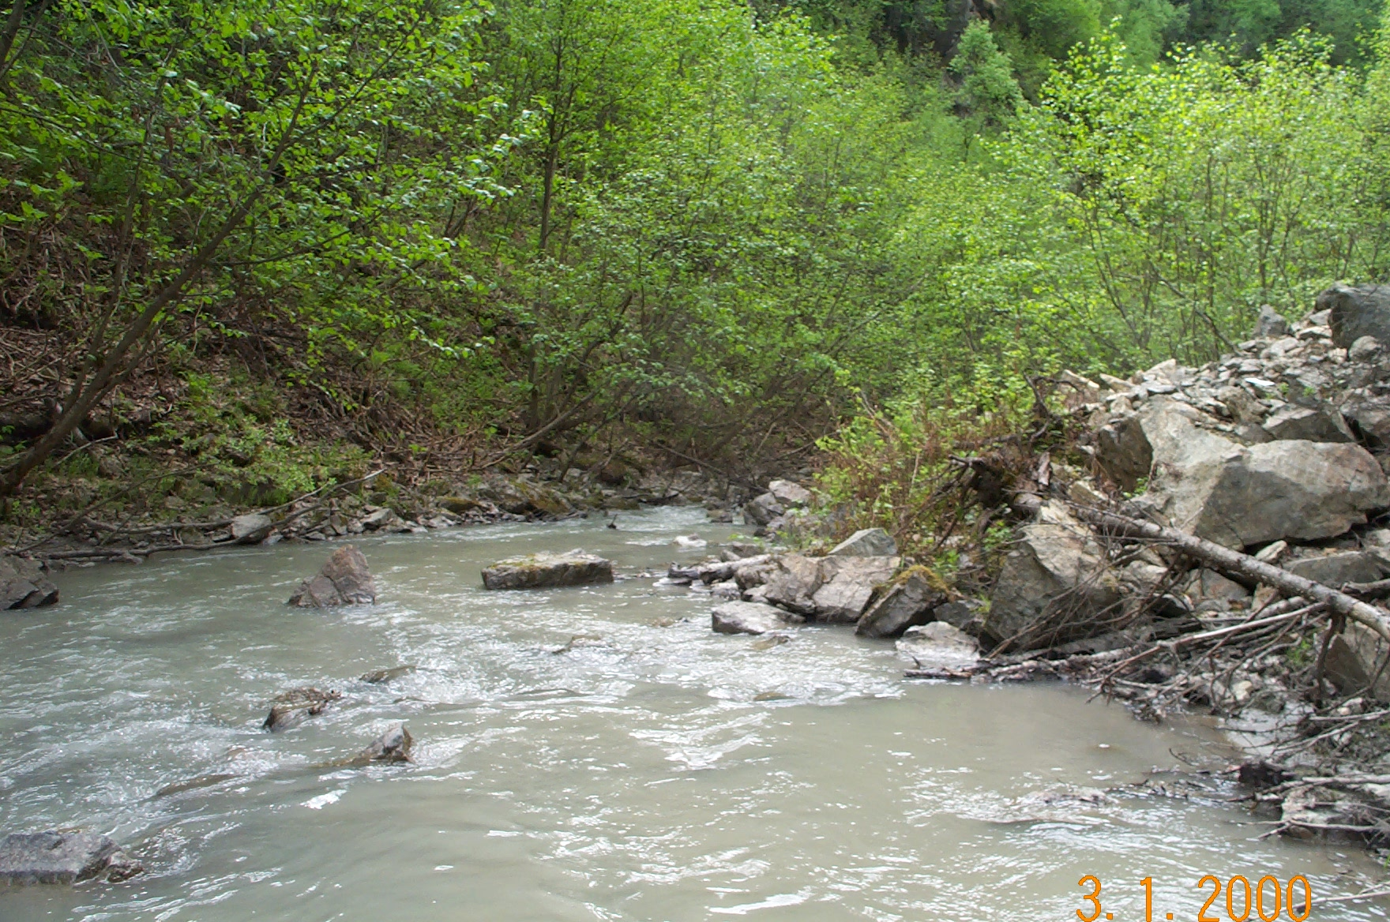 | 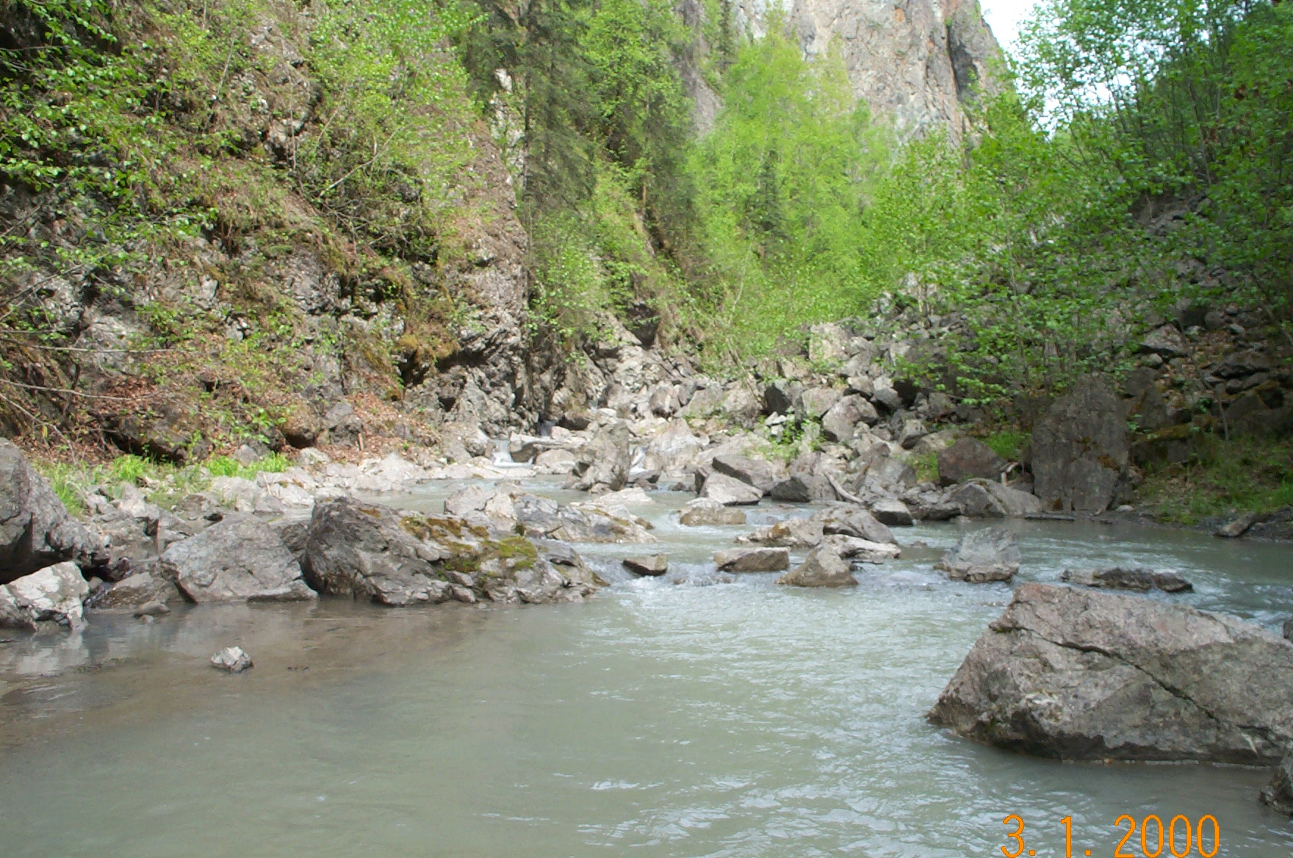
Reach 5-Segment 19 / downstream / photo 1069 | Reach 5-Segment 19 / upstream / photo 1070
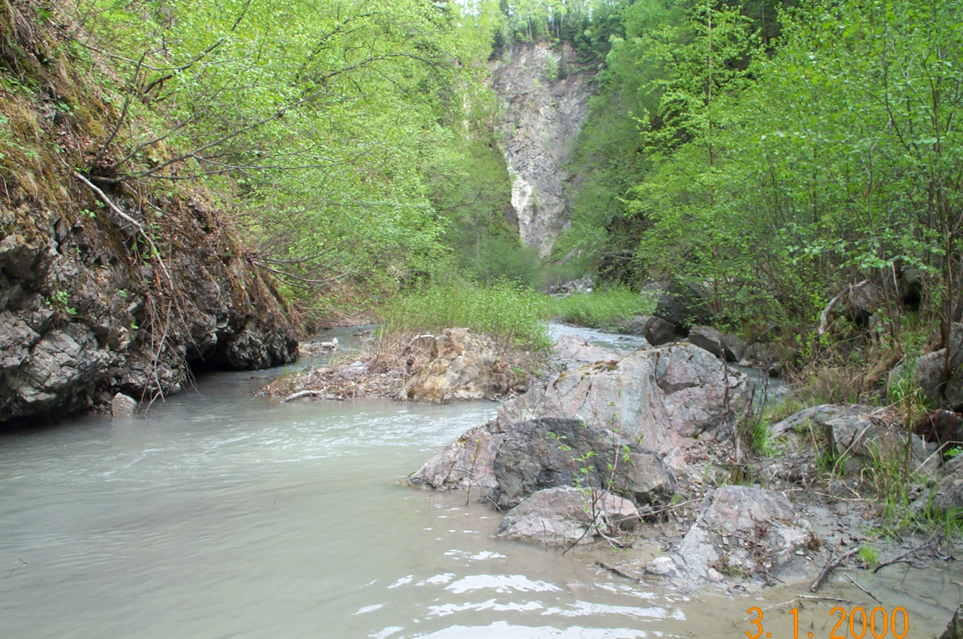 | 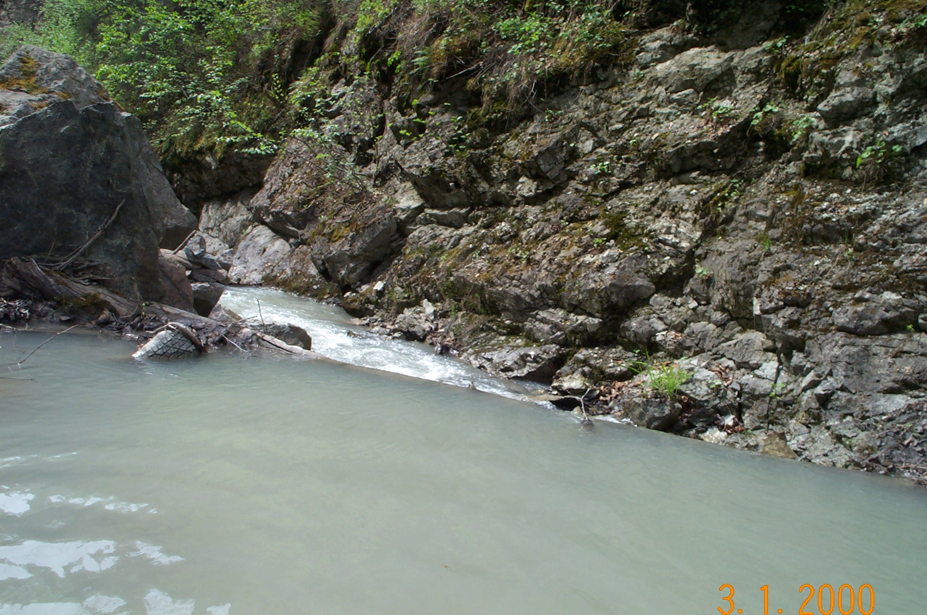
Reach 5-Segment 20 / upstream / photo 1067 | Reach 5-Segment 20 / downstream / photo 1066
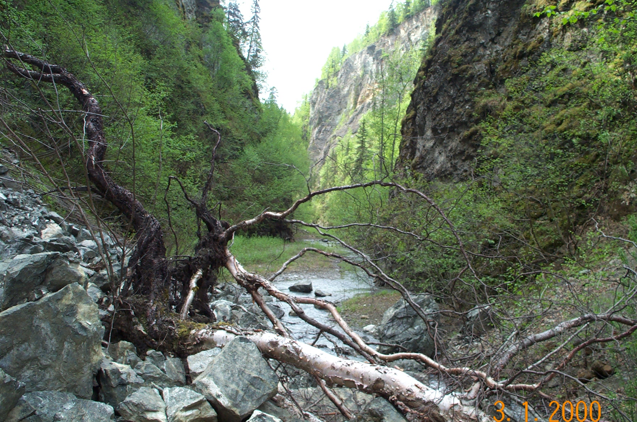 | 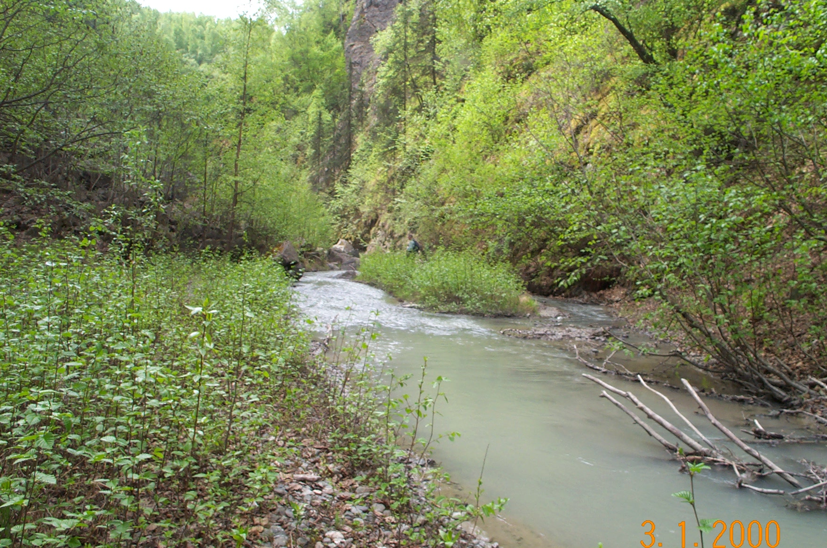
Reach 5-Segment 21 / downstream / photo 1060 | Reach 5-Segment 21 / downstream / photo 1063
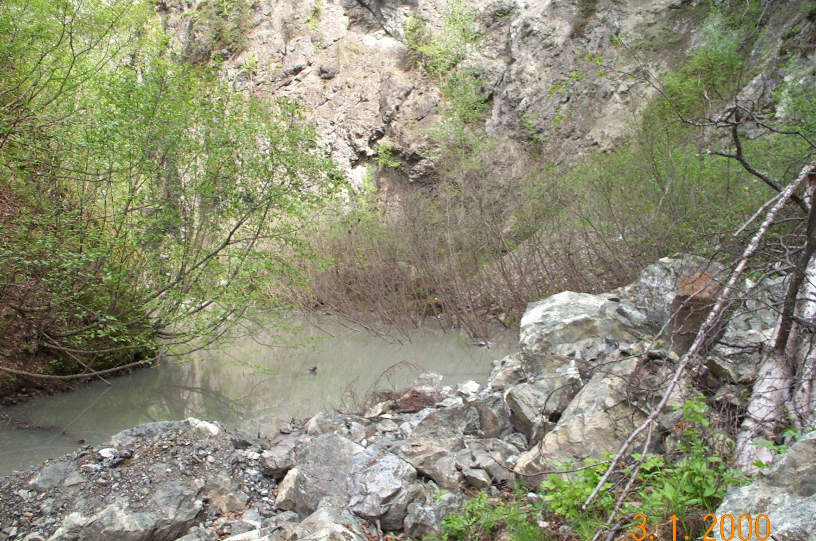 | 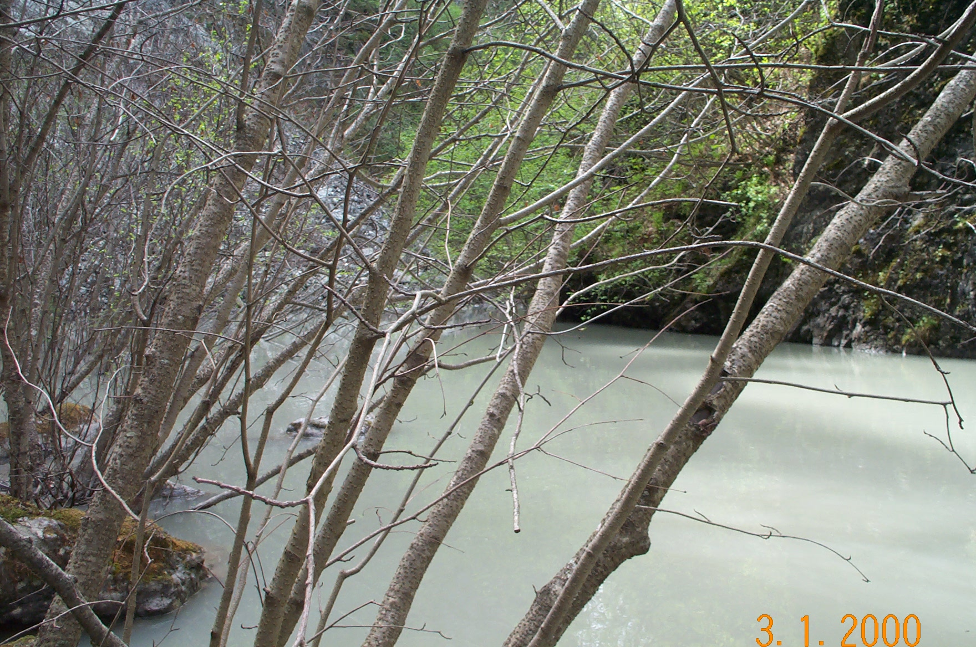
Reach 5-Segment 22 / upstream / photo 1061 | Reach 5-Segment 22 / downstream / photo 1058
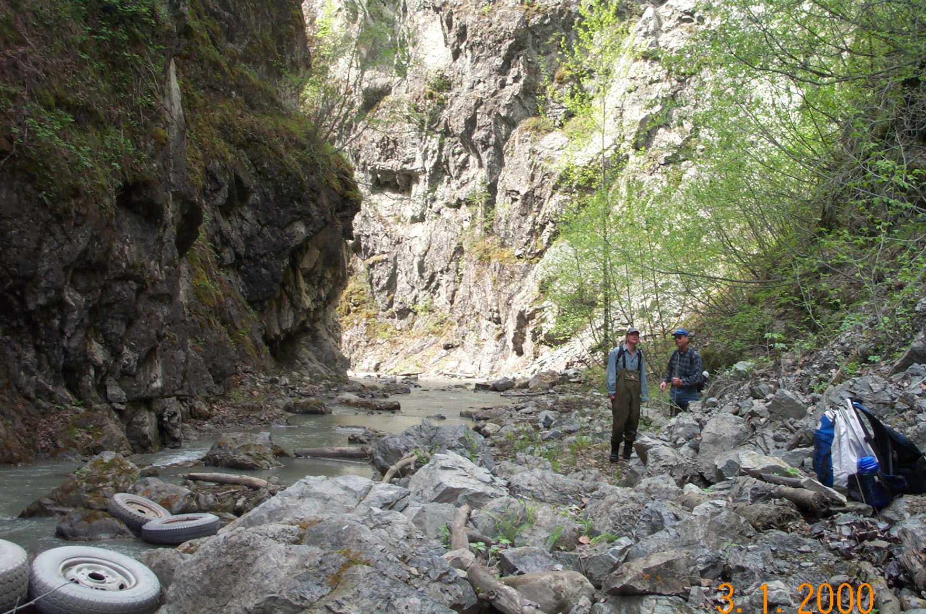 | 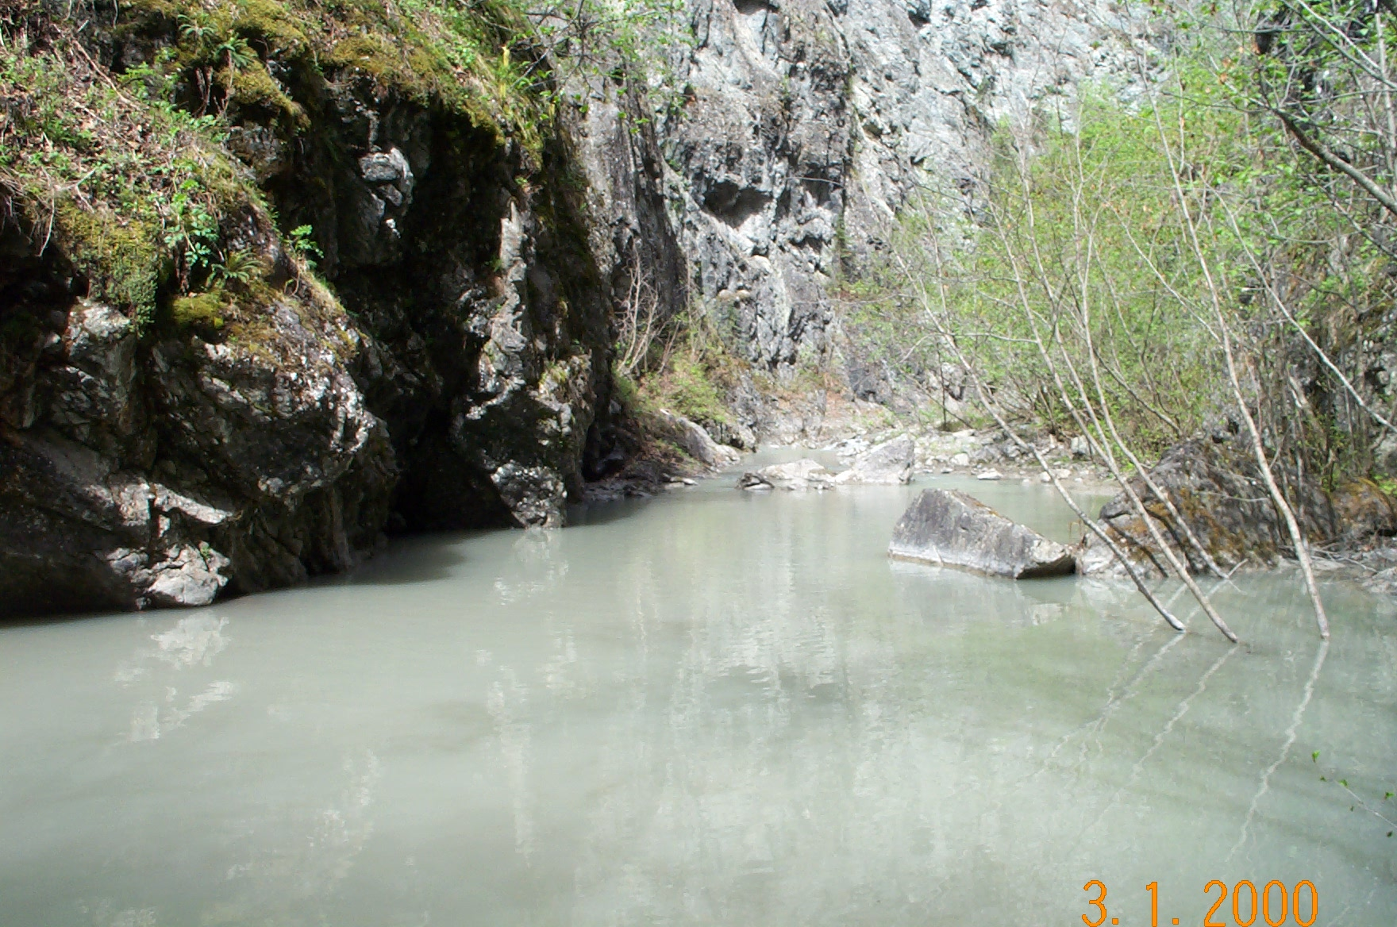
Reach 5-Segment 23 / downstream / photo 1055 | Reach 5-Segment 23 / upstream / photo 1059
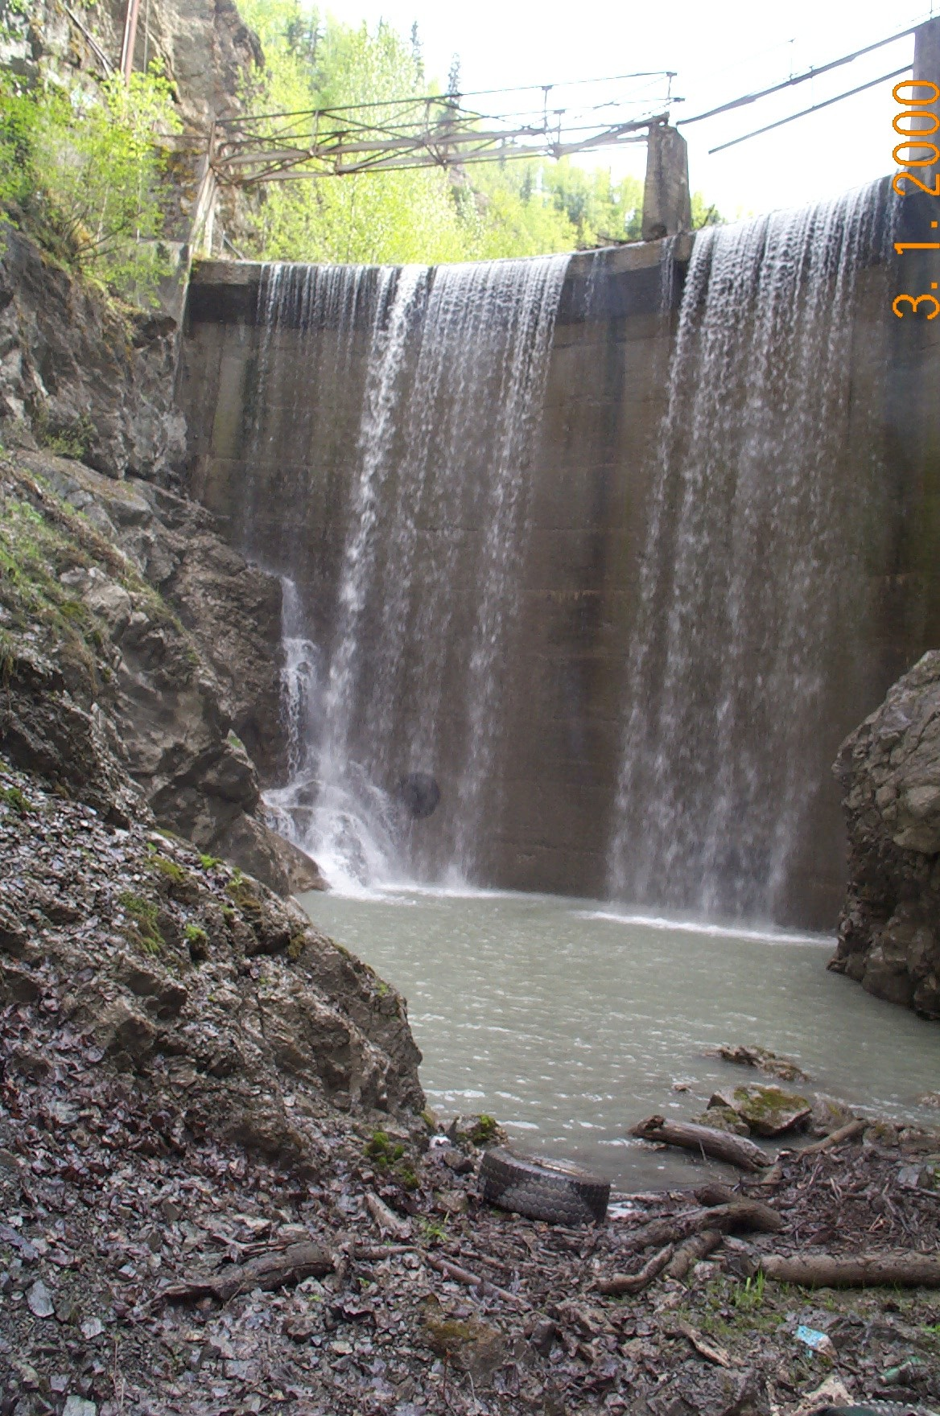 | 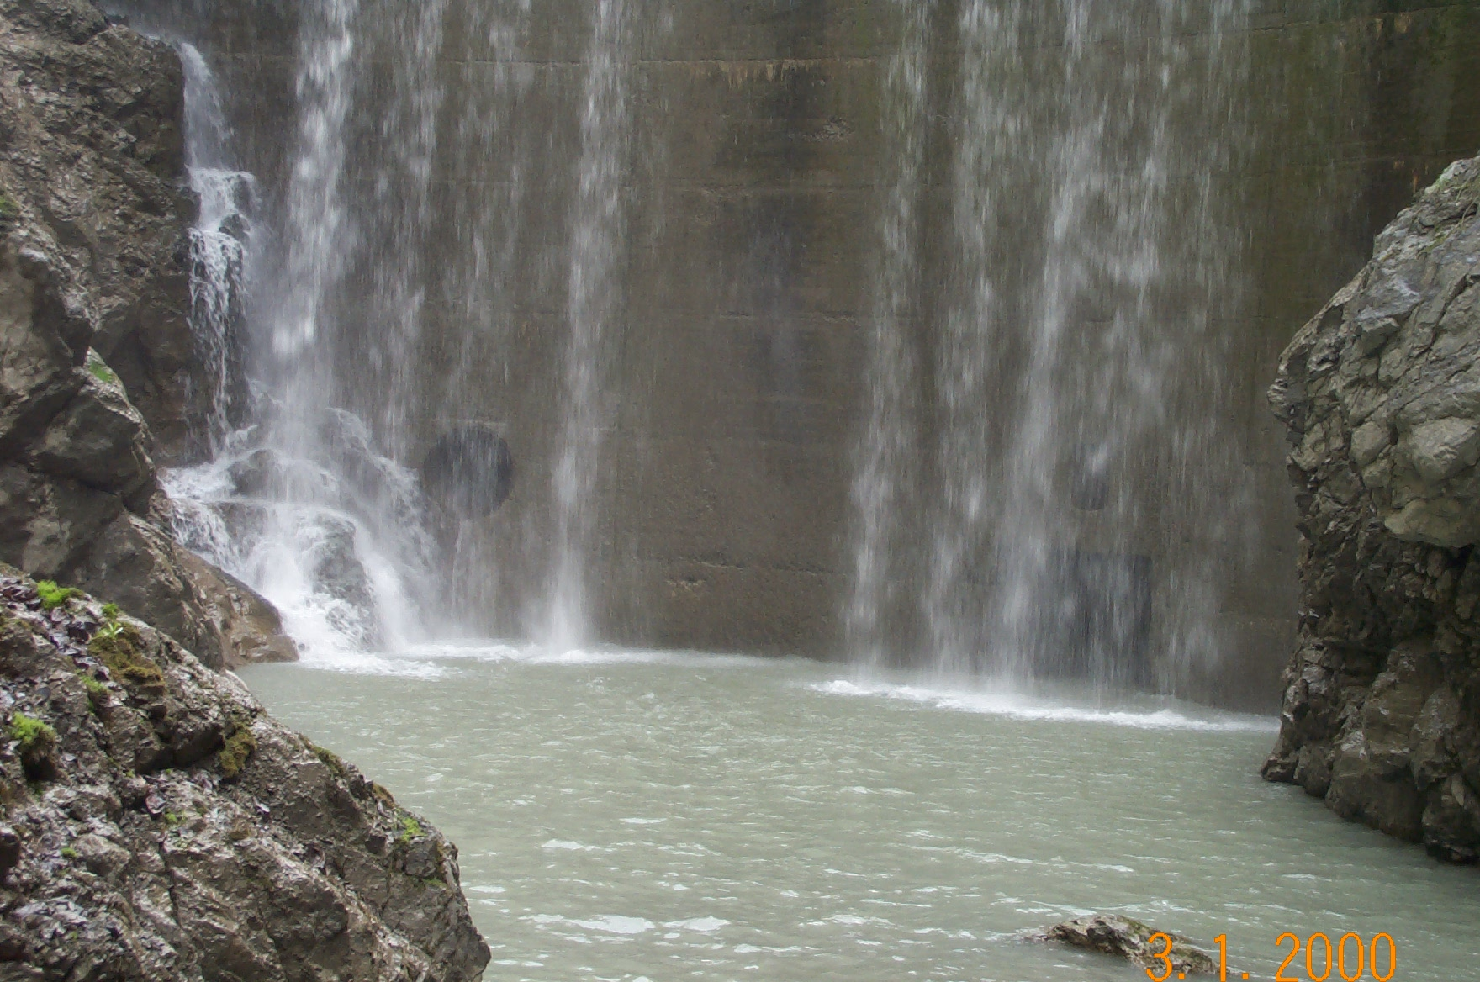
Reach 5-Segment 24 / upstream / photo 1054 | Reach 5-Segment 24 / upstream / photo 1052

